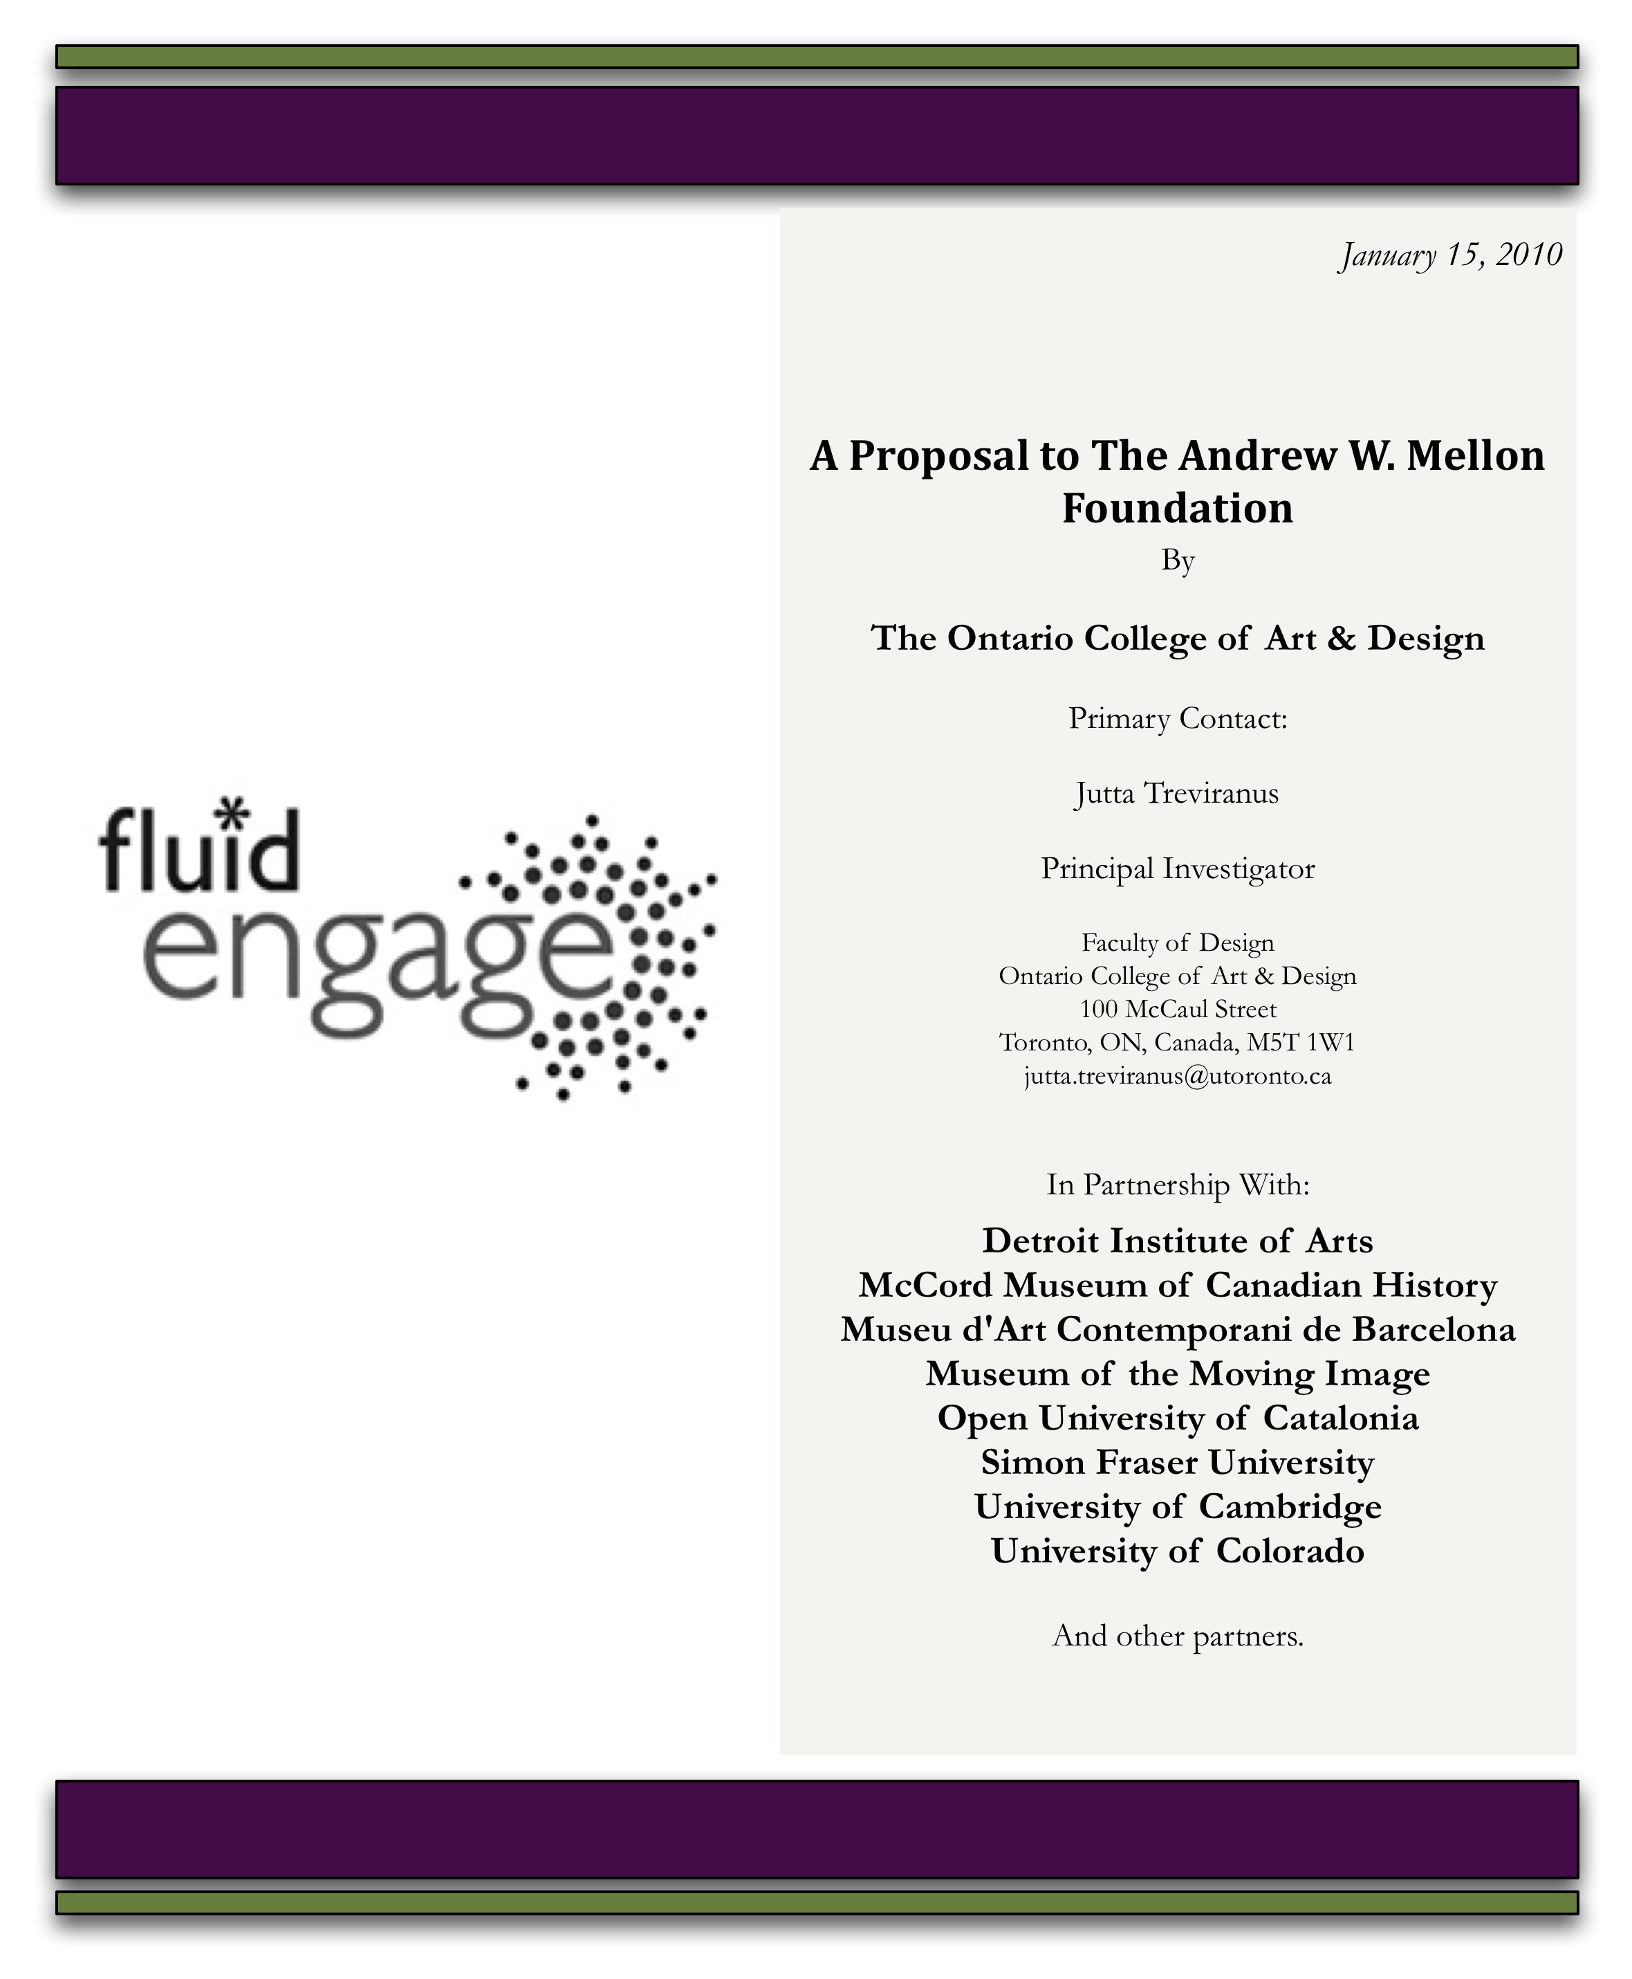
Table of Contents
Executive Summary 5
Project Motivations and Contributions 6
Challenges to be Addressed 6
Accessibility 7
High Level Goals 8
Progress Report and Accomplishments of Year 1 8
Engage 0.1 9
Goals of Engage 0.1 10
End-user Functionality 11
Museum Developer Features 11
Components and Features 11
Documentation 11
Design 12
Supporting Fluid Infusion Releases 12
Engage 0.3 14
Goals of Engage 0.3 14
Components and Features 15
Museum Developer Services 15
Mobile Development Tools 15
“My Collection” use-case 15
Design 15
Supporting Fluid Infusion Development 16
Engage 0.5 17
Goals of Engage 0.5 17
Deliverables Included in Release 17
Components 17
Services 17
Engage "Labs" 17
Design 17
Supporting Infusion Development 17
Focus of Year 2 19
Project Impact 20
Why is Fluid Engage a Priority for Museums and Galleries? 20
Fluid Engage as a Critical Member in the Museum Application Domain 21
Why the Fluid Approach 21
Accessible Engagement 21
Sustainability 22
Project Deliverables and Project Execution 24
Putting it all together 24
Key Features 25
Scenarios 27
Scenario #1: Designing a new mobile device tour of a featured exhibit 27
Scenario 2: Creating a new tour for a featured exhibit for a tour kiosk 28
Scenario 3: Creating a new in-gallery display for a book exhibit 28
Architectural Approach 29
Engage Authoring Tool Technical Overview 31
User Experience Design Approach 32
UX for authoring toolkit 32
UX for services 33
Educate the communities about UX developments, roles, and contexts 33
Iterative Design 33
Full-scale Solution 34
Project Plan and Schedule 34
Fluid Engage Year 2 Quarterly Deliverables 35
Q2 2010 Engage 0.6 35
Development 35
Architecture 35
UX 35
Q3 2010 Engage 0.7 36
Development 36
Architecture 36
UX 36
Q4 2010 Engage 0.8 37
Development 37
Architecture 37
UX 37
Q1 2011 Engage 1.0 38
Development 38
Architecture 38
UX 38
Future Directions 38
Project Governance 39
Leveraging Collective Resources and Effort 39
Project Structure Overview 39
Project Management 40
1. Board of Directors 41
2. Steering Committee 42
3. Advisory Panel 42
4. Technical Team 43
5. Implementation and Evaluation Team 43
6. Design Team 43
Budget 48
Appendix 2: New Fluid Engage Partners and Advisory Board Members 48
Advisory Panel 48
Partners: 49

Figures and Tables
Figure 1: The new Fluid Engage website 9
Figure 2: A screenshot from Engage 0.1 showing the ability to browse through a collection of artifacts. In this case, McCord's 13
Figure 3: A screenshot from Engage 0.1 showing details about a specific artifact, also from McCord's collection. 14
Figure 4: A design wireframe illustrating the ability for users to create their own custom collections. 16
Figure 5: A design wireframe showing the "gallery card" interface for the in-gallery kiosk. 18
Figure 6: Sketch of possible authoring environment, showing freeform page layout and the ability to customize components using a graphical interface with panes and palettes. 27
Figure 7: An illustration of Engage’s architecture, showing how information flows through data feeds and is presented using dynamic UI components and the Fluid Skinning System. 30
Figure 8: The iterative design process used by the Fluid Engage design team. 33
Figure 9: Governance Structure of Fluid Engage Year 2 reflecting new partners and advisors. 41

Executive Summary
To remain a relevant and supported part of current society, museums and galleries must create an engaging online, mobile as well as in-house presence, but for the average curator or education director this terrain is in chaos. While technology-savvy pioneers are exploring exciting new possibilities, most curators must contend with very little integration of tools or content, few guidelines or supports for user experience design and accessibility, no support for reuse or repurposing and no guarantee that large investments in gaining the skills needed to become familiar and adept in the terrain will not result in orphaned content, unsupported online environments and irrelevant knowledge. In an unforgiving time when there is no allowance for inefficiency or redundancy, and the impact of any investment of effort must be maximized to benefit the core mission, museums and galleries require effective, robust, sustainable, “future-proofed” tools to create compelling applications to engage and capture the attention and imagination of visitors and potential visitors. Fluid Engage is a project and a collaborative community launched in April 2009 to equip museum and gallery professionals with these tools and resources.
Fluid Engage Year 1 has made great progress by creating a robust, extensible, flexible and optimally interoperable framework for authoring visitor experiences in museums and galleries. This authoring framework enables museum professionals to author visitor experiences that will display on the Web, on personal mobile devices and on in-house displays such as kiosks, without redundant development. This has been tested and refined and will be implemented and evaluated in museum partner institutions by the completion of Year 1 in March of 2010. The framework supports accessibility: the user experience components that act as building blocks for creating an exhibit or activity are accessible and the toolkit assists developers in creating accessibility features for existing content that is dynamically displayed (e.g., alt-text for images, captions and descriptions for video). Most significantly, Fluid Engage has created a well functioning, collaborative team and exemplary design and development processes that are referenced and emulated by other software projects around the world.
Year 2 of the Fluid Engage project will focus on enhancing this authoring framework to enable its implementation by museums and galleries without software or Web programming staff – with one major caveat or critical requirement – the authoring environment should not constrain individual creativity or innovation but allow the creation of distinct and unique exhibits and displays with respect to presentation and content but also structure and interaction. In addition the authoring environment itself should be customizable to match the workflow, needs and preferences of each institution or author. The authoring environment should be capable of dynamically pulling in content from any number of museum and Web sources, in all popular media formats. It should allow the meaningful integration of social networking applications. It should also interoperate with museum-based software applications and other relevant Web applications. This tool will have broad applicability beyond the museum and gallery to the presentation and curation of any digital collection, enabling the creation of engaging methods of interacting with and contextualizing the artifacts or digital objects. The Fluid Engage team is uniquely positioned and equipped to achieve this ambitious goal by virtue of expertise and reusable resources built up through collaboration with portal (e.g., uPortal), learning management (e.g., Sakai, ATutor), content management (e.g., Drupal, Joomla), collections management (e.g., Collection Space), rich media tools (e.g., Open Cast), software development kits (e.g., jQuery, Dojo) and browser (e.g., Mozilla and Firefox) applications and projects.
This proposed Year 2 of the project will be conducted over 12 months beginning in April 2010 by an expanded collaborative community made up of museums, galleries, universities, and leaders in the field.

Project Motivations and Contributions

Challenges to be Addressed
The riches and thereby the incredible value and societal importance of museums remains largely hidden from the public. The breadth and depth of intellectual capital and knowledge is often opaque to the average citizen, scholar and researcher. Beyond the public education mandate of museums and galleries, given the distractions of the Google age and the current economic reality, it is critical that museums make their relevance and importance clear to the public and to decision makers responsible for funding. Weaving the museum experience into the popular discourse and engaging (frequently information overwhelmed) visitors in the museum experience is crucial to the survival of these important institutions.
As in any crisis, when resources are needed most, resources are most scarce. Museums and galleries must become proficient in using quickly evolving digital tools at a time when most museums and galleries have difficulty keeping the lights on, let alone recruiting, training and maintaining technical staff.
This is a time when museums and galleries need to pull together and share collective resources but not at the expense of distinctiveness or unique identity. Collective survival depends on pooling resources but individual survival depends on retaining distinctness.
Technical applications and systems currently deployed in museums have fallen far short of early expectations with respect to providing mechanisms to engage the public, rather they have frequently acted as distractions and barriers for museum or gallery professionals. Because of poor usability and reliability they have pulled the focus toward learning, relearning, keeping up with, maintaining and fighting the constraints and shortcomings of the technology itself rather than the functions they were meant to fulfill. Museum and gallery professionals tasked with creating a Web presence, kiosks and mobile tours express frustration with:
- proprietary systems that quickly become obsolete;
- incompatibilities between applications, tools and hardware;
- no easy mechanisms for displaying and refreshing the wealth of content held by museums and galleries;
- off-the-shelf solutions that are expensive and ill suited to the museum needs;
- dependence on external technical expertise;
- lack of control and independence in designing the exhibit, activity or display and in realizing the curatorial or educational vision.
Technical solutions that are created in-house are an unaffordable, unsustainable luxury as are one-off interactive applications that cannot be repurposed to capitalize on the labor investment. Most museums have recognized that curatorial applications and tools cannot be developed and maintained by any single institution no matter how large. Museums have also discovered that these mission-critical applications cannot be left to outside commercial entities that create proprietary code, are often platform specific, foster dependence but may disappear or reduce customer service and responsiveness when dependence is established.
Content (including the digital form of the artifact, the interpretive content and the online display or interactive activity) frequently becomes orphaned when systems are upgraded, requiring redundant entry. Many applications require conversion of content into proprietary formats that cannot be exported when the system becomes obsolete. The content thus captured is also not amenable to display on other platforms (e.g., mobile systems, kiosks) or discovery through federated collections. Of even greater concern is that the ownership and control of the content is frequently relinquished.
The public expectation of more than simply a reference experience but an interactive experience as part of the museum visit is currently beyond the technical capability of professionals at most museums and galleries. Unfortunately, when resources are invested in computer mediated interactive activities they are most often specific to a single exhibit and specific to a single technical platform. The interactive applications are not created to be repurposed or repopulated with new material or migrated to other exhibit platforms (mobile, kiosk, updated Web sites) meaning that the investment is lost when the exhibit is replaced.
As many museums do not have in-house software or Web developers, authoring tools are needed that can be used by existing museum staff without restricting these staff to creating formulaic exhibits or activities. Luckily, museums and galleries are endowed with incredibly creative and talented curatorial and education professionals with well-developed design skills and no lack of ideas about how to draw the public into discourse regarding the collections they steward. However there is a technical gap between these ideas and their realization, between the primary and interpretive content and its presentation in digital form. To bridge this gap requires tools that extend the talents of these professionals to the various forms of digital expression. To facilitate ease of implementation, these tools must be configured to the museum and gallery workflow, presented in the native “language” of museums and sufficiently easy to use that they become transparent so that the professional can focus on designing the unique and engaging visitor experience. Like non-digital studios, labs or toolkits these authoring tools should also be configurable to the authoring tasks and needs of each professional and museum. These applications must unleash rather than constrain the creativity and innovative expression of the museum and gallery author. Thus both the visitor experience created and the authoring experience can be distinct and fitting to the unique context.
There is a growing realization among cultural institutions that what is needed is collectively owned, designed, developed, refined and maintained applications to create the visitor experience. These applications should benefit from collaborative and cumulative contributions, be sustained by a growing collective of cultural institutions, but they must also enable customization, individual expression and the maintenance of a distinct and responsively evolving identity for each participating institution. These applications must work with and capitalize on the rich variety of general domain tools and applications such as Web authoring, social networking and wayfinding tools but provide a fit-for-purpose interface that is contextualized to museum and gallery requirements. It is essential that they communicate and harmonize with other tools in the museum and gallery domain including collections management, content management, conservation and museum administration applications. The applications must also capitalize on the wealth of curatorial, interpretive, design and educational expertise that exists in museums and galleries by providing easy to use, cost effective tools for displaying this wealth and inviting visitors, researchers and scholars to engage in the museum experience.

Accessibility
The accessibility of the museum experience is gaining in importance as museum visitors’ age and as the legal obligations of museums and galleries are affirmed and strengthened through litigation and legal settlements. Of particular relevance to museums and galleries in the US, the office of the President has identified this as a priority. This was highlighted in a recent Newsweek article:
Since the passage of the Americans With Disabilities Act in 1990, museums and other institutions have been required to make their facilities "accessible" to everyone, regardless of their particular type of disability. For decades at many museums, this meant little more than providing ramps for people who use wheelchairs and Braille museum guides for people who are blind. But a landmark 2008 Department of Justice ruling forced museums around the country to grapple with what accessibility actually means.
Jesse Ellison, Newsweek, Oct 23, 2009
While museums have a good understanding of architectural accessibility and the need for alternative print formats, there is a great deal of confusion about how to make wayfinding, physical exhibits, online environments and mobile experiences accessible. There are few exemplars or reusable, shared resources in this area. All museums identified this as a priority not only to mitigate legal risk, but also to expand the museum or gallery experience to a larger user base and to accommodate the needs of aging patrons. Most museums cannot afford to recruit accessibility experts. What is needed is a sustainable, integrated accessibility strategy that delivers accessibility as part of the user experience.

High Level Goals
The increasing importance and relevance of Fluid Engage goals has been repeatedly validated over the past year at conferences, in forums and in discussions with museums and galleries around the world. The goals of Fluid Engage are to collectively create the necessary supports, tools and resources for curators and educators within museums and galleries so that they can:
- Create engaging visitor experiences across all three exhibit environments: the computer mediated physical space, online and through mobile devices.
- Provide accessible exhibits and experiences in these environments, thereby meeting legal commitments while at the same time making the experience more usable and engaging for all visitors.
- More seamlessly and efficiently integrate existing and new applications applied in museums to create engaging visitor experiences (content management system, collection management systems, maps, social software, mobile applications, and beyond)
- Bridge the gap between creative design vision and its expression in the digital realm and participate in the larger user experience design community.
Added to these goals is the imperative to ensure that these supports, tools and resources:
- are usable by existing museum and gallery staff,
- are extensible and scalable,
- enable customization and reconfiguration to the specific workflow of each institution as well as the specific authoring tasks, and
- support the creation of distinctly unique exhibits and displays.

Progress Report and Accomplishments of Year 1
The Fluid Engage project began in April 2009 and is now three quarters through the first year. Not only is progress on schedule, but as the importance of this task, the broad applicability of the proposed deliverables, and the incredible diversity of museum and gallery needs became apparent, the project took on the task of building an even more scalable, flexible and robust foundation upon which to develop an extensible, responsive authoring environment. To optimize the longevity of the Fluid Engage resources, enable broad cross-platform compatibility, and address the diversity of configurations required by museums the Fluid Engage project put additional emphasis on creating the foundational architecture upon which to develop a rich array of authoring supports.
During the first year Fluid Engage will produce three software releases, each consecutive release building upon and refining the previous release using the Fluid agile, iterative user experience and quality assurance methods developed and refined through application in a growing number of projects (and emulated by many other projects). These software tools will be implemented and evaluated by museum partners through several reference implementations.
Below is a high level summary of the progress to date organized into the three releases and a summary of work to be completed by the end of Year 1. Work in progress or yet to be completed is expressed in italics, all other work has been completed as of December, 2009. Associated hyperlinks link to demonstrations and more detailed descriptions of the accomplishments. An overview of work to date can also be seen at: http://fluidengage.org (see Figure 1).
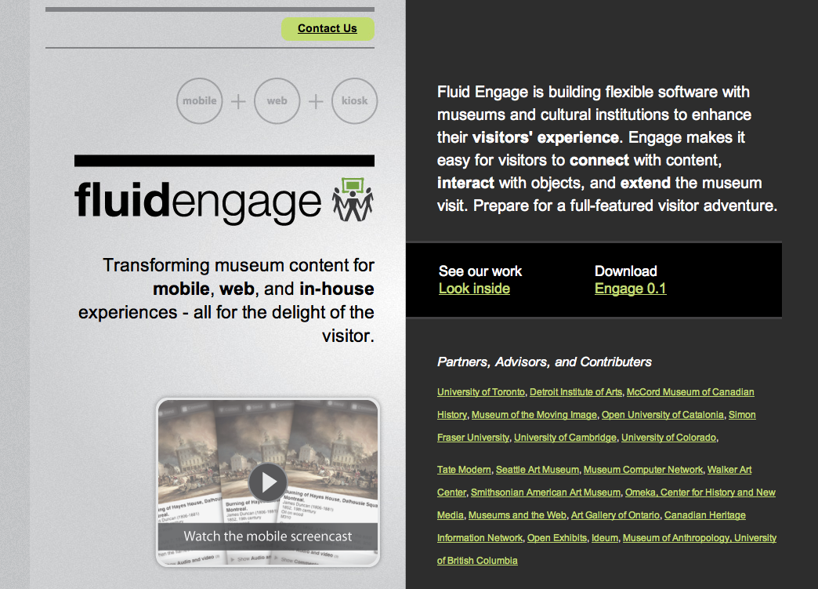
Figure 1: The new Fluid Engage website

Engage 0.1
Work toward the first release of Fluid Engage initially focused on user research. There are two distinct classes of Fluid Engage users: 1) the museum or gallery professional, and 2) the end user or museum and gallery visitor. True to the Fluid focus on inclusive design this research did not focus on the “typical” user but the range and diversity of users, contexts, skills and needs. Extensive user research addressed such questions as:
- what lessons have been learned by similar projects in the past?
- what are the range of workflows within museums and how is the creation of the visitor experience integrated into the administrative structure of a museum and gallery
- what is the range of resources, tools and skills museum professionals have available
- what is the technical proficiency and comfort of museum staff
- what are museum and gallery priorities
- what is the range of content sources
- what is the range of current and potential museum visitors and their interests and technical proficiency
- who are other museum end users beyond the visitor (e.g., researchers, educational institutions) and what are their needs.
This phase also worked on clearly delineating the technical context including the identification of other software in the domain; tools, formats and technical specifications for collection management systems used to store the collection data; current authoring systems deployed in museums; equipment and hardware available to museums and promising technologies and software projects to integrate and collaborate with.
This research was used to guide the initial design and development of foundational components. The research led to the conclusion that a much broader and extensive foundation was required than initially anticipated to enable the diversity and extensibility of future developments and to shore up gaps in existing systems that Fluid Engage would draw from. This included the creation of a server-side development environment called Kettle. See Figure 6 for an outline of the Fluid Engage Architecture.
These foundational components were used to release an initial mobile prototype. This prototype addressed the issues of automated data ingestion from existing collections management systems as well as enabling the types of activities visitors expected to be able to achieve in a mobile platform. At the same time the release was true to the Fluid principles of accessibility, good user experience design, optimal reconfiguration for individual needs, use of open standards and broad interoperability and extensibility.
Fluid Engage is built upon the work of the Fluid Project and Fluid Infusion (the software architecture and components of the Fluid Project). Fluid Infusion is also the mechanism whereby developments and advances achieved in Fluid Engage are made available and usable by other applications or software projects including other projects supported by the Mellon Foundation including Sakai, uPortal, Kuali Student, Collection Space and Open Cast. During this phase of the project a number of foundational extensions were required of the Fluid Infusion product to support the work of Fluid Engage.

Goals of Engage 0.1
The primary goals of release 0.1 were to:
- build basic functionality for a web-based mobile application that ingests museum data and then allows the user to perform various “verbs” of activity: browse, view, select.
- build up the functionality for the verbs while also building up the server-side solution for conducting the ingestion, transformation, and presentation of data feeds from various Collections Management Systems, and
- conduct extensive design research by diving into context (museum, visitor, and staff) while also developing and evaluating mobile and kiosk scenarios and use-cases.

End-user Functionality
The initial release functioned on iPhone, iPhone Touch devices or in a Web browser. The release implemented interaction capabilities and behaviors available on iPhones and iPod Touch devices. End user or visitor functionality in the first release included:
- the ability to choose a collection (in our demo instance, choice of MMI or McCord data)
see the functioning demo at: http://fluidengage.org/engage/demo/index.html
- the option to browse a collection
- the option to view an individual artifact including (see Figures 2 and 3):
  - “Tombstone” data
  - Picture
  - Description
  - Related artifacts
  - View tags

Museum Developer Features
Features implemented for the museum professional included:
- Overall system architecture for services and application:
http://wiki.fluidproject.org/display/fluid/Engage+Architecture
http://wiki.fluidproject.org/display/fluid/Engage+Server-Side+Technology
- Ability to import data from museum data sources into Engage-specific database in a variety of formats, including XML and CSV
- Creation of Web-enabled data feeds from museum data using CouchDB
- Easy to use server-side development environment (named Kettle)

Components and Features
The specific components and features developed include:
- iPhone theme for the Mobile Fluid Skinning System
- Screen Navigator, providing native-like navigation on iPhones and iPod touches
- Browse: explore a collection of museum artifacts on mobile devices
- Cabinet: expand and collapse to see more information about artifacts
- Navigation List: display lists of information in a convenient, mobile-friendly way
- Artifact data feed
- Deployable Engage server-side development environment (Kettle)
- Description: tap to see an object’s full description
- Tags View: see how an artifact has been tagged by the museum
- Artifact View: see information and pictures about on individual object

Documentation
These developments were extensively documented to guide implementation and to enable contributions to the effort by the larger community. Documents included:
- “What's Engage?”
- “What's in this release?”
- “Expectations about this release”
- “Building & deploying Kettle”
- “Getting & installing Couch”
- “Development and Authoring guide”

Design
The following is a list of design activities and the associated links articulating and demonstrating the results:
- Articulate starting places for design work: http://wiki.fluidproject.org/display/fluid/General+principles+for+designing+visitor-facing+museum+tools
- Museums and Accessibility review: http://wiki.fluidproject.org/display/fluid/National+Gallery+Accessibility+Conference+notes
- Benchmarking research on museums use of new technologies: http://wiki.fluidproject.org/display/fluid/Benchmarking+-+Museum+websites
- Create hi-fidelity models of partner and advisory panel member ideas and priorities:
http://wiki.fluidproject.org/display/fluid/All-hands+brainstorm+and+affinity+diagram
- Research museum visitors:
http://wiki.fluidproject.org/display/fluid/Museum+visitors
- Research museum staff:
http://wiki.fluidproject.org/display/fluid/Museum+staff
- Researching web, mobile, and kiosk information delivery systems: http://wiki.fluidproject.org/display/fluid/Information+Delivery+Strategies
- Conduct contextual inquiries of visitors while they're in museums: http://wiki.fluidproject.org/pages/viewpage.action?pageId=6818521
- Produce scenarios for mobile experiences:
http://wiki.fluidproject.org/display/fluid/Mobile+scenarios
- Early, foundational research and collaboration on kiosk: http://wiki.fluidproject.org/display/fluid/DIA+In-museum+Kiosk+Wireframe+Walkthrough+-+Notes+August+26+2009
- Create design ontology http://wiki.fluidproject.org/display/fluid/Interaction+Model+Ontology+and+Example+Proto-Model
- Define design processes:
http://wiki.fluidproject.org/display/fluid/Ontological+Design+Process
- Produce proto-models for kiosk and mobile: http://wiki.fluidproject.org/display/fluid/Ontological+Proto-models
- Mapping research and thinking:
http://wiki.fluidproject.org/display/fluid/FE+-+Spatial+mapping http://wiki.fluidproject.org/display/fluid/FE+-+Conceptual+mapping
- Map scenarios: http://wiki.fluidproject.org/display/fluid/Map+tool+overview+and+scenarios; http://wiki.fluidproject.org/display/fluid/Mapping+scenarios
- Compile a list of museum design resources:
http://wiki.fluidproject.org/display/fluid/Engage+Resources

Supporting Fluid Infusion Releases
Two Fluid Infusion releases were developed to support the release of Engage 0.1 and to make the advances within Engage available to the broader group of Fluid Infusion implementations. These releases are outlined below:
- Released 1.1 June 2, 2009.
  - Updates our supported browsers to include the latest from Yahoo's A-grade browser list
  - Provides the ability to create custom builds
  - Adds jQuery UI Themes for working with Fluid Skinning System (FSS) themes
  - Adds new and powerful decorators for the Renderer:
  - Updates the Pager:
    - Improved handing of column sorting
    - Fixed persistence of focus
  - Updates the Uploader:
    - User can manually switch to the standard non-Flash http file uploader
    - Uploader Browse button now respects DOM z-index in Flash 10
  - Updates the User Interface Options:
    - Better cross browser support
    - Better keyboard and screen reader accessibility
  - Changes some Framework API
  - Fixes many bugs
- Released 1.1.1 August, 12, 2009.
This release addressed important issues in the Inline Edit and Reorderer components such as:
  - Desired persistence of text after canceling the text edit.
  - Desired persistence of existing text when using "Click here to edit"
  - Proper or expected behavior of the “element drop” function in the Reorderer.
  - Behavior of tiny_mce Inline Edit when used with advanced theme
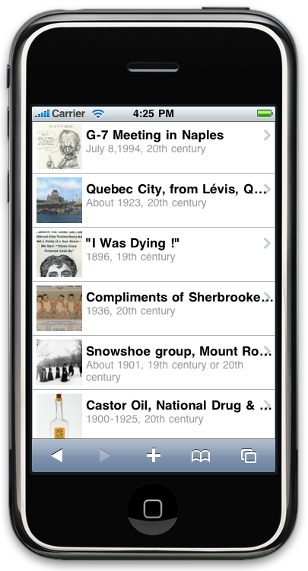
Figure 2: A screenshot from Engage 0.1 showing the ability to browse through a collection of artifacts. In this case, McCord's
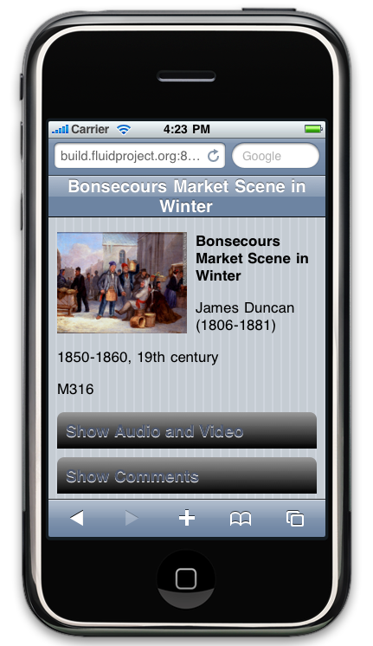
Figure 3: A screenshot from Engage 0.1 showing details about a specific artifact, also from McCord's collection.

Engage 0.3
The Engage 0.3 release extends the user research to onsite contextual inquiry at a number of representative museums and galleries as well as user testing. Engage 0.3 enables the “My Collection” use case, enabling visitors to create, browse and annotate their own collection. The release also provides early kiosk wireframes based on extensive user modeling and design research related to kiosks. Engage 0.3 extends the mobile capabilities of the first release to new platforms while at the same time refining and addressing improvements identified through user testing. Engage 0.3 is ready to be released in January, 2010.

Goals of Engage 0.3
The specific goals of this release included:
- Build additional functionality on top of 0.1 solutions, design and develop functionality that allows visitors to collect, comment, view from home, and email a personalized “collection” of artifacts.
- Design visits to each partner site plus additional museum visits for user testing and contextual inquiries with visitors.
- Continue to refine early wireframes (implementable user experience designs).

Components and Features
The components and features designed and developed in this release are:
- Search
- MyCollection: users can make personal collections of artifacts on a mobile device (see Figure 4)
- Create and view collections on mobile device
- Share a collection via email
- See user collections on a home desktop browser
- Refinements to Browse, Artifact View
- Includes support for special exhibits and featured objects
- Improved integration of components into mobile user experience
- Comments: users can comment on artifacts and exhibits; includes moderation
- Preliminary Map Display: show a vector-based map tagged with information of interest
- Current exhibits list
- Theme-based collections
- Performance improvements

Museum Developer Services
- User interface for importing data
- Published API for integrating external museum data feeds with Engage
- Search service: Lucene plus REST interface for Lucene

Mobile Development Tools
- New Mobile Fluid Skinning System theme for the Android mobile device

“My Collection” use-case
1. From the homepage, the visitor can see a list of current exhibits
2. From the list, the visitor can choose an exhibit to explore
3. From the exhibit page, the visitor can browse artifacts organized by theme
4. The visitor can look at comments about the exhibit left by others, or enter their own comments
5. From an artifact page, the visitor can see or enter comments
6. From an artifact page, visitors can collect the artifact into their own personal collection
7. From My Collection, the visitor can send an email enabling them to view the collection from home

Design
Below is a list of design activities to support this release and their associated links to view the resource or results:
- Refine wireframes for mobile based on user testing and close collaboration with partners
- Produce three initial wireframe options for kiosks
- Deliver Scenario Interaction Overview: http://wiki.fluidproject.org/display/fluid/Scenario+Interaction+Overview
- Refine design process:
http://wiki.fluidproject.org/display/fluid/Design+and+Development+Process
- Conduct tagging research:
http://wiki.fluidproject.org/display/fluid/Museum+metadata+overview
- Tagging resources:
http://wiki.fluidproject.org/display/fluid/Conceptual+mapping+and+tagging+resources
- On-site visits with all 3 museums partners: http://wiki.fluidproject.org/display/fluid/Notes+from+partner+museum+visits;
- Visits with additional museums: http://wiki.fluidproject.org/display/fluid/Visit+to+the+Museum+of+Anthropology+%28MOA%29+-+Nov+3%2C+2009
- Research into designing and testing for emotion: http://wiki.fluidproject.org/display/fluid/Designing+and+Testing+for+Emotion
- Accessibility/blind-visitor contextual inquiry in-museum: http://wiki.fluidproject.org/display/fluid/Museum+experience+of+blind+visitor

Supporting Fluid Infusion Development
Fluid Infusion development to support the requirements of Fluid Engage and to make Fluid Engage advances available to other projects implementing Fluid Infusion included:
- Release 1.1.2, October 15, 2009.
  - New Demo Portal with improved component demos:
http://build.fluidproject.org/infusion/demos/
  - Sneak Peak for Mobile FSS iPhone theme
  - Improved and simplified Image Reorderer documentation
http://wiki.fluidproject.org/display/fluid/Image+Reorderer+Tutorial
  - Uploader support for Firefox 3.5 and improved experience for Internet Explorer
http://issues.fluidproject.org/browse/FLUID-3196
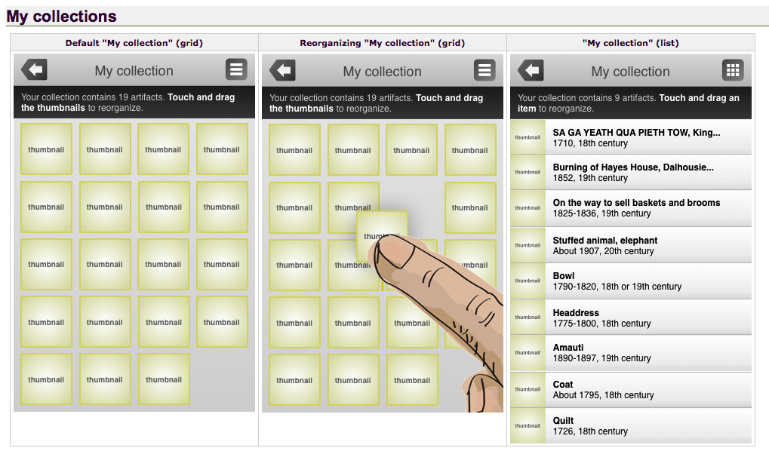
Figure 4: A design wireframe illustrating the ability for users to create their own custom collections.

Engage 0.5
The last release of the first year of Fluid Engage (0.5) extends both the authoring functions and end user functions of the previous release and improves the ability to achieve hi-fidelity rendering and highly professional presentations of the exhibit on all three platforms (mobile, kiosk and Web). In addition this release adds 2D barcode based location detection and delivery of location based content and map solutions for kiosks. Although Engage 0.5 is to be released in March, 2010 a large amount of work contributing to this release has already been achieved (listed below in non-italic text).

Goals of Engage 0.5
The specific goals of this release are to:
- build upon the fleshed-out features in 0.3 and extend them with a 2D barcode solution and an early map solution.
- refine mobile and kiosk wireframes based upon user testing and input (see Figure 5)
- conduct user testing, use the results to iteratively refine the design, and conduct implementations with associated user evaluations at representative museums.

Deliverables Included in Release
The developments that have been achieved or will be achieved for this release include the following components, services and design activities

Components
- Improvements to Map Display
- Refinements and deeper integration of Browse, Search, View, Comment, Collect

Services
- Improved importer supporting XML and CSV formats, providing integration with collections management systems such as TMS and CollectionSpace

Engage "Labs"
- Map authoring tool
- Experimental 2D barcode support: ability to take a picture and see the Artifact View page for it

Design
- Fully fleshed out hi-fidelity kiosk wireframes or design building blocks
- Fully fleshed out hi-fidelity mobile wireframes or design building blocks

Supporting Infusion Development
Infusion development to support this release includes:
- Next release by March 2010
  - Custom Builder allowing users to customize how the download the product:
http://forge.fluidproject.org/infusionBuilder/html/InfusionBuilder.html
  - New Inversion of Control container:
http://forge.fluidproject.org/infusionBuilder/html/InfusionBuilder.html
  - Pager improvements that allow easier use
  - Simplified Renderer 2.0
  - More accessibility features in Reorderer
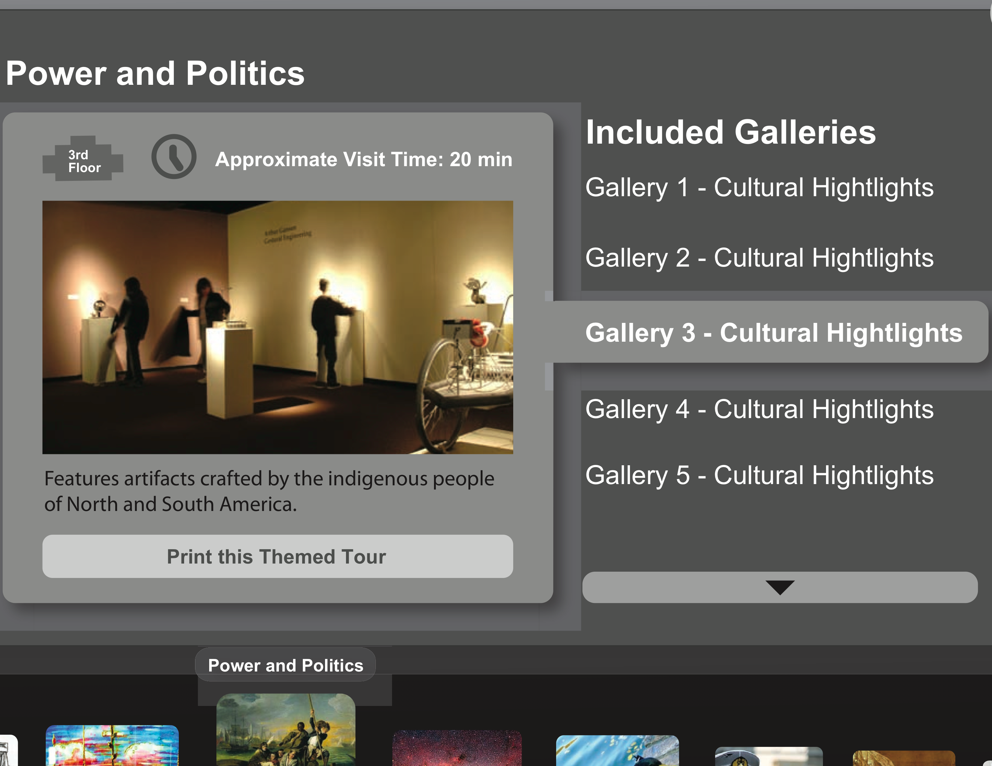
Figure 5: A design wireframe showing the "gallery card" interface for the in-gallery kiosk.

Impact of First Year
Throughout this year it has become clear that the mission of Fluid Engage is gaining in importance as museum resources are squeezed, competition for funding increases and public attention is pulled toward a growing list of critical priorities. Interest, support and commitments to implement Fluid Engage resources are steadily increasing as word of the Fluid Engage products and community spreads. The first year has established a well functioning, vibrant and collaborative team that represents the range of museum and gallery needs and realities. It has also laid the foundation for a highly responsive, extensible, robust and accessible authoring environment. Both the authoring experience and the resulting visitor experience have been refined and will undergo further evaluation and improvement by March 2010. Most importantly Fluid Engage has offered the first iteration of a cost effective, open source, extensible, interoperable authoring toolkit with which museums can create engaging visitor experiences on all three exhibit environments (mobile, kiosk and Web), drawing data from existing collections and eliminating the need for redundant entry or authoring.

Focus of Year 2
The resounding demand from museums and galleries, following nearly a year of discourse, consultation and work in the domain, is to create an authoring system that can be used in museums and galleries without a “Web team”, by existing curatorial and educational staff to extend their skills to the digital domain. This authoring environment should:
- enable the creation of a unique identity for each museum,
- allow creative exploration of exhibit and activity design,
- enable the museum professional to customize the authoring interface itself,
- enable the presentation of information on mobile devices, on in-house displays and on the Web,
- support the integration of social networking tools in meaningful ways,
- dynamically pull content in multiple formats, from all available sources, including sources outside the museum to enable curation of “content in the wild” and contextualization of museum content with current content on the Web at large,
- meet commitments and obligations to equal access or inclusive design,
- communicate with or integrate other popular authoring tools in the general domain as well as in the museum and gallery domain (including Omeka, Pachyderm and Sophie), and
- enable migration of content from other applications.
This is a deceptively tall order. Existing Web authoring tools either provide an authoring interface that can be used without the ability to handle code and markup at the expense of flexible and unique design (e.g., template driven systems), or they enable flexible design but demand proficiency in coding. The Fluid Engage team is uniquely positioned and equipped to achieve this ambitious goal by virtue of expertise and reusable resources built up through collaboration with portal (e.g., uPortal), learning management (e.g., Sakai, ATutor), content management (e.g., Drupal, Joomla), collections management (e.g., Collection Space), rich media editing and capture (e.g., Open Cast), software development kits (e.g., jQuery, Dojo) and browser (e.g., Mozilla and Firefox) applications and projects. Fluid Engage will also leverage the transformable layout and presentation of the Fluid Architecture (including the Fluid Skinning System).
True to Fluid design, this authoring environment will not be a monolithic application but a modular and component-based authoring system with enough “glue” and scaffolding to make it usable by the novice user but enough flexibility to enable the more familiar user optimal room to rearrange, reconfigure, expand and innovate.
This authoring environment will have broad applicability beyond the museum and gallery to the presentation and curation of any digital collection or set of digital collections and distributed content, enabling the creation of engaging methods of interacting with and contextualizing the artifacts or digital objects.
The project has committed to avoid redundant work, integrate relevant tools in the domain and help to fill the gaps in creating a complete solution for museums and galleries. To keep to this commitment the project team has diligently monitored developments and projects to assess gaps and determine the tasks and issues Fluid Engage must shoulder directly and which tasks and issues are being addressed elsewhere and can be integrated and adjusted to harmonize with the Fluid Engage authoring environment. This optimizes the impact of the invested resources while achieving the original goals. Surveying the defined problem space has led to adjustments in the focus and priorities of Fluid Engage development for Year 2.
Location detection, and location annotation are areas of development that have been taken up by many open source and commercial initiatives as has the integration of this location detection with wayfinding services. Initiatives such as the Android project and Google maps have recruited a great deal of creative attention to this technical challenge. Within museums and galleries, the use of RFID technology to track and trace collections has increased the popularity of RFID technology as a location detection system for location-based exhibit information. Wifi-based position detection systems are also maturing (including several projects led by the Adaptive Technology Resource Centre). Rather than duplicate this effort Fluid Engage Year 2 will focus on technologies in this domain that are not handled well elsewhere (e.g., 2D barcodes for personal mobile devices with built-in cameras) and integrate quality solutions developed elsewhere, refining these technologies where needed and addressing any shortcomings. One major shortcoming identified by museums and galleries exploring this type of exhibit has been the necessary authoring tools to create compelling exhibits and activities to be delivered through these location-based services.

Project Impact

Why is Fluid Engage a Priority for Museums and Galleries?
The common consensus within the museum community is that the Fluid Engage project is highly ambitious and critically important to the field. Museum and gallery directors agree that it is also not a project that any one institution, no matter what its size, could embark upon. Much of the work and investment is in service of mid-to-long-term benefits, sustainability and the greater collective good and is therefore not something institutions struggling with immediate local needs and demands can afford to consider. But the work Fluid Engage has outlined is critical to the health and wellbeing of museums and galleries. Especially in these times of fiscal restraint museums cannot afford to contend with the disjointed, chaotic and dysfunctional systems available to them. To maintain public interest they require responsive and flexible tools to craft engaging experiences and exhibits. Content should not be created redundantly or become obsolete with each application update. There should not be technology-imposed barriers to coordinating mobile, online and physical exhibits internal to an institution.
Distinctive creative vision, novelty, and experiential impact are all hallmarks of good museums and galleries. These critical strengths are also however not conducive to creating the foundational information technology substrate needed to support robust, coordinated, sustainable applications or systems. The Fluid approach and the Fluid Engage deliverables address this tension between unique creative or interpretive expression and usable, interoperable, reliable applications.
Museums and galleries are steeped in creative design talent. As museums and galleries move into the online, mobile and social networking realm, tools and resources to realize their design vision lag behind. Tools developed in-house are frequently not interoperable, poorly supported and fused to a specific design approach or exhibit. Applications built for the museum community in general have not given enough attention to flexible user interface design. Generic applications repurposed in museums and galleries do not address the unique needs of museums and galleries and are woefully lacking in user experience design and development features. Few applications have attended to interoperability and extensibility.
This project is an obvious and opportune confluence of strengths and needs between design-rich cultural institutions and the Fluid community which prioritizes and enables design in software projects. Through Fluid Engage we will bridge the gap between the creative intent and its realization in the digital realm by developing flexible, responsive tools and resources. These tools, applications and processes will also be future proofed or constructed in such a way that they can be easily updated to accommodate new platforms, design approaches, client devices and content formats.
You might ask why invest in this effort at this time when museums and galleries are struggling to keep the lights on and the doors open. The survival of museums and galleries is dependent on engaging visitors, establishing sustaining connections with these visitors and doing so in an effective, responsive manner. Museums and galleries have recognized that this time of fiscal restraint calls for collaboration and a collective effort. With the Fluid Engage approach each institution can maintain a distinctive, unique identity and approach while taking advantage of pooled resources. Fluid Engage will create the framework that enables cultural institutions to pull together to collectively overcome the current threats to survival. The proposed project will help the museum and gallery community emerge from these difficult economic times far better equipped to effectively achieve their vision and mission.

Fluid Engage as a Critical Member in the Museum Application Domain
In designing the goals and deliverables of the project, the primary tasks of Fluid Engage have been referred to as:
- the “glue” or the “mesh” that weaves together and enables communication between the disparate applications in the museum domain, as well as “mashups” of new applets, scripts and applications, and
- the coalescing user experience layer
Fluid Engage will not “build yet another..” of any of the tools already available to museums and galleries. Rather Fluid Engage will create a substrate that enables museum designers and developers to create once and apply in multiple platforms and to enlist tools created in other contexts and integrate these into the Fluid Engage authoring experience.
Fluid Engage will work with and interoperate with open source tools in the domain, including CollectionSpace, Decapod, Omeka, Pachyderm, the emerging OpenExhibit, Fenestra and others. The project will also address interoperability with popular proprietary systems such as TMS, iPhone, Blackberry and others.

Why the Fluid Approach
The component based, flexible, customizable and extensible approach to application design created by the Fluid project has obvious advantages for museums and galleries. Among the advantages are:
- Greater longevity and responsiveness to changing technologies and curatorial approaches,
- Applicability to all sizes of institutions and technical expertise levels,
- Better support for a diversity of curatorial styles, users and contexts, and
- Greater extensibility and applicability across sectors.

Accessible Engagement
While there is legislation in most jurisdictions asserting and protecting the rights of people with disabilities to equal access to culture and public services, there is a great deal of confusion regarding the legal obligations of cultural institutions. How do you provide equal access to a Picasso painting for someone who is blind, to a Mozart sonata for someone who is deaf or to a highly physically interactive experience for someone who is paralyzed? Within the US, the Americans with Disabilities Act has specific titles that refer to cultural institutions, however these provide very little practical guidance. Recent legal settlements make it clear that “interactive and multi-media” exhibits are not excluded. The law requires “full and equal enjoyment” by patron’s with disabilities. Not only is there general confusion regarding the requirements, accessibility is frequently dealt with as an afterthought, is rarely integrated into museum processes and while there are exemplary, innovative strategies developed they are not sufficiently embedded in the general IT infrastructure or processes to be sustainable.
Fluid Engage will address these accessibility issues. The project goals with respect to accessibility are to:
- provide museums and galleries with the tools and applications needed to comply to legislative requirements with respect to computer mediated experiences and exhibits, whether online, kiosk based or through a mobile device,
- enhance the experience and engagement of all visitors through inclusive design,
- attract and engage the ever increasing number of individuals who experience a disability, including the growing number of seniors, and
- develop sustainable, integrated, cost effective means of providing equal access.
As an international center of expertise in accessible information and communication technology the ATRC is deeply embedded in the accessibility community and well positioned to achieve the accessibility goals. The ATRC is assisted by Clayton Lewis of the University of Colorado, who is an international expert in cognitive accessibility, and the Office of Learning Technologies at UOC, who have considerable experience in inclusive media design. The project will work with the US Access Board, consumer organizations such as the National Foundation of the Blind and similar arbiters of legal requirements in other countries to develop tools and strategies that ensure equal enjoyment by people with disabilities.
The project will create a set of accessibility strategies that are sufficient to enable museums or galleries to comply with accessibility regulations with respect to computer mediated physical, online and mobile exhibits or experiences. For example tools to render delicate physical artifacts accessible to someone who is blind may include an curator authored audio description of the object that can be queried by the patron, a description that is created through a social network with multiple perspectives expressed, integration of systems to create physical replicas that can be manipulated or a digital haptic model that can be manipulated using a haptic device. As can be assumed, all tools and resources created through the project will meet accessibility requirements. The tools will also support and guide curators or other authors in creating accessible exhibits or experiences. The project will also integrate accessible wayfinding systems to assist all patrons in navigating the museum or gallery, including individuals who are blind.
These innovative designs will inevitably involve more than a single sense and enable interaction in a number of ways. This will undoubtedly make the experience richer and more engaging for all patrons. More explicit information about a painting or the ability to explore an artifact with your hands are experiences that many patrons desire.
Most importantly Fluid Engage will create an inclusive design framework that is sustainable given the constraints, realities and resources of an average cultural institution. Tools, components and toolkits will be created so that inclusive design becomes a naturally integrated part of “doing business.”

Sustainability
In developing this proposal the project team has heavily referenced what has been referred to as the “graveyard of museum projects” as a sober reminder of the need to build in sustainability and learn from prior mistakes. This graveyard contains close to 100 mobile projects as well as numerous exhibit management projects. These examples have been used to determine what problems and weaknesses must be avoided or guarded against.
Speaking to museum experts with “skinned knees” the following failings or shortcomings have come up repeatedly:
- museums do not have sustained in-house support for technical staff and contract staff frequently have no ongoing commitment to the institution and frequently do not produce code that can be maintained or updated by others,
- museum funding is uncertain and support for a particular technology lasts only as long as the grant
- mobile projects have caused rampant content obsolescence, each hardware or platform upgrade made previous content incompatible and content had to be created anew
- many projects are based on a particular special purpose hardware platform which frequently goes out of production
- there is no support to update the systems to keep them compatible with current technologies
- most projects produce monolithic systems that duplicate other applications and create proprietary, poorly documented code that is dependent on the original developer for maintenance and updating
- many projects create unique, proprietary information models, vocabularies or ontologies and schemas that are not sufficiently extensible,
- many projects inflexibly commit to or “bake in” one file format, markup system, metadata schema or communication protocol and become obsolete when these diminish in popularity or are overtaken by more current protocols
- many projects impose one particular curatorial philosophy or are dependent on a single project leader or “evangelist” and are orphaned when that person leaves
The Fluid Engage deliverables are agnostic with respect to any particular content, interpretive philosophy or artistic approach. Thus the deliverables will not be threatened by inevitably changing trends or evolving approaches.
The tools and systems will be modular, highly reconfigurable or transformable, and optimally extensible to enable updating and adaptation to changing needs and technology. No style, information model, vocabulary or tool configuration will be hard coded into the deliverables. The mobile applications will not depend on a single hardware platform but will work across current platforms. Using the Web and nonproprietary development environments will ensure that the deliverables survive changes in popular hardware.
An agile, iterative design and development process will be applied. This will enable the project to change directions or adjust development technologies and approaches in response to the larger technical environment and to capitalize on popular technologies in any of the IT realms that are relevant to the project.
The Fluid Engage tools and resources will be highly interoperable with other systems and applications that exist or enter into the museum and gallery domain. Institutions will not need to choose between new enterprise systems and Fluid Engage applications as Fluid Engage will “play nice” with other systems.
The Fluid Engage project will be part of the larger Fluid community. The project will produce and implement UX components that will be part of the Fluid Component Library. In trying to pull together a team qualified to achieve the complex technical goals of the project it became apparent how “thin on the ground” experienced developers and software architects were in the museum community. The small group of technically experienced museum staff were completely overwhelmed with crisis management, Herculean efforts to keep projects functioning or immediate deadlines with limited resources and almost impossible technical challenges. Thus the Fluid Engage team resorted to filling the gaps with university research and development units with prior experience in working with cultural institutions. Because of the heavy university involvement we were initially concerned that the project might be undeservedly viewed as the university community imposing its view of what was needed on museums and galleries (and a view tinged with technical triumphalism at that). To our surprise and relief this was not the case. On the contrary museums were relieved that a more technically well-resourced and experienced community would become involved in the effort and thus help to safeguard its sustainability. The project will adapt and weave together resources, tools and applications from the academic software realm thereby increasing the support base and the number of communities with investment in the applications.
Fluid Engage has collaborated with museum and gallery members from the beginning of the project. Fluid Engage will develop a membership program for cultural institutions. The membership "value-added" will be participation in determining the design and development criteria of the project. Initial inquiries have confirmed that museums will see this as a valuable investment if Fluid Engage tools and resources can be used to provide sustainable open source methods of improving the user experience. Fluid Engage will also generate revenue following the grant period by providing a UX service to museums and galleries.
The highly knowledgeable and experienced Fluid Engage advisory panel will assist in iteratively reviewing the sustainability of the project. Fluid Engage will remain vigilant to avoiding problems encountered by prior projects.

Project Deliverables and Project Execution

Putting it all together
The proposed Fluid Engage authoring tool is the culmination of extensive foundational work completed through the Fluid Project (2007-2009) and the first year of Fluid Engage. The Fluid Project produced code solutions for commonly experienced user interactions – the product, Fluid Infusion, has reached a broad user base. Fluid Engage’s first year extended that base of building blocks from Infusion to the museum and cultural institution use-case. Now, with Fluid Engage year two, the work will extend to a rich authoring environment that bridges the gap between those who design and those who write code. Web solutions based on standard Web technologies allow us to envision an authoring solution that will allow non-developers with a background and skill in design (of interfaces, exhibits, etc) to extend their content by “designing” it in the environment they intend to distribute it: web, mobile, kiosk, or other. The work of Fluid Engage 2 will build that authoring tool, making complex Internet interactions accessible and usable by museum staff.
Fluid Engage has found success in focusing on helping museum partners reuse existing content. Now, the team wants to extend the control that museums have by allowing them to design and transform that content with resources they already have. In the spirit of “making due” in today’s economic climate, museums are turning inwards, are experiencing layoffs, are refocusing their strategic direction to accommodate a ‘do more with less’ approach. Fluid Engage’s authoring tool fits into this context, by alleviating the need to have an extensive IT staff to create new and exciting interactions, by making use of the extensive expertise museum staff have, and doing so while keeping control of content and how it is used in the hands of that staff.
We will build an authoring tool that, when situated within Fluid Engage’s architecture, will complete a workflow that will allow museums to extract rich content from existing Collections and Content Management Systems, choose how to present and style that content, and then distribute that content to any number of devices and visitor experiences. A few key features of this system are:
- Usable by non-IT museum staff
- Enables creativity and uniqueness while extending usability and accessibility
- Facilitates customizability of content for platform
- Extends capabilities for social networking
- Allows for easy ingestion of data from a variety of sources
- Works collaboratively with other applications already in use (Collection or Content Management Systems, etc.)
The solution, from Fluid Engage, will be:
- A low-cost, easy to use and implement open source product
- Approachable by and useful to in-house museum staff
- Flexible enough that the content can be managed from end to end by the museum
- Designed for and by museums

Key Features
The Fluid Engage authoring environment will enable museum staff to design compelling experiences for Web, mobile, and in-house displays without being dependent on extensive IT support or a dedicated development team. It will lower the barrier to entry by giving authors a choice of useful and well-designed templates, user interface components, and themes that can be combined to create unique exhibit presentations.
These built-in designs aren’t the end of the story, however. Engage’s approach to authoring breaks out of the familiar, rigid, template-only approach by allowing freeform page composition and layout. Authors can freely edit and adapt templates, or can start from scratch by using drag and drop to create whole new layouts and designs. Engage will bring authoring within reach of non-technical museum staff, without compromising creative vision or uniqueness.
Exhibits created with Engage’s authoring tool aren’t just static. Authors can connect up a variety of dynamic interface components with data from collections and content management systems, providing visitors with live and interactive features such as the ability to make personal collections, comment on artifacts and exhibits, and search.
The Engage authoring tool will help exhibit designers bridge the gap between mobile interfaces, in-house displays, and Web-based exhibits. The same content can be themed differently for each environment, and many of the available user interface components will provide unique, environment-specific interactions for a particular user activity such as browsing content or making personal collections. In this way, content can reach the widest audience while still remaining idiomatic for the context or device.
Using the Engage authoring environment isn’t an all-or-nothing prospect; it integrates with other collections and content management systems, producing sites that can work alongside content from other tools. Engage can connect up with a variety of data sources and feeds, so exhibits can draw from many points of information both inside and outside the museum. Being Web-based itself, Engage can potentially even be included or embedded inside other authoring, content creation, and collections management tools.
Authoring with Engage is open and sustainable. Many existing solutions for exhibit design are proprietary, costly, and suited only to one platform. Vendors often offer content creation services that are inseparable from their technology, forcing museums to pay to use their content in different environments and give up control of intellectual property rights. With Engage, the platform is fully open, ensuring that museums retain control over their content and have a wide range of choices for technical support and content creation services.
Users of the Engage authoring environment will be able to:
- Design pages consisting of text, images, video, and interactive elements using drag and drop
- Select from a variety of layouts and templates designed specifically with mobile and in-gallery touch screens in mind
- Customize these out-of-the-box templates or create whole new designs from scratch
- Choose from a variety of dynamic user interface components designed for museum exhibits, including the ability for visitors to browse, search, view, and collect content
- Search and browse through material in collections and content management systems
- Connect dynamic components up with live collections and exhibit data (for example, displaying a list of all objects in a collection or information about featured artists)
- Create exhibits that connect to Web and social networking resources such as Wikipedia, YouTube, ArtBabble, and museum data feeds
- Define transitions, animations, and navigation from one page to another
- Create experiences that are more accessible to a variety of users, and validate the accessibility of content against several accessibility standards such as WCAG 2.0
- Migrate or transform content for use across mobile, kiosk, and Web environments
- Use and adapt great templates, content, and design advice from a community of museums and Web designers

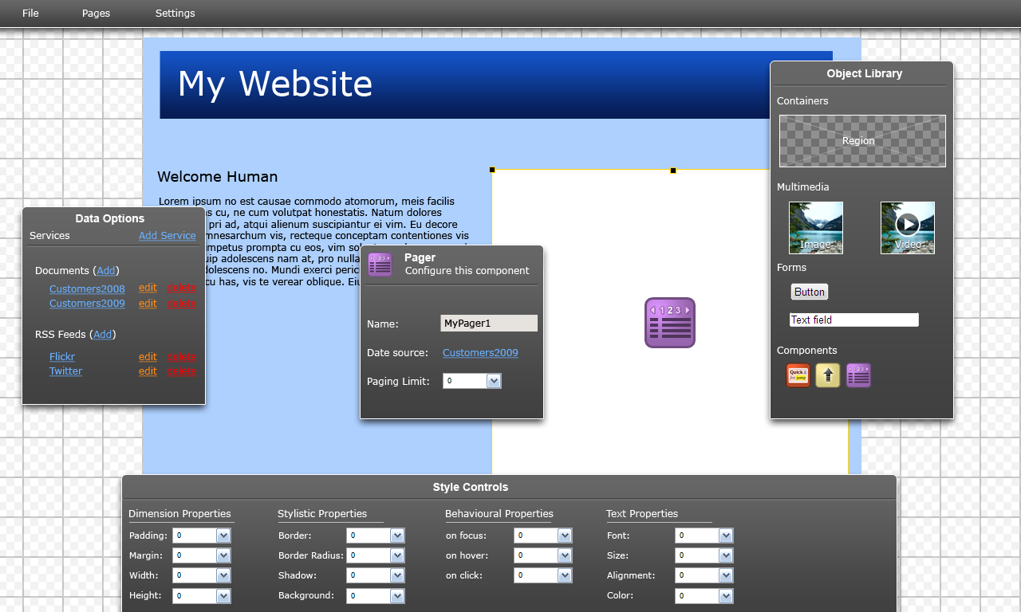
Figure 6: Sketch of possible authoring environment, showing freeform page layout and the ability to customize components using a graphical interface with panes and palettes.

Scenarios
The following scenarios illustrate the scenarios that will be made possible using the Fluid Engage authoring system.

Scenario #1: Designing a new mobile device tour of a featured exhibit
Author: Sedona is a talented and creative Education/Interpretive Specialist at the Institute of Arts. While she designs and coordinates the physical exhibit in house she has previously outsourced any technical work including audio tours, kiosk content and information regarding the exhibit on the Web to outside agencies and consultants at a rising cost with less than satisfactory results. This has also meant that the museum does not own the digital content and cannot repurpose it on other platforms or in future iterations. Sedona is familiar and adept with graphic, design and layout applications but cannot code and is not familiar with manual Web markup.
Challenge: To create a new tour for personal mobile devices that visitors bring into the museum for a new feature exhibit. The tour must be engaging and interactive. Timelines for completing the mobile tour are tight as is usually the case. There is no budget for outside technical help. Expectations are high as the museum administration sees this as a way to engage and continue contact with visitors drawn in by this high profile exhibit. There is a great deal of scattered content available in promotional material, in planning documents and in the collections management system that can be reused to prepare the mobile tour. The tour must also be promoted and available for download on the Museum Website and on a Museum Overview kiosk upon entry into the museum.
Process: Sedona opens the Fluid Engage web application and chooses a mobile tour design that is closest to her vision of what the tour should look like. She adjusts and tweaks the layout, adds additional behaviors or interactive functions and links to other tours and activities made available by the museum for mobile devices. She has previously created a skinning theme for the IA but embellishes this to reflect the feature exhibit using images and color schemes from the promotional material for the exhibit. In preparing the feature exhibit overview page she pulls in lists of special events associated with the exhibit by linking to the Web site calendar of events. She populates the tour design template she has refined by linking to feeds of specific images, video and other media of the featured objects in the collections management system. The authoring tool takes care of adjusting the material to render properly on the small displays of mobile devices. She draws in maps of the museum created previously and adjusts them to reflect the renovations made for the new exhibit and links in the appropriate images, videos and interpretive text for the featured objects. Following brief user testing, review by her administration and the completion of suggested revisions she creates a description of the tour (again in part using available promotional material) for the Web site and museum entry kiosk, including a download component from the Fluid application.
Result: Sedona is able to create a well functioning, unique and engaging mobile tour of a new exhibit using existing content, without resorting to use of outside technical help. She retains the IP of the content she creates so that it can be repurposed for the next exhibit and she can move seamlessly between authoring the mobile, Web and kiosk visitor interface.

Scenario 2: Creating a new tour for a featured exhibit for a tour kiosk
Author: Sedona as in Scenario #1, see description above.
Challenge: It has been decided that the in-house kiosks should be refreshed to reflect and highlight the feature exhibit. Time is even shorter and again there is no budget to seek outside technical help.
Process: Sedona pulls up the mobile tour she has created for the feature exhibit and imports relevant pieces to her customized kiosk template. Because the kiosk has much more screen space but is viewed by the visitor for a much shorter time she adjusts the interaction and amount of content shown at any one time. She also increases the number of videos and writes additional narrative to be displayed in text and spoken through a text-to-speech engine that comes with the kiosk component. She decides to add a feature whereby visitors can also customize the tour to be downloaded onto their personal mobile device using another Fluid Engage authoring component. Following user testing, that is facilitated through the Fluid Engage authoring system, and administrative review she adds the last refinements and loads the kiosk tour onto the kiosks on the floor.
Result: Sedona is able to create a new kiosk tour using existing design work on another platform. All investment in content creation can be leveraged and repurposed. Exhibits can be refreshed and updated by in-house staff. In-house staff can design for and test for accessibility compliance using the Fluid Engage tools.

Scenario 3: Creating a new in-gallery display for a book exhibit
Authors: Ian is a curator of the book exhibit with extensive subject matter expertise in philology, the history of the book and conservation of rare books but no Web development or programming skills. Ian is very familiar with the content management system at the museum and with text processing tools, OCR systems, digital imaging systems and text mining tools. Ian is assisted by Paulo, an exhibit designer with an impressive fine arts background. Paulo is familiar with illustration, photo editing and graphic design tools but does not have Web development or programming skills.
Challenge: The museum has recently acquired and is creating an exhibit surrounding a historically very significant but rare and delicate book. The challenge is to enable the visitor to explore and experience the impressive qualities and significance of the book which cannot be touched and manipulated but must be stored in a secure and controlled transparent case. Quality, high-fidelity images have been created of the pages of the book and are kept in part in the museum’s content management system and in part in the online archive of another institution. In addition there are translations and interpretations of the text available in an online archive at a prominent university. Numerous articles in the popular press and in academic journals discuss the book and are available online. The museum has recently acquired a multi-touch table as an in-house kiosk and wants to use this exhibit as a “test-run” of the table.
Process: Ian and Paulo use the Fluid Engage authoring environment to pull up a kiosk design that closely matches their vision of the display they want to produce. They find a book display that was created by another museum and modify this with the museum’s skinning theme. To this design they add multi-touch behaviors (originally created for the iPod touch mobile application). They decide to create a simple experience that emulates turning the pages of the book using the images of the book pages pulled from both their CMS and the remote online archive with transitions available in the Fluid Engage toolkit. They collect relevant narrative, articles and references and link these to the virtual pages of the book, illustrating the links using images they have created in the promotional material for the exhibit. The exhibit is enhanced by an accompanying audio description of the display that can be accessed on a personal mobile device or iPod touch provided by the museum for visitors who are blind. This links to the OCR version and interpretation of the text and a text-to-speech component available through Fluid Engage. Following user testing, administrative review (facilitated by the Fluid Engage authoring system) and refinement of the design it is loaded onto the multi-touch table positioned in front of the displayed artifact.
Result: Ian and Paulo have created a compelling, interactive display pulling in resources from many sources, leveraging work done by other museums and customizing the design to match their particular display platform. Without programming and Web development skills they are able to weave in interactive behaviors appropriate to the specific display.

Architectural Approach
As an architecture, Engage is designed for openness and resuse, enabling museums to extend and adapt the technology to their own unique needs and constraints. Engage makes heavy use of open Web standards such as HTML, JavaScript, and CSS to create highly interoperable tools that can blend seamlessly with existing Web content. This style of architecture helps to bridge the technological gaps between web, mobile, and physical environments.
Interoperability is a critical concern for Engage. Invariably, a successful online exhibit requires the designer to pull together resources from a variety of information sources across the museum and the Web at large. Currently, museums often face the challenge of poor integration between collections management systems, exhibit planning tools, and Web content management systems. Engage weaves together disparate sources of information through the use of standards-based data feeds that can easily be connected up to a variety of user interfaces.
In terms of structure, Engage takes a markedly different approach to data. Every museum collection is unique, and there is already a bewildering array of competing schemas and formats for representing them. There's no benefit to creating yet another new schema, and it's unlikely that choosing a single standard will satisfy everyone. Rather than forcing all collections into a single schema, Engage can accommodate a diversity of data formats by taking a "schemaless" approach. Collections are stored in a document-oriented database, called Couch DB, which provides a flexible representation of exhibit information. Each museum can store data in the format that best suits their collection, and they can easily map their data at the presentation layer.
Engage is implemented entirely using HTML, CSS, JavaScript and the Fluid Infusion framework. The Fluid community has developed a framework for writing server-side JavaScript applications called Kettle, and all of the Engage data feeds have been implemented using it. Server-side JavaScript is an increasingly popular approach that combines the simplicity and familiarity of JavaScript programming with the integrative capabilities of server-side development.

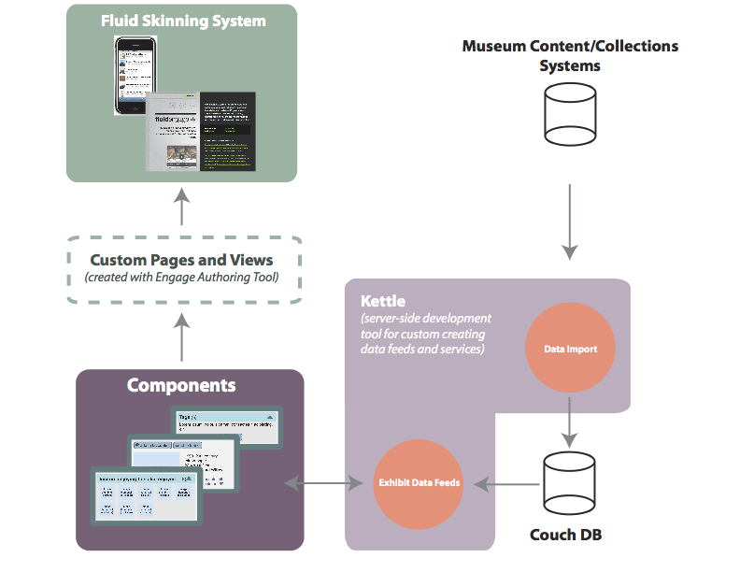
Figure 7: An illustration of Engage’s architecture, showing how information flows through data feeds and is presented using dynamic UI components and the Fluid Skinning System.

Mobile Architecture
Today, the mobile space is incredibly diverse, with new devices appearing on the market constantly. At the same time, the newest generation of smart phones such as the iPhone, Google's Android phones, and modern Nokia handsets provide an exciting opportunity to provide rich and interconnected mobile experiences to museum visitors. For the first time, ordinary cell phones and music players are powerful and ubiquitous enough to deliver meaningful content inside and outside of the museum.
A key Engage goal is to let visitors use their own mobile devices to access the online exhibit. As a result, the architecture needs to support a variety of mobile platforms. In the past, the work of targeting each of these platforms was typically complex and time consuming, requiring development in different programming languages and toolkits. More recently, popular smart phones now come equipped with Web browsers that can handle rich content and interactions. As a result, Engage is built around an open, Web-driven style of development that uses standard technologies such as HTML, CSS, and JavaScript. Leveraging the ubiquity and interoperability of the Web, Engage can deliver rich user experiences to a variety of mobile devices in a way that significantly reduces the cost of development. This Web-based approach also ensures that content is more easily repurposed, avoiding the need to create completely separate sites for mobile and desktop Web browsers.
Components and the Fluid Skinning System
As a product, Engage consists of a toolkit of user interface components, templates, and data feeds that can be designed and composed with an easy-to-use graphical authoring tool. All Engage components take advantage of the Fluid Skinning System, enabling them to be easily styled and customized to fit the needs of a particular museum or collection. Users themselves can even personalize the user interface to meet their own particular needs, such as high-contrast display or larger tap targets, using the UI Options component. Specific mobile themes for the Fluid Skinning System provide a natural look and feel for each supported mobile devices. This theme-based approach significantly lowers the cost of delivering exhibit experiences to different mobile platforms, ensuring that designers don't have to recreate all their content for each device.

Engage Authoring Tool Technical Overview

The Fluid Engage authoring tool builds on the foundation provided by Infusion and the Engage Year 1 design tools, enabling museum staff to create compelling visitor experiences for Web, mobile, and in-gallery platforms with a minimum of technical experience. Implemented as a browser-based application, this authoring tool will benefit from the open, accessible, and cross-platform approach of Fluid's technology.

Fluid Infusion is an unprecedentedly flexible framework for building applications and user interface components, building accessibility and usability in from the start. Authors working with the Engage authoring tool will directly benefit from this, reusing the components, themes, and designs we've created and sharing their own work with a larger community. Fluid's user interfaces are designed specifically with customization in mind, allowing authors to adapt and rework components based on the unique constrains of their exhibit, collection, or curatorial goals. With excellent templates and designs already assembled, museum staff can get a head start on the creative process without being limited to only the features provided by rigid, hard-baked "out of the box" templates.

Accessibility can be a challenging and confusing aspect of content authoring on the Web. The Engage authoring tool will help to ease the burden of creating accessible and flexible user interfaces that can be used by a wide variety of users, including those with assistive technologies. All content created by the authoring tool will use the Fluid Skinning System, which provides flexible and adaptable layouts that work across a variety of devices. By extension, content will be automatically UI Options-enabled, providing users with the ability to customize their experience based on personal needs and preferences, all without any additional work on the part of the author. The tool will also include built-in validation of Web markup, allowing authors to verify their designs against a variety of Web accessibility guidelines and standards such as the W3C's Web Content Accessibility Guidelines (WCAG) 2.0. Each Fluid component is tested across a wide range of devices and assistive technologies, and supports a range of flexible interactions out of the box.

The user experience of the Engage authoring tool benefits from the fact that it's a Web-based application. Traditional authoring tools typically suffer from a gap between how designs look within the authoring tool and how they appear when exported to the Web or mobile device. By leveraging the Web for both the authoring tool's user interface and the content itself, authors are assured that what they see throughout the authoring process is truly what they'll get in the end.

In contrast to other authoring tools, which require their users to write programming code to create new templates or user interfaces, Engage's authoring tool is entirely graphical. Leveraging the declarative, data-driven approach of the Engage services and UI components, there's no code generation required. The output of the authoring tool consists of standard open Web formats: HTML, CSS, and JSON (JavaScript Object Notation). A significant benefit of this open approach is that it's easier to migrate existing Web-based content into the authoring tool, adapting it for use on in mobile and kiosk-based environments. Given the richness of available content within most museums, and the cost of having to recreate it from scratch, this is a compelling argument for Engage's unique approach to design and authoring.

User Experience (UX) Design Approach
Museums and galleries have no lack of design sensibility and creative talent. The deep frustration felt by curators and education directors when venturing into the digital realm stems from the extreme difficulty in realizing this design vision using current technologies. The applications, tools and platforms are not sufficiently responsive, flexible or yielding to the author's needs. Creative effort is distracted by low-level technical challenges. In particular with community or open source software, there is a disconnect between the developers of the tools and the creative staff at museums and galleries. At the same time, the incredible potential to address the diverse needs of museum visitors through computer-mediated exhibits and experiences is frequently not realized. This is in large part due to the awkwardness of the tools and lack of interoperability of the infrastructure.
The Engage authoring tool will empower authors to realize their creative vision across the entire expanded domain of the museum or gallery. At the same time, the project will harness the potential of computer-mediated systems to address the highly diverse user experience (UX) needs in cultural institutions. This project is an obvious and opportune confluence of strengths and needs between design-rich cultural institutions and the Fluid community, which enables and prioritizes design in software projects. Through Fluid Engage we hope to bridge the gap between the creative intent and its realization in the digital realm through flexible, responsive tools and resources.
Embedding good user-centered design techniques into the development and authoring process is critical to accomplishing the goals of this project. The Fluid community has a commitment to improving user experience in web applications that will be carried into this project. By virtue of using Fluid components whenever possible and also building new components, the Engage authoring tool will benefit from the expertise, research, and designs that the Fluid designers have established alongside the creative input of curators and museum educators. Additionally, the Fluid community will continue to be a champion of user-centered design, contributing thoughts and processes for user-centered design to the larger design community. Because this proposed project takes on distinct yet complementary spaces in the museum (physical, online, and mobile), the design team will do extensive work to create designs and templates that bridge these spaces, making sense of it to the user.

UX for authoring toolkit
At the heart of the Engage authoring toolkit will be a set of useful exhibit and activity templates built with user-centered design techniques. Curators can use and adapt these templates to easily construct exhibit web sites and interactive activities that will work on the web, mobile devices, and kiosks. These templates will help curators organize and present their objects in meaningful ways by collecting together relevant Engage services, UI components, interactive activity scripts and other useful resources. This layer is where the power of a usable, skinnable, and customizable interface is most clearly demonstrated.

UX for services
As museums start to connect their data infrastructure and reach out into social networking services and interactive activities, they find themselves squarely in a place where UX inconsistency becomes a problem. The Fluid Engage services will tie together extant enterprise solutions with the Fluid authoring toolkit. Designers will help provide a consistent look and feel through use of Fluid components and the Fluid Skinning System. These solutions will allow users to customize content to fit local branding and style needs. The UX team will also endeavor to ensure that all user interfaces maintain a seamless experience when plugging in new services.

Educate the communities about UX developments, roles, and contexts
Fluid Engage will help to bridge the gap between open source development communities and museum and gallery software users. To effectively reach out to other open and community source projects applicable in cultural institutions, the Fluid Engage design team will continue to attend "unconferences" where team members will teach software developers how to conduct user testing, how to design in an agile development environment, how to work closely with developers, etc. The group will contribute to a blog, writing about notable design activities and lessons learned. The Fluid Engage team will also continue to attend museum community conferences, presenting methodologies and processes for effectively realizing design plans in the digital realm. The designers will bring attention to the work being done in Fluid Engage, soliciting volunteers and a larger design conversation about best practices.

Iterative Design
One defining characteristic of the Fluid team’s approach to design is the commitment to doing extensive user testing throughout the lifecycle of the Engage authoring tool project. The team will conduct user testing at each stage in the design process below. The diagram below articulates the various stages, activities, deliverables, and team collaborations that make up an iterative design project. At each stage the team tests assumptions, narrative scenarios, visual designs, and interface flow, using feedback as inspiration for further iterations to progressively improve the design. This highly participatory process ensures that the diverse needs and preferences of both museum staff and visitors are reflected in the final authoring tool product. Coupled with the technical team’s approach to agile development, these processes allow the Fluid team to produce flexible, reusable, user-centered, highly iterative, modular solutions to complex problems.
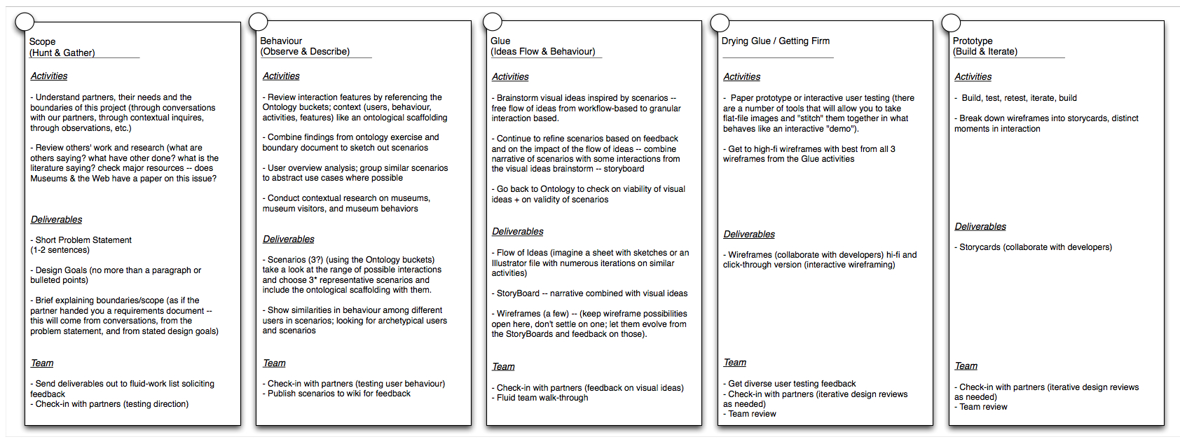
Figure 8: The iterative design process used by the Fluid Engage design team.
Through frequent and open conversations with potential users (curators, educators, etc.) at various institutions, the Fluid Engage User Experience team will build a strong set of additional scenarios to fully understand and support the work that goes on at the institutions while creating rich exhibit experiences. Direct contributions from the community of cultural institutions will be encouraged. This collaboration will provide an opportunity for the designers on Fluid Engage to learn about the myriad needs, goals, contexts, and behaviors of museum staff and visitors, and consequently make informed design decisions.

Full-scale Solution
The Engage authoring tool will be built using a combination of best practices from design and development as refined by the Fluid team. The resulting solution will allow museums to reuse and control their content and its distribution. Museums will be able to make use of in-house skills to produce rich, unique interactions for various “interpretives” while never losing ownership of their content. Museum staff will work with tools that have deep user experience design foundations plus accessibility baked-in. This will fundamentally make it less costly, less difficult, and more sustainable for museums to offer rich, technical interactions that extend the content of the museum to visitors, repeat and new. For the visitor, this product will provide a mechanism by which museums can provide access to their deep collections and make more materials available to the public.

Project Plan and Schedule
April-June 2010  Engage 0.6 | July-Sept 2010  Engage 0.7 | Oct.-Dec. 2010  Engage 0.8 | Jan.-March 2011  Engage 1.0
Create page layouts by choosing from a variety of pre-built options; import and lay out images, video, and other media on the page; add and style text and markup to the page. | Add and configure dynamic components; create pages that are automatically UI Options-enabled; search and browse through data feeds, connecting data up to dynamic components. | Choose from a variety of pre-built templates optimized for kiosk and mobile experiences; ensure content is compliant with a variety of accessibility standards; allow authors to weave together different screens with clear and effective navigation schemes. | Provide authors with the ability to create their own unique, dynamic, template-driven presentations.
Ongoing work throughout all quarters will include:
- Refinements and improvements to existing mobile, kiosk, and server-side features of Engage
- Support for museum implementations of Engage
- Documentation and training
- Quality assurance testing
- Collaborative and iterative user testing and design research

Fluid Engage Year 2 Quarterly Deliverables
The following section provides an expanded description of the plan and schedule presented above.

Q2 2010 Engage 0.6

Development

Choose from a variety of pre-built layouts
- User interface provides a gallery showing the various layouts available to choose from
- Implementation will use existing Fluid Skinning System layout styles

Upload and organize images, video, and other media into the authoring tool
- Asset Manager: provides a user interface for uploading and organizing images, video, and other media
- Automatically organized into groups based on media type
- Utilizes the Infusion Uploader component; will require the addition of binary streams in Kettle

Drag images, video and other simple HTML elements
- Includes support for creating HTML tables
- Users can edit properties such as URLs, sizing, and other attributes using a graphical interface

Drag text regions onto the page
- Based on a modified version of the Infusion rich text Inline Edit component
- Will reuse an existing text editor, likely Google's Closure rich text editor
- Support for basic text styling and markup, including headers, paragraphs, bold, italic, etc.

Architecture
- Define overall authoring tool architecture, including a simple application framework for page composition (drag and drop, expandable regions, etc) and multiple UI panels.

UX
- Design overall wireframes for authoring tool: object library palette, page composer canvas, and properties editor
- Collaborative design research process with museum partners to determine needs and requirements for exhibit authoring
- Extend research models to include more general authoring use cases, such as by users of the Infusion product

Q3 2010 Engage 0.7

Development

Drag components onto the page and configure options
- Each component will have a uniquely-designed configuration pane
- Authoring tool will automatically export the user’s configuration as JSON

Explore and display data in an easy to read interface
- Data Browser allows users to explore pre-configured data sources
- Expandable/collapsible interface, allowing the user to see more or less detail

Connect a component up to a dynamic data source
- Configure the component's model by URL or drag and drop from the data browser

Authored content automatically supports UI Options for customization and accessibility
- Improve UI Options with better configurability and cross-browser fixes
- Extend UI Options to support new Fluid Skinning System features, including mobile support

Architecture
- Create infrastructure for inspecting and data from Engage feeds

UX
- Design configuration panel wireframes for each component in Infusion and Engage
- Design wireframes for easy to use data browsing interface

Q4 2010 Engage 0.8

Development
Choose from a selection of mobile design templates
- A selection of small-screen friendly page compositions available for the author to choose from
- Includes automatic support for FSS mobile themes
- Choose from common components such as Navigation List, Cabinet, and Screen Navigator

Choose from a selection of kiosk design templates
- A selection of kiosk-oriented templates and navigation components
- Specific templates for tours, including the ability to create gallery cards and custom tours

Check and validate pages for accessibility
- Integration of authoring tool with AChecker for static markup accessibility checking
- Design improvements to ensure seamless integration

Allow users to define navigation from one page to another
- Includes a user interface for managing multiple pages within a site or application
- Optional support for navigation history, tabs, and other navigation-related components

Architecture
- Refinements to kiosk and mobile experiences based on implementer feedback started in Engage 1
- Work with museum partners to design reusable templates for mobile and kiosk authoring
- Define integration strategy for authoring tool and AChecker

UX
- Design a metaphor for navigating and presenting multiple pages of content
- Wireframes for navigation including improvements to navigation-related components in Infusion
- Design improvements to AChecker accessibility validation tool to ensure it seamlessly integrates with authoring tool

Q1 2011 Engage 1.0

Development

Add support to Infusion Renderer for fully declarative control structures
- Includes support for looping and conditionals in the component tree
- Enables fully authoring tool-driven creation of dynamic templates

Create custom dynamic pages and connect them up to data
- Users can bind data to markup using simple graphical or drag and drop tools
- Includes support for controls such as loops and conditional
- Supports form binding, allowing two-way data flow
- Output is a Infusion Renderer-compatible component tree, stored by default within the database

Architecture
- Design API and declarative format for looping and conditionals in the Infusion Renderer

UX
- Design wireframes for dynamic template binding
- Refinements to the data browser interface
- Icons and other visual hints to help with data presentation

Future Directions
The following section outlines a few of the promising features to include in Year 2 if the need and opportunity arises or to be considered for post-1.0 versions of the Fluid Engage authoring tool after March 2010. By virtue of being an open source community Fluid and Fluid Engage have been able to recruit volunteer effort to assist in working toward the goals of the project. To help to channel and capture the interest of this effort Fluid Engage must articulate where help is needed and how any effort can be integrated into the funded effort. These tasks will be clearly outlined and planned to optimize the likelihood that others can contribute to the Fluid Engage goals.
Generate and parse FSS-compliant CSS definitions
- Extend Infusion to support the generation and parsing of Cascading Style Sheets
- This task is infrastructure work to support customizable layouts

Design your own layout by creating draggable regions
- Expand or shrink the bounding box of a column or layout region to automatically resize it
- Drag new regions into the layout

Define new data feeds by importing data in a variety of formats
- Data Feed Builder: users can create a data source by URL, or import a XML or CSV file into the system
- Provides a two-paned UI allowing users to see their data and map it into a normalized structure
- Includes the ability to define common data transformations
- Intended for technical implementers and back-end museum staff, rather than content authors

Integration with Engage map authoring component
- Enable users to author custom maps directly within the Engage authoring tool
- Refinements to map authoring components and services

A plugin API to allow the authoring tool to be extended with new features
- Authoring tool can be customized with new object types, palettes, and tools

Ability to assign print 2D barcodes for artifacts directly in the authoring tool
- Using the data browser, create and print 2D barcodes for artifacts
- Authors can customize which page is visible to visitors who use the 2D barcode

Project Governance

Leveraging Collective Resources and Effort
Fluid Engage is user driven, capitalizes on lessons learned and successes of prior and related projects and attempts to find synergies with other scholarly domains. Fluid Engage employs a community source model, adopting the successful strategies of the Fluid, Kuali Student, Sakai and CollectionSpace projects. The overall strategy is to pool resources and intellectual capital investments and leverage them to create a sharable solution that is of, by, and for cultural institutions around the world. To shore up scarce technical resources, to broaden the structural base for sustainability and to leverage experience in community source projects, project partners also include research and development teams at universities with experience in working with cultural institutions. As a community source project, Fluid Engage employs the development principles of open source software with the project management of institutional investments of staff time. It builds upon and advances the “precarious values” and development methods of the Fluid Project.
Kuali, Sakai, Fluid, CollectionSpace and other projects have been perfecting and evolving the community source approach to pooling resources, knowledge sharing, and leveraging technical and user support to create attractive solutions for the larger community. The software work products of community source are licensed for royalty-free use, modification, extension, or derivative works by institution, company, or individual using the Open Source Initiative approved Educational Community License. Fluid Engage will leverage and evolve these systems.
The distributed nature of the team requires and ensures that all communication and especially all decisions are explicit, transparent and comprehensible by the entire community. This also enables participation and input from the wider community and interested volunteers. The project has created support structures and collaboration tools to encourage broad participation in achieving the project deliverables and contributing related resources. Thus the project can be enriched by interested institutions not in the original partnership.

Project Structure Overview
At the center of the project governance structure is the Fluid Engage Steering Committee with representation from all core cultural institutions. The Steering Committee membership also includes the technical lead, the design lead and the project manager. The Steering Committee will govern the day-to-day progress of the project. The makeup of the Steering Committee ensures that the project direction is integrally grounded in and responsive to the needs and realities of cultural institutions.
The Steering Committee will be assisted by the Project Management Team consisting of the Project Manager and the financial and administrative coordinator. The project management team will work closely with project management and administrative staff at all participating institutions.
Both the Steering Committee and the Project Management Team report to the Principal Investigator, Jutta Treviranus. High-level project oversight will be provided by the Fluid Engage Board of Directors with representation from all participating partner institutions, chaired by the PI. The Board will have ultimate responsibility for project deliverables.
Project deliverables will be achieved by three tightly integrated teams: the Technical Team, Design Team and Implementation and Evaluation Team. The agile, iterative design and development process will ensure that there is frequent exchange of interdependent prototypes among these teams.
All teams will be informed and receive input, constructive criticism and advice from the advisory panel made up of prominent and strategic leaders in the museum and gallery community. The Advisory Panel has been expanded in Year 2 to add additional international and cultural advice through several museums in Barcelona and to recruit the valuable advice of the Pachyderm project.

Project Management
Jess Mitchell, the Project Manager for Fluid and Fluid Engage, has significant experience leading large, complex, distributed projects. She is particularly skilled at drawing in all members to form a cohesive team. Another strength is her ability to facilitate rather than dictate in decision-making, strategic planning, and community outreach. With her leadership, the Fluid Engage team has coalesced into a community that has focus, purpose, and vision. That community is strong and particularly well structured to do ambitious projects like Fluid Engage.
Members of the Fluid Engage community are committed to flexibility, openness, collaboration, and communication. These principles encourage healthy and collaborative ways to work, make decisions, and ensure project outcomes. The success of the Fluid approach to project management can be attributed in large part to our continual efforts to refine processes, adapting and adjusting as needed.
Fluid Engage is continuing this open approach, incorporating the unique practices of new team members and member institutions. The Fluid team accomplishes this openness by being committed to including all voices, ensuring the quality of the product, and pushing boundaries with innovative solutions.
All team members are encouraged to be thorough, curious, and communicative. Members work with a number of tools that help bridge the geographic gaps. The team strives to keep communication frequent, with daily meetings that last approximately 15 minutes where the members give quick updates. This allows team members to stay connected personally, and make meaningful connections between their work and their colleagues', encouraging collaboration.
Both the development and design teams do paired work (often pairing team members with different experience levels and areas of expertise). The teams make iteration work plans every fortnight. Those work plans are created from a breakdown of the quarterly project deliverables that have been further broken down to fit into monthly releases. So, the PM starts from the big picture perspective and then narrows down the work into tasks accomplishable in two weeks, an agile approach to development and design. With this process, the Fluid community is experienced at setting project goals within a realistic timeline and accomplishing them.
Fluid Engage is committed to building products that can be used easily, so each member of the team plays a role in writing thorough documentation. The team is dedicated to teaching others in addition to providing them with rich solutions. As an open community, the project has endeavored to create an environment that includes volunteers and outside contributors. Fluid Engage is a community that is particularly interested in, and pays close attention to, team building and the positive outcomes that a healthy community has on deliverables.
The team succeeds in part because, where necessary, there are authoritative processes that are well-documented, publicly available, and created by the community. The Fluid Engage team makes extensive use of the Apache model for decision-making for everything from commit access for developers to decision-making about strategic direction on design questions.
The PM is committed to equally representing all partners. In the same way, all partners have equal voices in the project. The PM works to smooth cultural differences that result from different disciplinary perspectives and different practices. And furthermore the PM works to overlap the project goals with the local institution goals where possible. The approach of the Fluid community is to find solutions to problems or opportunities that community members articulate.
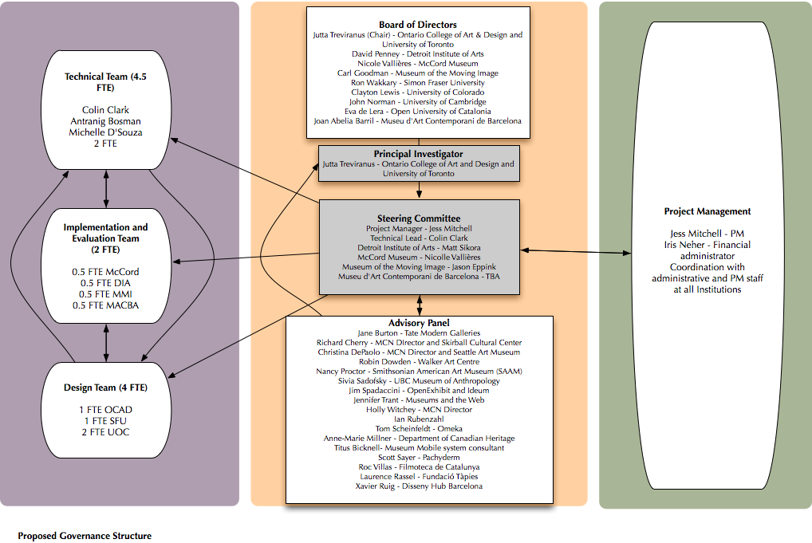
Figure 9: Governance Structure of Fluid Engage Year 2 reflecting new partners and advisors.

1. Board of Directors
The Fluid Engage Board of Directors is comprised of the institutional leads for all partner institutions. The Directors are responsible for their institutional resource commitment to the project and are ultimately accountable for the execution of the project. The chair of the board is the lead PI on the project, Jutta Treviranus, from the University of Toronto and Ontario College of Art and Design.
The Fluid Board of Directors are:
Jutta Treviranus (Chair) – University of Toronto and Ontario College of Art and Design -
David Penney - Detroit Institute of Arts
Nicole Vallières - McCord Museum of Canadian History
Carl Goodman - Museum of the Moving Image
Ron Wakkary - Simon Fraser University
Clayton Lewis - University of Colorado
John Norman - University of Cambridge
Eva de Lera - Open University of Catalonia -
Joan Abelia Barril - Museu d'Art Contemporani de Barcelona

2. Steering Committee
The Steering Committee will oversee the day-to-day progress of the project and will be responsible for design, development and implementation decisions. The majority of the Steering Committee will be made up of representatives from the cultural institution partners to support participatory design.
Wherever possible all decisions will be made at the level of the people working on the problem and every effort will be made to resolve any disagreements at that level. When consensus cannot be reached at this level there will be a decision-making escalation path from the teams to the Steering Committee and if necessary to the Board of Directors. It is our expectation and hope that this escalation path will never be necessary. It is believed that by utilizing the Apache decision-making tool and fostering a community, which seeks to understand, is open to healthy and respectful debate, and builds consensus wherever possible, we will produce a better product and a more sustainable community.
The Steering Committee is made up of the following members:
Project Manager - Jess Mitchell
Technical Lead - Colin Clark
Detroit Institute of Arts – Jennifer Czajkowski
Museum of Canadian History – Hugues Boily
Museum of the Moving Image - Jason Eppink
Museu d'Art Contemporani de Barcelona - Joan Abelia Barril

3. Advisory Panel
The Advisory Panel is made up of leaders and experts in the museum and gallery community. This includes members of the Museum Computer Network, leaders of collaborating projects, potential implementers of the Fluid Engage deliverables and innovators in mobile and online curation. The Advisory Panel will apply their expertise to ensure that the project learns from the successes and failures of the past, is well integrated into the museum community and becomes sustainable.
The members of the Advisory Panel will be:
Jane Burton - Tate Modern Galleries
Titus Bicknell- museum mobile system consultant
Richard Cherry - Museum Computer Network Director (MCN),and Balboa Park Online Collaborative
Christina DePaolo - MCN Director and Seattle Art Museum
Robin Dowden - Walker Art Centre
Nancy Proctor - Smithsonian American Art Museum (SAAM)
Sivia Sadofsky - UBC Museum of Anthropology
Tom Scheinfeldt – Omeka, George Mason University
Jim Spadaccini - OpenExhibit and Ideum
Jennifer Trant - Museums and the Web
Holly Witchey - MCN Director
Anne-Marie Milner – Canadian Heritage Information Network
Ian Rubenzahl
Scott Sayre – Pachyderm
Roc Villas - Filmoteca de Catalunya
Laurence Rassel - Fundació Tàpies
Xavier Ruig - Disseny Hub Barcelona

4. Technical Team
The technical team will be responsible for the technical development in the project and will be led by Colin Clark the Technical Lead. Colin has extensive experience in adeptly leading the technical development in the Fluid Project and the first Year of Fluid Engage. Colin will be assisted by experienced developers and software architects at the University of Cambridge as well as volunteer open source developers recruited to the project.

5. Implementation and Evaluation Team
Four core cultural institutions will help to iteratively design, implement and evaluate the project deliverables. The implementation and evaluation team will be made up of staff experienced in rolling out innovative programs and well positioned to deploy the tools and resources developed by the Fluid Engage project in their respective institution.

6. Design Team
The team will take design input and input regarding functional requirements from the implementation team. The design team will also receive extensive guidance on participatory design methods from Clayton Lewis and Ron Wakkary who are world leaders in participatory design within cultural institutions. The team includes UX designers and UX developers from University of Catalonia, Ontario College of Art and Design, and Simon Fraser University.

Core Cultural Institution Partners | Description of Contribution and Role
Detroit Institute of Arts | - provide evaluation data about visitor needs for informal learning in museum environments  - model exhibit development work processes  - create interpretive exhibit projects for prototypes  - evaluate prototype modules in real-time museum settings.  More specifically:  - summative evaluation on the new reinstallation will provide data and direction for selecting prototype projects  - a web-based curriculum resource and social media tie-ins will be based upon our special NEH-funded exhibit, "Through African Eyes"  - prototype "fitting room" for off-site desktop and mobile visitor designed tours of newly installed permanent collections galleries.  - tie projects to a social media/e-philanthropy initiative.
McCord Museum of Canadian History | - increase accessibility with the collections of McCord by redefining its tools of mediation;  - encourage a greater interaction with the visitors with a view to diversification of the customers;  - support the innovation and creation in a context of development of heritage material by using emergent technologies and mobile tools (PDA, iPhone, etc.) ;  - set up a bridge between online and physical exhibits  - engage visitors in personalized experiences of the online museum (Web 2.0, “My McCord”).
Museum of the Moving Image | - bridge the Fluid Engage and CollectionSpace projects, enabling interoperability between the two  - develop mobile gallery prototype application that connect display artifacts with items in the museum collection (drawn from CollectionSpace repository), other museum intellectual assets, and external digital resources.  - utilize the FluidEngage Exhibit, Map, and Audio tour tools, social networking, Mobile and Web applications, and related underlying and related services to achieve this goal.  - build from its pioneering work on the 2001 eDocent project, a prototype wifi-based gallery information system for off-the-shelf devices, with related institutional expertise.
Museu d'Art Contemporani de Barcelona | - represent the bilingual use case in FluidEngage  - provide a culturally diverse perspective as a core FluidEngage partner  - implement mobile gallery prototype application
Unfunded core partners  Arts Santa Mònica (www.artssantamonica.cat)  Centre de Cultura Contemporània de Barcelona, CCCB (www.cccb.org)  Museu Marítim de Barcelona (www.mmb.cat) | - deploy and evaluate pilot implementations of select Fluid Engage products  - assist in extending Fluid Engage relevance to a larger diversity of institutions
Core University Partners | Description of Contribution and Role
Ontario College of Art and Design | - lead institution for project and new home of core team  - overall project management and administration  - technical leadership  - UX design and development  - expertise in inclusive design  - context and location aware mobile system expertise  - Curatorial Practice evaluation input  - Web accessibility expertise
University of Colorado, Boulder | - offer expert advice on HCI  - cognitive accessibility  - mobiles systems expertise and existing relationships with Android  - Open Social expertise  - system integration experience
Simon Fraser University | - contribute participatory design coordination and support of the project  - haptic and tactile expertise  - extensive museum experience
Cambridge University, UK | - contribute user engagement with Museum Staff and Visitors to ensure the project meets UK and European needs (up to 20 individuals from up to 6 museums)  - Java/Javascript developer with Fluid development experience.  - synergistic input from CollectionSpace developers.
University of Catalonia, ES | - UX lead  - expertise in accessibility  - UI design expertise  - connection with European museums
Advisory Panel | Description of Contribution and Role
Tate Modern Galleries - Jane Burton | advice and direction from large galleries
Walker Art Center - Robin Dowden | advice and direction from art centers with experience in digital exhibits
Museum Computer Network Director (MCN),and Balboa Park Online Collaborative - Richard Cherry  MCN Director and Seattle Art Museum - Christina DePaolo  MCN Director - Holly Witchey | advice and direction from extensive expertise of the Museum Computer Network
OpenExhibit and Ideum - Jim Spadaccini | advice and direction, coordination with Open Exhibit and multi-touch table techology
Smithsonian American Art Museum (SAAM) - Nancy Proctor | advice and direction, mobile systems
UBC Museum of Anthropology - Sivia Sadofsky | advice and direction, cultural museums
Titus Bicknell | advice and direction, mobile integration
Center for History and New Media, George Mason University - Tom Scheinfeldt | advice and direction, integration with Omeka
Museums and the Web - Jennifer Trant | advice and direction – future directions of museums and the Web
CHIN – Anne-Marie Millner | advice and direction – needs of broader museum community and funding bodies
Ian Rubenzahl | advice and direction of curators and museum designers
Pachyderm - Scott Sayre | advice and direction – harmonization with Pachyderm and curatorial approaches
Filmoteca de Catalunya (www.gencat.cat/cultura/icic/filmoteca) | Advice and direction – internationalization and cultural customization of Fluid Engage
Fundació Tàpies (www.fundaciotapies.org) | Advice and direction – internationalization and cultural customization of Fluid Engage
Disseny Hub Barcelona (www.dhub-bcn.cat) | Advice and direction – internationalization and cultural customization of Fluid Engage

Appendix 2: New Fluid Engage Partners and Advisory Board Members

Advisory Panel
(1) Filmoteca de Catalunya (http://www.gencat.cat/cultura/icic/filmoteca)
(2) Fundació Tàpies (http://www.fundaciotapies.org)
(3) Disseny Hub Barcelona (http://www.dhub-bcn.cat)

Partners:
(4) Arts Santa Mònica (http://www.artssantamonica.cat) (unfunded)
(5) Centre de Cultura Contemporània de Barcelona, CCCB (http://www.cccb.org) (unfunded)
(6) Museu d'Art Contemporani de Barcelona, MACBA (http://www.macba.cat )
(7) Museu Marítim de Barcelona (http://www.mmb.cat) (unfunded)

