User Experience Walkthrough Report: Moodle 1.8.2

Evaluation Completed by: Herb Wideman, Ron Owston, Maureen Patterson, Denys Lupshenyuk

Date(s): December 17th 2007 – February 11th 2008

Cognitive walkthroughs were performed on a 17 inch MacBook Pro using a 1680 x 1050 resolution and Millions colors using Firefox 2.0.0.11 Mac OS X 10.5.1 at an on-campus connection rate.; and 3 Win XP SP2 PCs using a 1280X1024 resolution (most common resolution) and 32 bit colors with IE 7. See

Scope of Walkthrough

Functional areas focused on for review: check those applicable
- Announcements
- Home
- Assignments
- Drop Box
- Email Archive
- Forums
- Mail tool
- News
- Quiz & surveys
- Resources
- Syllabus
- Web Content
- Wiki

User profile(s) and context of use:

Personas
- Sara Windsor, Overwhelmed faculty
- Yu Jin Jeong, Graduate Student - Teaching Assistant
- Ed McClellan, Undergraduate

Scenarios employed: see “Moodle UX test 2 scenarios.doc” at http://wiki.fluidproject.org/download/attachments/328019/Moodle+UX+test+2+scenarios.doc

Usability Positives Encountered | Tool
When adding a due date for an assignment it is automatically added to the calendar. | Assignments/Calendar
I like that if you leave Moodle and return it remembers your username. | login
Grades were easy to find as an Instructor

Priority Legend:

High = Task cannot be completed
Medium = Task completed with significant effort and failed attempts
Low = Task completed with minor complications and/or annoyance

Cognitive Walkthrough Worksheets

Scenario numbers correspond to those in Moodle 1.8.2 Usability Walkthrough testing procedures and scenarios– Phase 2, Nov/Dec 2007 document. Add rows as needed.

A. Teacher Scenarios

Priority | Operation/Area | Screen shot link | Comments/Issues | Principle | Suggestions for Solution | Tester Name
Teacher scenario 1
Low | Login | Image1 | I’ve made this mistake more than once. After entering my username and password I click on the “Yes, help me log in” without giving it much thought/reading. | Error prevention | Either:  Make “Forgotten your username or password?” the link, and remove the “Yes, help me log in” button.  OR  Move the Login button immediately underneath the password field. | Maureen
Low | Editing Teacher’s Page | Image2 | I couldn’t find how to add discussion. Then I realized that I did not turn on the editing mode. | Visibility of system status  Consistency and standards | Editing permissions should be enabled/disabled based on the user role. Enable an editing mode for a teacher by default. | Denys
Low | Adding a Forum using “Add a Resource/Add and activity” | None | I was initially looking for the word “discussion” and didn’t look at the list in detail. I learned by rolling over “Week 1 discussion” that this was actually a “Forum.” | Visibility of system status | “Discussion group” is a common alternate term for forums. Maybe indicate “Forum/Discussion” instead of just “Forum”. Once familiar with just “Forum” it was ok. | Maureen
Low | Adding a Forum | Image3 | When clicking on the “?” icon I found the descriptions for the different types of forums were in a different order than listed in the drop down menu. I was interested in what a “Standard Forum for General Use” was and so instinctually looked at the bottom of the “?” file for that description. | Help and Documentation | Make the order of descriptions in the “?” file the same as in the drop down. | Maureen
Low | Forum main page | Image4 | The Forum display page feels a bit unclear. I think this is because I expect the title of the forum, in this case “Cancer Prevention” to be somewhere close to/associated with the description of the Forum, and somewhere more obvious. Currently it is only in the breadcrumb. | Aesthetic and minimalist design | Repeat the title of the forum just above the description of the forum – either inside or outside of the box – in a large bold font. | Maureen
Low | Posting discussion topics | Image5 | Help window doesn’t describe clearly the function of “Forum Introduction” box. | Consistency and standards | Explain the usage of “Forum Introduction” in the “Help” window. | Denys
Low | Posting discussion topics | Image6 | At the bottom of the Add a new discussion topic screen there is a “Format: HTML format” text. Is this necessary? The assumption is that this discussion topic will be posted on the webpage. Users don’t need to know this is “HTML format” for any reason I can tell. | Aesthetic and minimalist design | Remove “Format: HTML format.” | Maureen
Low | Editing forum description | Image7 | Unclear how to go back to edit forum description after typo discovered in it later; back button does not work; after some trial and error it was discovered that “update this forum” puts you into edit area. | User control | Add “edit/” label to “update this forum” label on existing edit/update button beside forum description; move button to more central location near “add new question” button. | Herb
Teacher scenario 2
Low | Announcements area labeling |  | The Announcements area is not named as such. It is topic 1 and the text is a “Label”. Instructor probably shouldn’t have set it up this way. It took me a bit of time to figure out what was going on. |  | Not a Moodle issue (course instructor issue) | Ron
Medium | Add text, including a link to top area of the page | Image8 | It was not readily clear how to add text to the top “Announcements” section of the course homepage. It took me a while to figure this out, and I only did figure it out after I clicked on the “edit” icon of someone else’s text – to discover it was called a “Label”. You add text by adding a Label. I find “Label” really isn’t a correct/descriptive label. | Recognition rather than recall; Match between system and world | Something like “Add introductory text to this section/week/topic” is more descriptive and correct. | Maureen
Medium | Create text on course page | None | You can either edit the content already in the relevant text box, or use “insert a label” from the “add a resource” dropdown. Not clear what added functionality “insert a label” resource brings, or why it is called a label (unless you can add it to linked resources?). | Match between system and world; help and documentation | Rename “insert a label” in dropdown menu; better discussion in documentation of when using label resource is better than modifying existing text in section. | Herb
Low | Course main page | None | When Label text is very long the course homepage becomes too long and less usable. | Aesthetic and minimalist design | Label text should ideally have a character/word limit. I don’t find it’s appropriate to have long paragraphs on this main homepage, and that instructors should be creating secondary text webpages instead. | Maureen
Low | Page text editor | Image9 | Not clear how to exit enlarged text editor window without losing added content; no save button visible; no clear way to return to minimized editor, where you started out. | User control | Make button for returning to minimized editor window clearer by using bigger button with text label, as this is where you have to go to save your content. | Herb
Low | Post a question to a Forum | Image10 | “Update” button is used to make changes in this program which was misleading. | Consistency and standards | “Update” can be replaced by “Edit” to avoid confusion. | Denys
Medium | NYT Article Discussion Forum | Image11  Image12 | I couldn’t create a discussion of the article for all participants (Image11). It seems that the discussion forum has already designed for separate group discussions. I tried to choose “No Groups” didn’t work. Only when I selected “A Single Simple Discussion,” (Image12) I achieved my purpose. Thus, two options “Forum Type” and “Group Mode” are confusing. It took several attempts to accomplish a task. | Error prevention | If “Group Mode” is already set for all discussions, it shouldn’t be displayed on the editing page as it can mislead a teacher. Define accurately the type of forums. | Denys
Teacher scenario 3
Medium | Adding an assignment | Image13 | When adding the Due Date for an assignment I found I had to leave the application to open a calendar to figure out what day was appropriate for this due date – i.e.) a week day at the end of the term. | Recognition rather than recall | Add a small pop up monthly calendar that allows you to click on a date to add it. (as you see at most airline/hotel websites). | Maureen
Medium | Adding an assignment | Image14 | When adding an assignment, the associated help button doesn’t provide any definitions of what the different type of assignment choices available in the “add an activity” dropdown menu actually are. | Help and documentation | Provide better documentation of the assignment choices to allow informed selection. | Herb
Low | Adding an assignment | None | When you create an assignment there is no option to have the assignment description you enter in that window appear in the proper section of the course – only the assignment name appears; this requires duplicate work: creation of more text via use of label resource to enter assignment description in course section. | Match between system and real world | Provide button for “insert description in course section.” | Herb
Teacher scenario 4
High | Adding a Forum | Image15 | Making the discussion forum such that only students only see and respond to postings from students in their own section was not clear. The word “Group” was helpful, but I felt I needed more clarity/explanation – without having to click on the “?”. I couldn’t be sure that this “Group” reference was the same/related to the “Groups” of the course. “Common Module settings” is not helpful.  “Visible Groups” was also not helpful. Visible to who?  Further, there is a second “Visible” drop down menu. It’s unclear how this one is related to the one inside the drop down menu above. What is the difference between “Group mode: Separate Groups” and “Visible: Hide”? There is no “?” here. | Match between system and the real world. | Be explicit. The Group mode drop down could be replaced with wording like:  • “Allow student groups to only see/respond to other students in their group.”  • All students to view members of other groups (if that’s what visible means).  Making these radio buttons instead of drop downs will give more space for text and will prevent users from having to click on “?” all the time. | Maureen
Low | Login/Logout | None | You are logged in as xxxx (Logout) is not in a consistent location. On the main pages and Calendar it is at the top right. In the forum pages it is on the bottom center. | Consistency and Standards | Keep in one consistent place. Recommend top right as this is what is the common convention. | Maureen
Low | Project discussion | Image17 | “Update forum” and “Editing Forum” are used interchangeably causing inconsistency. | Consistency and standards | Use “Edit” instead of “Update.” | Denys
Teacher scenario 5
Low | Create an assignment | Image18  Image19 | There can be confusion around the different types of assignment when developing an assignment. For example, if I choose “Assignment with online text,” students will not be able to submit a document as an attachment. | Error prevention  Aesthetic and minimalist design | Provide more information on what each type of assignment means (Image19), or have only one type of assignment with all options for student included (whether student want to upload one or several docs or doesn’t want to upload). | Denys
Teacher scenario 6
Medium | Creating a quiz | Image20 | The “Add 3 fields to form” does not look like it is a part of the “Overall feedback” section due primarily to its position. | Match between system and the real world | Put this button inside the Overall feedback box. Also remove the words “to form” because that could be interpreted to adding fields to the whole form, and then the user is unclear to what section of the form these fields will be added. | Maureen
Medium | Creating a quiz | Image21 | Could not remove fields that I add by mistake. | User control and freedom |  | Maureen
Medium | Creating a quiz | Image22 | The Question name seems unnecessary. I’m not sure what its use is. | Minimalist design | Is this necessary? | Maureen
Low | Create a quiz | Image23 | “Update Quiz” button is unnecessary. | Aesthetic and minimalist design | Remove “Update Quiz” button. | Denys
Medium | Create a quiz | Image24 | In “Editing questions” mode, there is no confirmation of saved changes. | Visibility of system status | Add “Save changes” button to the bottom of the page. | Denys
Medium | Quiz preview | Image25 | When I previewed the quiz, the questions were not displayed. It turned out that the question should be posted in “Question Text” in order to be shown on the student’s quiz. | Help and documentation | Provide clear explanation in Help window as to the functions of “Question name” and “Question text.” | Denys
Medium | Quiz creation | Image26 | When adding new questions to quiz, if you do not hit the save changes button at the bottom of screen then added question not saved; but the button has to be scrolled down to – not visible at first. | Error prevention | Add an additional “save changes” button to top of screen. | Herb
Medium | Quiz creation | Image27 | Box for entering answer too small (one line); feedback entry box much bigger, and label for same not close enough to the box. Net result is that user may enter answer into feedback box due to its poor labeling and prominence. | Error prevention | Make answer box multi-line, put label of feedback box closer to box. | Herb
Teacher scenario 7
High | Creating a Wiki | Image28 | The Wiki type matrix is complex and confusing. It seems the outcome is dependent on the “Group mode” which is shown below, which makes it difficult to make a “Type” selection if they haven’t yet made a “Group mode” selection. | Recognition rather than recall | “Common module settings” and “Group mode” should go higher up on the page. Then “Type” should change dynamically based on the “group mode” selection made above. The labels on the “Type” selection should be changed to be more explicit ie) One wiki per group, editable by group members only instead of the ambiguous “Separate Groups.” | Maureen
High | Creating a Wiki | None | I would like to create one wiki for all groups that the teacher and all students can edit. I don’t see this option. | User control and freedom | Make this an option – and if the option does exist – clarify this in the type matrix. | Maureen
Low | Creating a Wiki | Image29 | “Update Wiki” and “Editing Wiki” are used interchangeably causing inconsistency. | Consistency and standards | Use “Edit” instead of “Update.” | Denys

B. Student Scenarios

Priority | Operation/Area | Screen shot link | Comments/Issues | Principle | Suggestions for Solution | Tester Name
Student scenario 1
Low | Clicking on a link on homepage | None | The link was broken (teacher’s fault when posting). I hoped/expected that this link would open in a new window or tab. When I discovered that the page was “not found” I closed the window and then lost Moodle all together. |  | Open link in a new window that is somewhat smaller and offset so that it is obvious to the user that this is a new window, and that Moodle rests behind. | Maureen
Low |  | Image30 | When students click on a Forum they are not authorized to post in, the unfriendly error message below comes up. Clicking Continue doesn’t take you back to where you were. | Mismatch with real world | Modify text and return link | Ron
Medium | NYT article discussion | Image31  Image32 | I couldn’t reply or post a comment (Image31). When I click “Reply” it says “You are trying to reply to a post in a forum and are not allowed to do so.” (Image32) | Error prevention | As “Reply” button is displayed, it should be activated. | Denys
Student scenario 2
Medium | Looking for due dates for assignments and quiz | Image33 | I first clicked on ‘Course events’ expecting that to give me a listing of course events in text format so I could easily scan for the assignments. This instead hid the blocked colours in the calendar. |  | Provide a link to text listings of events of certain types, as well as a link to a text listing of all calendar items.  To clarify the “show/hide” menu of the calendar right now add a small title called “Show/Hide” and perhaps checkboxes would be more familiar to users (keep the colour coding). | Maureen
High | Calendar | Image34 | Since I am inside the Calendar for a particular course I would expect that the “Upcoming Events” drop down menu include different types or categories of events within that one course. Instead it includes a list of other courses. |  |  | Maureen
High | Calendar | Image35 | There is a “Major Research Assignment” with a due date set in April, but it is not listed on this main Calendar page along with other upcoming course events. It is unclear why only these two events are listed. It doesn’t appear to be based on month because we are currently in January and it is displaying February events. With further investigation I discovered that under “Preferences” I could increase the “upcoming events look-ahead”. This is not instinctual. | Flexibility and efficiency of use. | Make the main calendar page list All Events by default. Provide the options to sort these events by the event type or by time period (ideally monthly). | Maureen
Low | Calendar | Three calendars on right. (same screenshot as above) | In January if I want to skip forward to April I have to click on February, and then March, before the April calendar comes up. This is awkward. | Flexibility and efficiency of use | Provide a drop down menu of all months to allow for a quick simple jump. | Maureen
Low | Calendar | Image36 | Noticed there are two different views/backgrounds used in Calendar. | Consistency and Standards | Use only one background/style throughout. | Maureen
Low | Accessing calendar | Image37 | Accessing calendar cannot be done by clicking on the calendar heading – you have to click on the date. | Flexibility/efficiency of use | Make heading open the calendar to full screen. | Herb
Student scenario 3
High | Forum | Image38 | I could not reply to the discussion topic provided by the instructor. I could only view it. I double checked logged in as the teacher that this forum was created correctly and that this student user was a subscriber for this forum and he was: see Student Nine in this screenshot. The Group Mode for this forum was set to “Separate Groups”. | Help and documentation | I’m not sure if this is a bug or something I’m missing. I was unable to complete this task. | Maureen
Student scenario 4
Medium | Calendar and Quiz | Image39 | In the calendar when I’m viewing the quiz description it took me a moment of uncertainty of how to actually start the quiz. The “Export Calendar” distracted me as I felt that is where the “Start the Quiz” button should go. Saw later that there is an “Attempt quiz now” in another (non-calendar) quiz view. | Consistency and Standards. | Add “Attempt quiz now” button to Calendar view of Quiz. | Maureen
Medium | Quiz | Image40 | For quizzes that have a limited availability, I clicked on “Continue” without reading the text, under the assumption this would start the quiz. I found myself returned to the Course Homepage with no explanation. | Help users recognize, diagnose, and recover from errors | Make the “The quiz will not be available…” text bold and add some color (red/yellow) indicating warning or unavailable. Further, make the text on the button more specific such as “Return to Course Homepage.” | Maureen
Low | Quiz | Image41 | To the student “Grading method: Last Attempt” is not descriptive enough. | Help and documentation | Provide more detail. | Maureen
Low | Quiz | None | After answering the first question I liked the clear feedback provided for a correct answer. The Incorrect feedback was different and too subtle. | Visibility of system status |  | Maureen
Medium | Quiz | Image42 | It wasn’t immediately clear how to go to the next question. I tried the “Submit” button but it didn’t seem to do anything. I expected a “Next” or “Next Question” prompt. I’m not clear on the “submit” and “submit page” concept/difference. | Flexibility and efficiency of use | Add a “Next question” button. | Maureen
High | Quiz | Image43 | I left one question unanswered in the quiz and submitted it. I was not prompted that I missed a question.  When I reviewed my quiz results and looked at the question that I had not answered the only indication that I hadn’t answered that question was a small “Marks: -/1”. The bright green bar and checkmark gave me visual impression that I had answered that question correctly. | Error Prevention | Add text such as “This question was submitted unanswered”. | Maureen
Student scenario 5
 |  |  | This was straightforward.
Student scenario 6
Medium | Calendar and Assignment | Image44 | To find a particular assignment I went into the Calendar and clicked on the date, and then the title of the assignment to bring me to that assignment. It brought me to the page seen in the screenshot. I could not find a way to submit my assignment here so I returned to the homepage to find it. | Flexibility and efficiency of use  Consistency and standards | Add a button for submitting assignments from the assignment Calendar link when an assignment is added to the course Moodle | Maureen
 |  |  | Clicked on the assignment from the homepage. Submitting it was straightforward. |  |  | Maureen
Student scenario 7
Low | Adding to wiki | Image45 | There is no access to a spell checker in the edit windows when entering a lot of text into the wiki. | Match between system and the real world | Add spell checker to the editing windows throughout the application, it is expected. | Herb

A. TA Scenarios

Priority | Operation/Area | Screen shot link | Comments/Issues | Principle | Suggestions for Solution | Tester Name
TA scenario 1
High | Respond to student’s comment | Image46 | I couldn’t respond to student’s comment because student was not able to post one. However, I was able to comment on teacher’s posting. | Visibility of system status | Allow student to reply on posting in “NYT Article Discussion Forum” (Currently as it is a news/announcements-class forum in the first topic section of the Moodle it does not permit postings by students; a forum automatically created by Moodle in the first topic section of a course Moodle does not allow student postings by default). Make it clearer what type of forum is being created or accessed. | Denys
TA scenario 2
Medium | Grading Assignments | Image47 | Grading was mostly straightforward. I wasn’t sure what the “Save and show next” was for or the “Next”. Once I clicked on “Next” I realized it was for the next assignment.  Because I clicked on “Next” my grade and text was not saved/recorded. | Error Prevention  User control and freedom | Be explicit and say “Next assignment”.  On these grading screens put the student name and assignment name above the grading. This is a more correct page hierarchy, and associate (by placement) the “Next” buttons with the Student/Assignment, not with the edit screen.  If user clicks to skip to another assignment, save data recorded in previous screen and let them know, otherwise, warn them that they are going to lose that data. | Maureen
TA scenario 3
Low | Grades | None | On the grades screen I would hope to see a final % out of 100 for the student. I didn’t notice the totals for each assignment/quiz until a little later at the top of each column, so I could not tell what the students final score was out of. | Flexibility and efficiency of use | Provide a percentage at the end of each row. | Maureen

Screen shots:

Teacher Persona
Scenario 1

Image 1
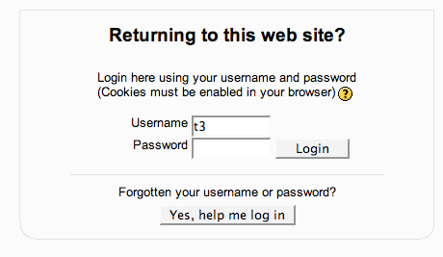

Image 2
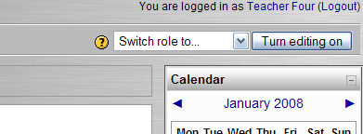

Image 3
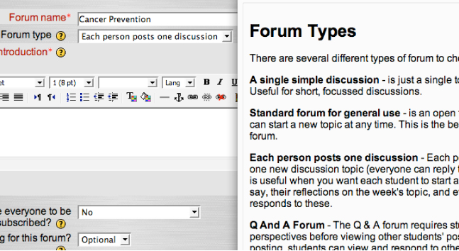

Image 4
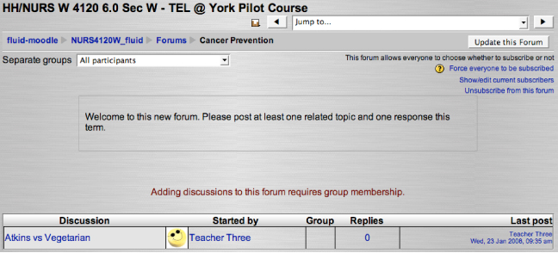

Image 5
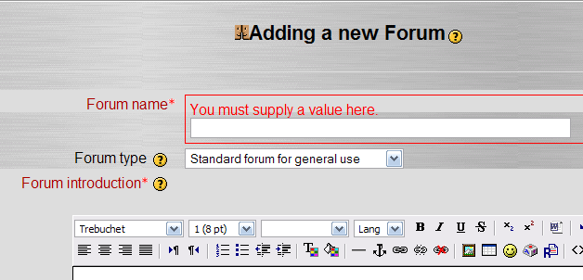

Image 6
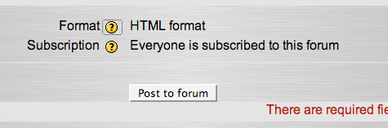

Image 7
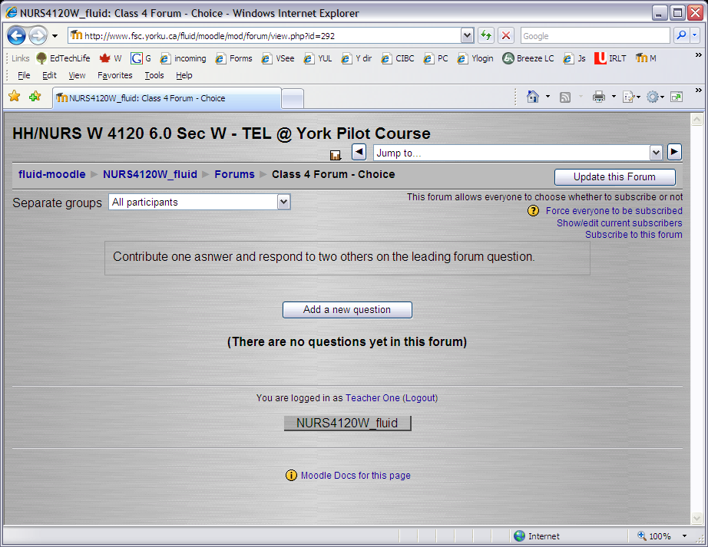

Scenario 2
Image 8
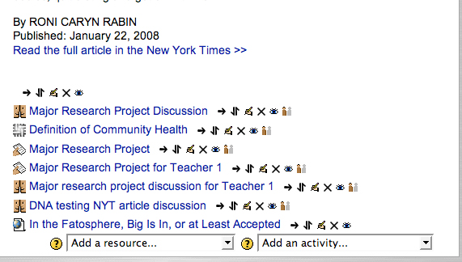

Image 9
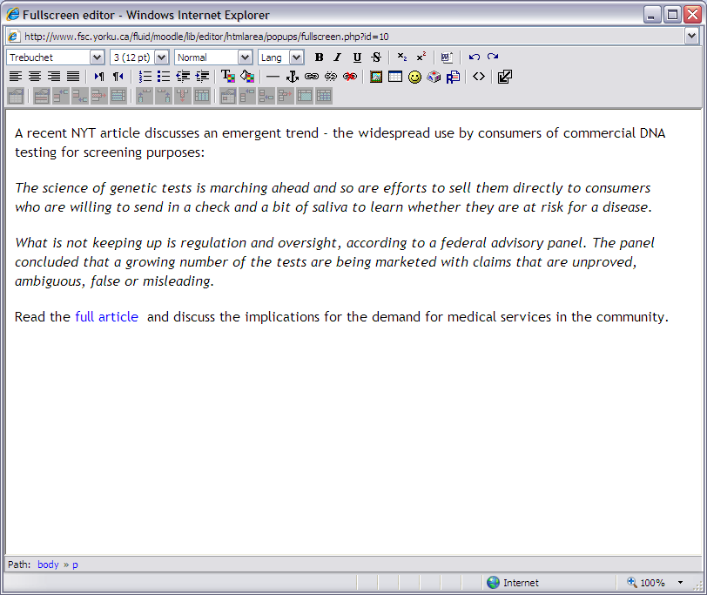

Image 11
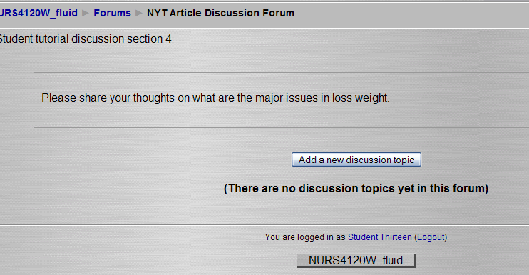

Image 12
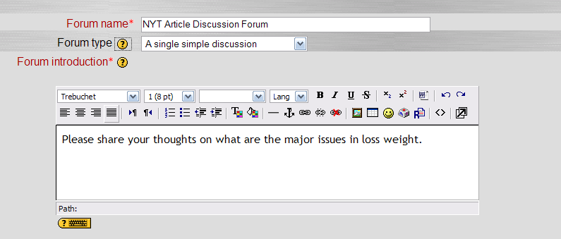

Scenario 3
Adding an assignment

Image 13
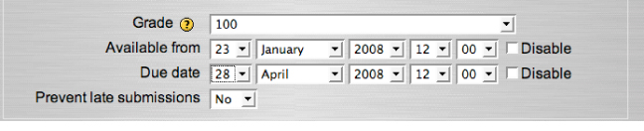

Image 14
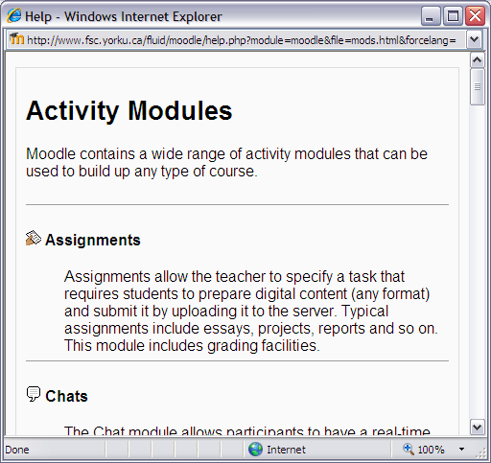

Scenario 4

Image 15
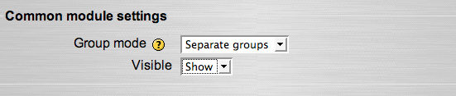

Image 10
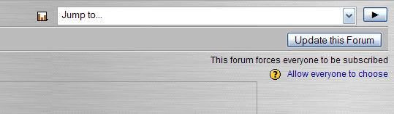

Image 17
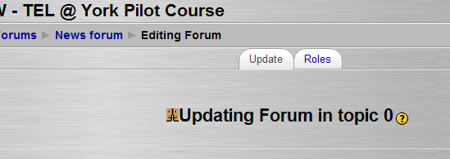

Scenario 5

Image 18
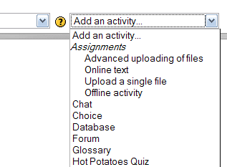

Image 19
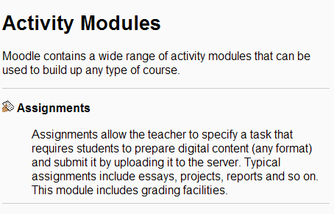

Scenario 6
Quiz

Image 20
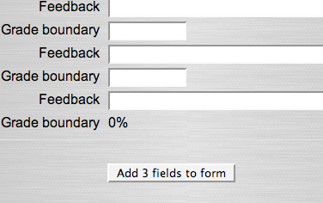

Image 22
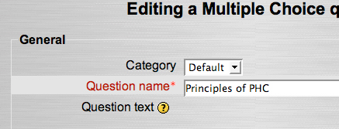

Image 23
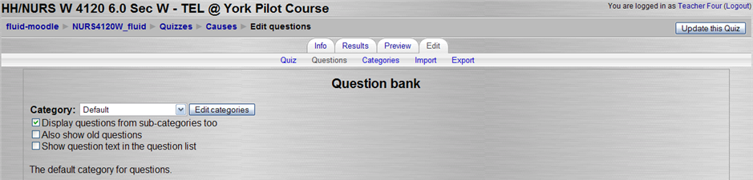

Image 24
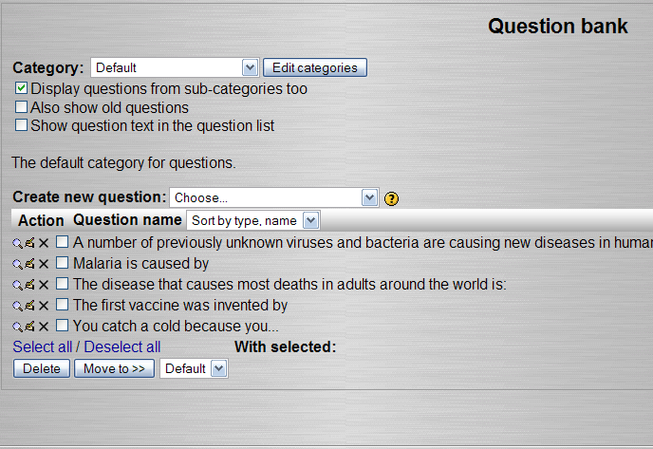

Image 25
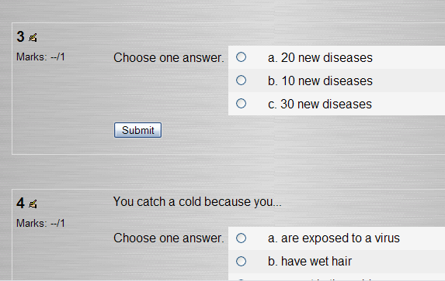

Image 26
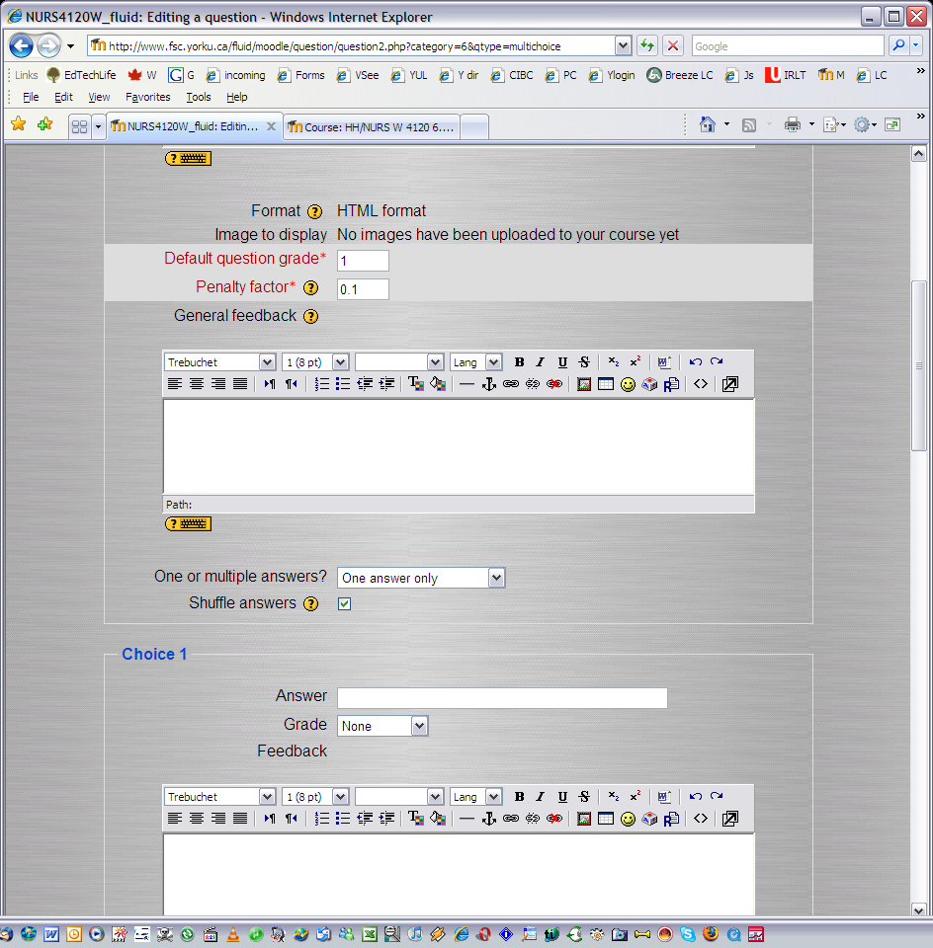

Image 27
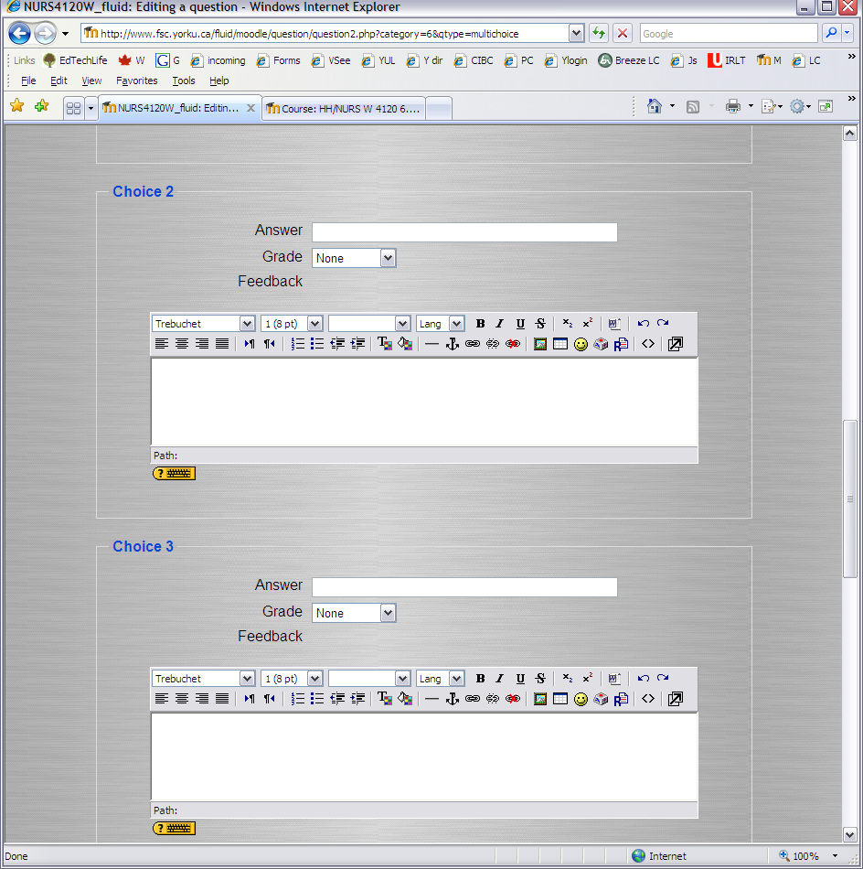

Scenario 7

Image 28
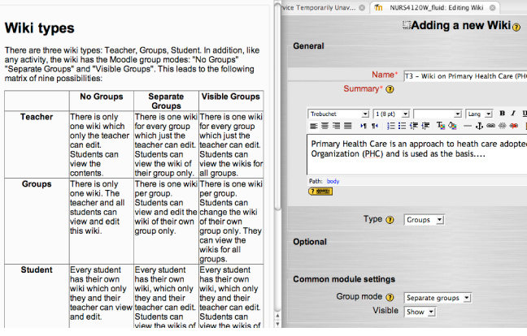

Image 29
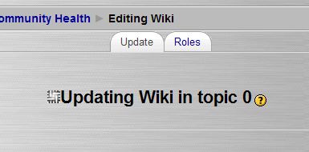

Student Persona

Scenario 1

Image 30
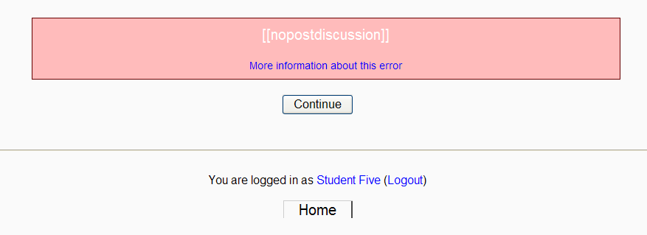

Image 31
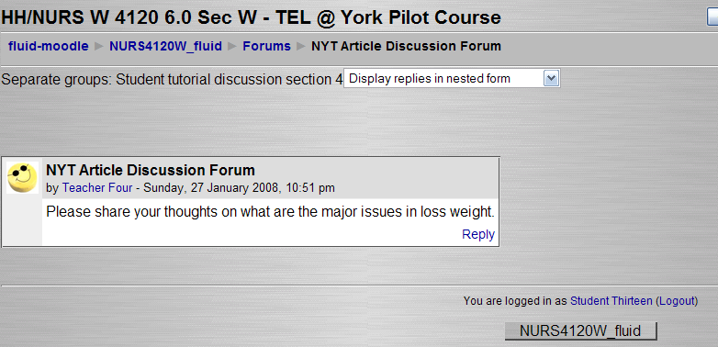

Image 32
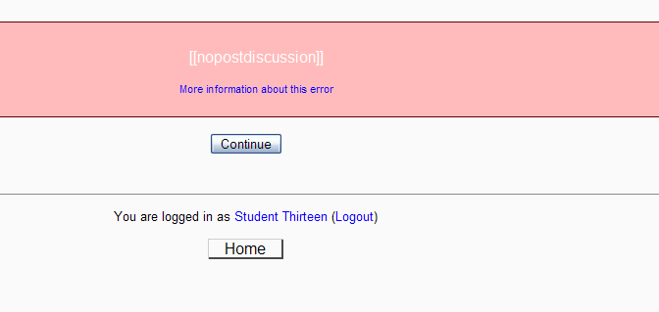

Scenario 2

Image 33
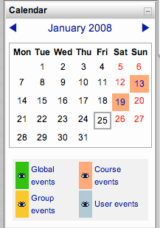

Image 34
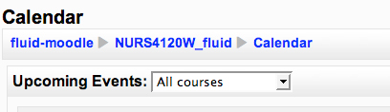

Image 35
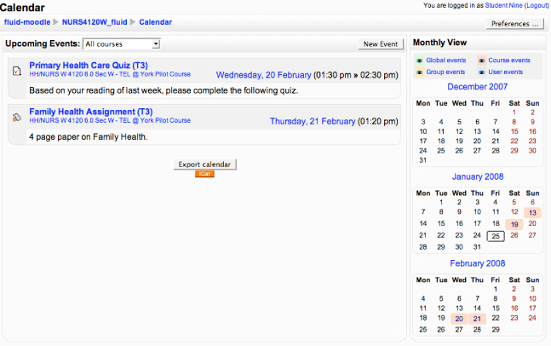

Image 36
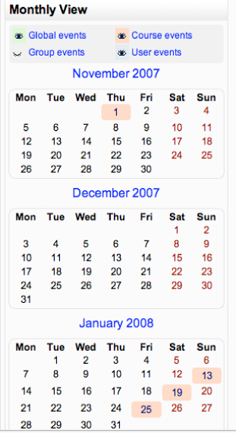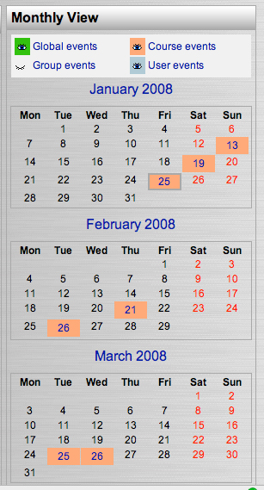

Image 37
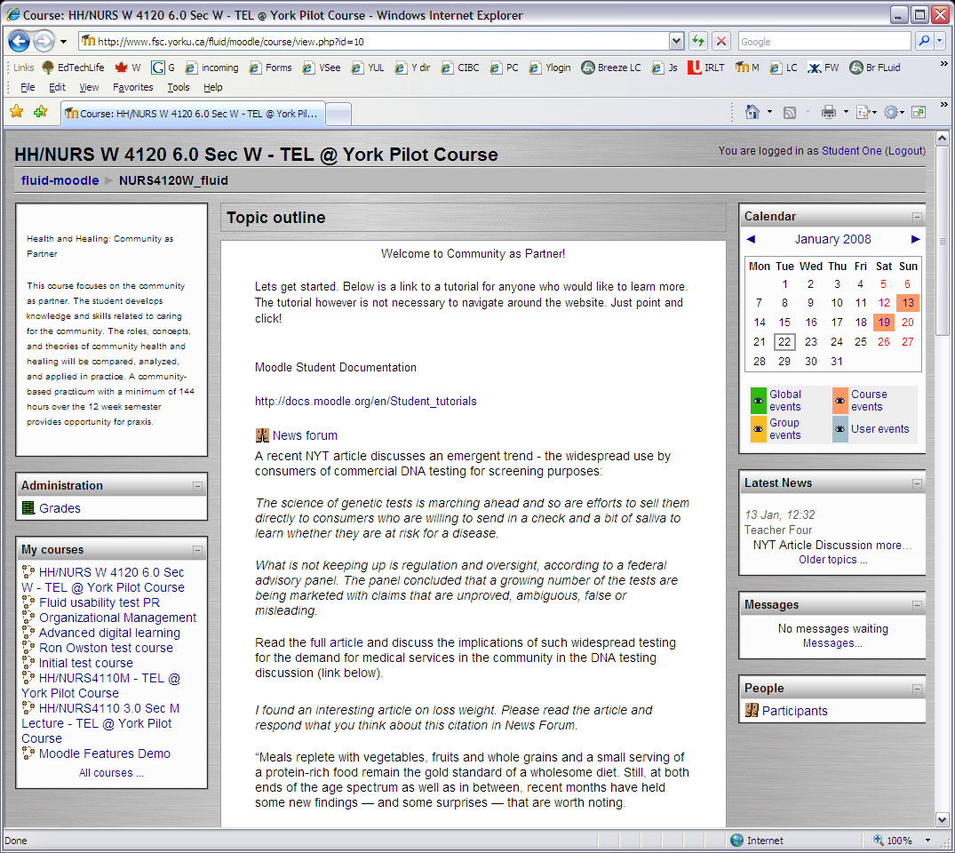

Scenario 3

Image 38
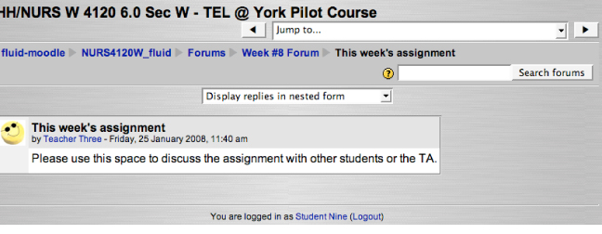

Logged in as Teacher – checking Forum #8 Subscribers:
Note: Student Nine is Subscribed to this forum.
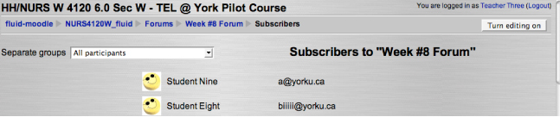

Senario 4
Quiz

Image 39
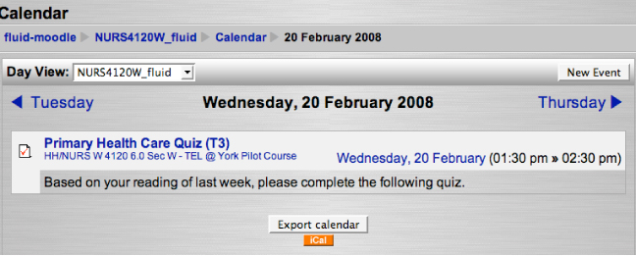

Image 40
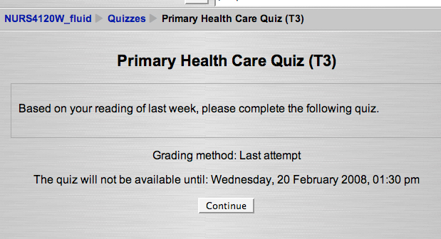

Image 41
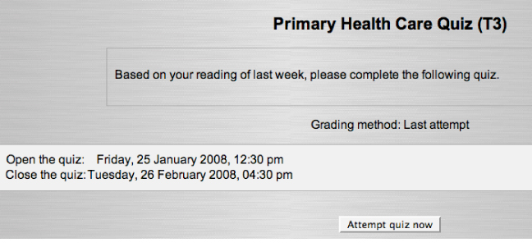

Image 42
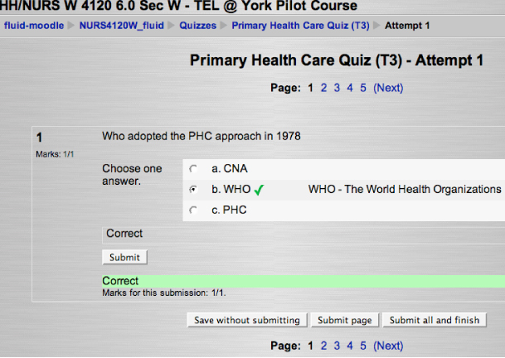

Image 43
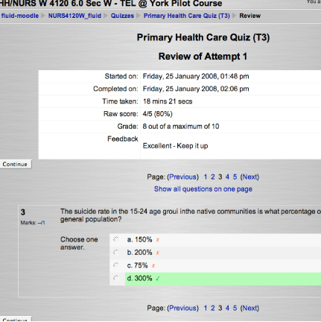

Scenario 6

Image 44
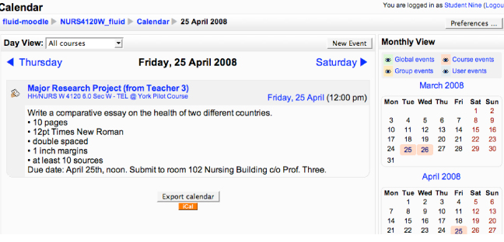

Scenario 7

Image 45
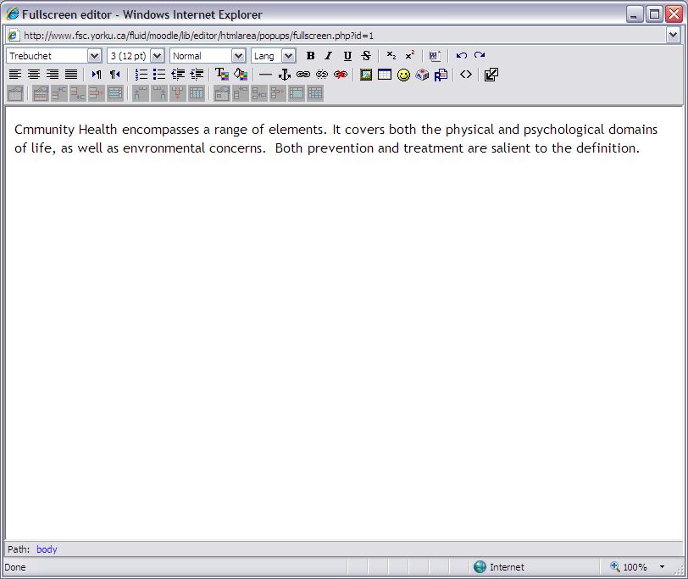

TA
Scenario 1

Image 46
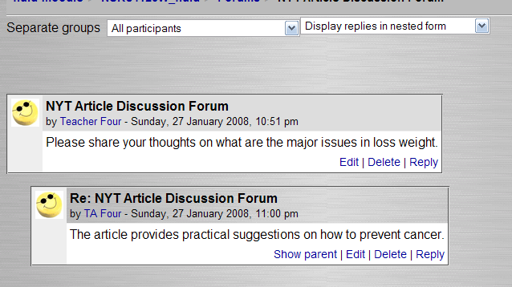

Scenario 2

Image 47


