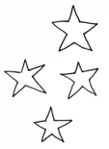

Project BEING Futures
final report
November 30, 2021
Submitted by: Inclusive Design Research Centre (IDRC)
IDRC team: Dana Ayotte, Caren Watkins, Michelle D’Souza, Colin Clark
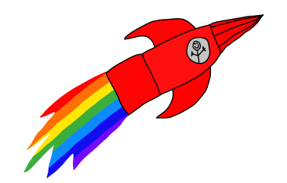

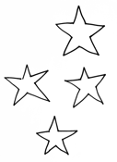

Contents
List of figures 3
Introduction 4
Summary of Outcomes 4
Summary of Process Reflections 5
Overview of Activities and Outcomes 6
Think Tank, April 20, 2021 6
Goal 6
Next step: 8
Additional resources: 8
Co-design Workshop 1, June 8, 2021 9
Goal 9
Prompt 9
Outcome 10
Additional resources: 12
Co-design Workshop 2, July 6, 2021 13
Goal 13
Prompt 13
Outcome 14
Additional Resources 16
Co-design Workshop 3, September 28, 2021 17
Goal 17
Prompt 17
Outcome 18
Additional Resources 18
Suggested Next Steps 19
Additional Documentation 19

List of figures
Figure 1 A slide from the Think Tank presentation. 6
Figure 2 Image of the Zoom gallery view during the Think Tank session. 7
Figure 3 Image of Caren drawing the artists’ shapes and colours live on a chalkboard during the session. 7
Figure 4 The final collaborative design titled “A Wonderful Pattern of Shapes”. 8
Figure 5 Still image from Workshop 1 video prompt. 9
Figure 6 Still image from Workshop 1 video prompt. 9
Figure 7 Still image from Workshop 1 video prompt. 10
Figure 8 One of the individual artist stars created during Workshop 1. 11
Figure 9 Example of a feelings constellation created based on feelings the artists shared during Workshop 1. 11
Figure 10 One of the images used in the Workshop 2 video prompt. 13
Figure 11 A screen capture from the Workshop 2 prompt, showing a demonstration of how the templates provided in the artist kits could be used to create artwork of Planet BEING Futures. 14
Figure 12 One of the artists sharing their artwork of Planet BEING Futures with the group. 15
Figure 13 One of the artists sharing their artwork of Planet BEING Futures with the group. 15
Figure 14 A slide from Workshop 3 introducing the idea of “BEING Online”. 17
Figure 15 A slide from Workshop 3 introducing the whiteboard activity. 18
Figure 16 A slide from Workshop 3 introducing the whiteboard activity. 20

Introduction
The BEING Futures project was a collaboration between the Inclusive Design Research Centre (IDRC) and BEING Studio. The goal of this project was to assist BEING Studio in brainstorming and conceptualizing an emerging digital / in person hybrid operating model. This work included needs-gathering through co-design with artist members, with the aim of creatively mapping out design ideas for tools and activities for artists to access resources and connect with other artists within and outside of BEING.
The BEING Futures project took place between April and November 2021 during which time we held a kick-off “Think Tank” session followed by 3 co-design sessions. The think-tank and co-design workshop activities were aimed at creatively exploring what events, activities, and online spaces the artists would like to keep or change and what new things they’d like to try. The discussion included BEING in-person, BEING on Zoom, and BEING online (as well as the BEING Studio and BEING Home website and social media).
It is our hope that the outcomes and reflections of the work done in 2021 provides guidance for future collaborative work that BEING Studio may embark on.

Summary of Outcomes
For the full list and detailed description of co-design outcomes, including ideas for next steps, please see the co-design outcomes spreadsheet.
- Artists are excited to be back in person again, but some expressed an interest in a hybrid of balancing Zoom gatherings/meetings with in-person
- Some artists expressed an interest in wanting to teach workshops in various mediums and skills, both online and in-person
- Some artists like using social media to promote and sell their work, but some were not aware of it
- Some artists said that they were unaware of the SHOP or of the Artist pages on the BEING Home website, and other web content
- The topic of online safety came up in reference to a past workshop on the topic; this may be something that artists would like to continue or repeat in future
- An advantage of being on Zoom that was expressed is meeting other artists from all over Canada and beyond
- Many artists expressed how much they like the SPEAK podcast, both the podcast itself and the process of creating it and the skills they learned in doing so
- The topic of taking good photos to promote your work came up; a workshop in photography might be of interest, including ways to find help to take photos of your work
- Artists expressed interest in learning several different skills, from sculpting, acting and stitching to zoom hosting and more complex jewelry making
- The final BEING Futures Space Map can be seen at https://wiki.fluidproject.org/display/fluid/BEING+Futures+Project?preview=/231801035/254050347/Final%20Map%20cropped.jpg

Summary of Process Reflections
Please see the Process Reflections document for a detailed report.
The Process Reflections document was created to capture our thinking about the co-design process both during and after completion. These reflections are based on post-co-design debrief and feedback discussions with BEING facilitators, as well as from our own reflections on the BEING Futures process and our experiences with doing co-design on other projects.
The following topics are covered in the report:
- Community-led Co-design practices
  - Collaborating with community facilitators
  - Attending existing community gatherings / events
  - De-briefing and getting feedback
  - Onboarding - The “Think Tank” Event
- Structuring and planning the co-design activities
- Documenting and communicating ideas
  - Activity Prompts and Descriptions
- Logistics
  - Using the Zoom chat
  - Sharing and participating on Zoom

Overview of Activities and Outcomes

Think Tank, April 20, 2021

Goal
The goal of the kick-off Think Tank session was to get to know each other, to introduce the artists to the BEING Futures project and to the idea of co-design, and to generate interest in participating in the co-design workshops. The Think Tank session was open to all BEING artists.
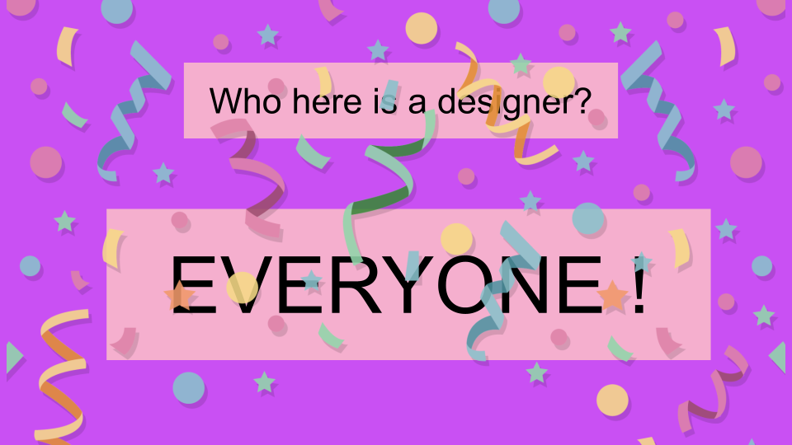
Figure 1 A slide from the Think Tank presentation.
A highlight of the Think Tank session was the “Shapes and Colours” activity in which the artists introduced themselves by choosing a shape and colour (e.g., “I’m Dana Diamond, and I’m the colour blue”). These shapes and colours were recorded live on a chalkboard in one of the facilitators’ spaces, and a group reflection on the process and final collaborative design helped to demonstrate the process of co-design. One artist named the design “A Wonderful Pattern of Shapes”.
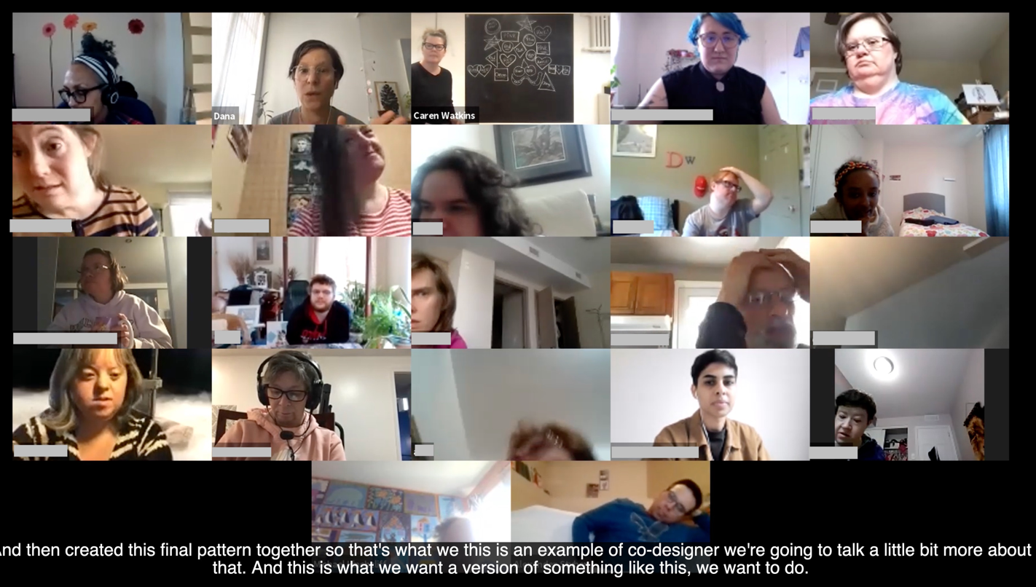
Figure 2 Image of the Zoom gallery view during the Think Tank session.
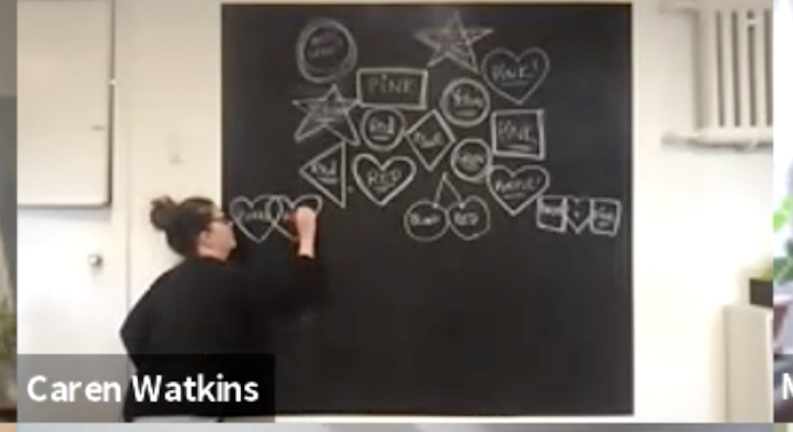
Figure 3 Image of Caren drawing the artists’ shapes and colours live on a chalkboard during the session.
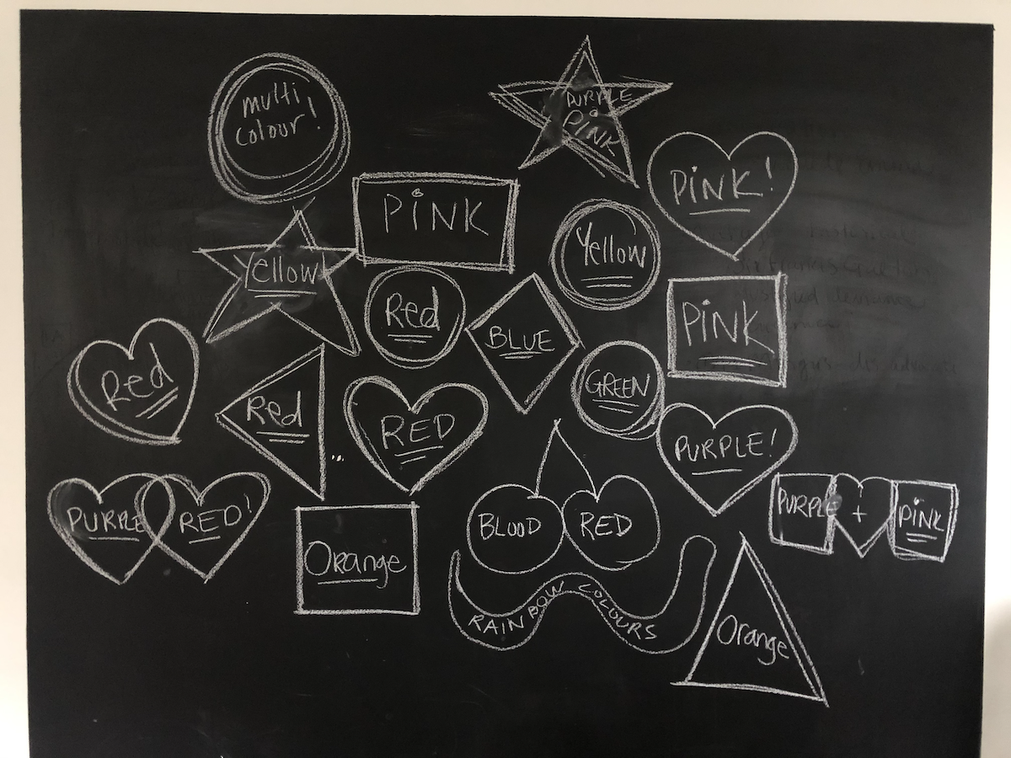
Figure 4 The final collaborative design titled “A Wonderful Pattern of Shapes”.

Next step:
After the Think Tank Session, 10 artists were selected to participate in a series of 3 co-design workshops, and a welcome email was sent out with a poster, text and audio clip.

Additional resources:
Email invitation
Co-design process animation
Think Tank Slides

Co-design Workshop 1, June 8, 2021

Goal
The goal of the first co-design workshop was to explore the things that the artists like to do in their day-to-day lives and to identify the feelings they have when doing those things. The outcomes would then lead into exploring the things they like about BEING in the second workshop.

Prompt
Prior to Workshop 1, the IDRC created and shared a video prompt inviting artists to reflect on something they like to do in their daily life, and their feelings about it.

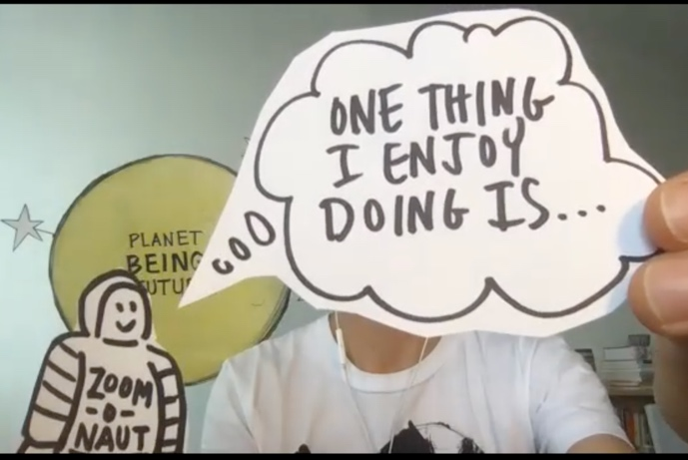
Figure 5 Still image from Workshop 1 video prompt.
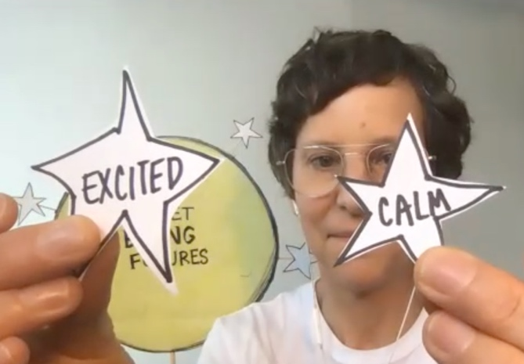
Figure 6 Still image from Workshop 1 video prompt.
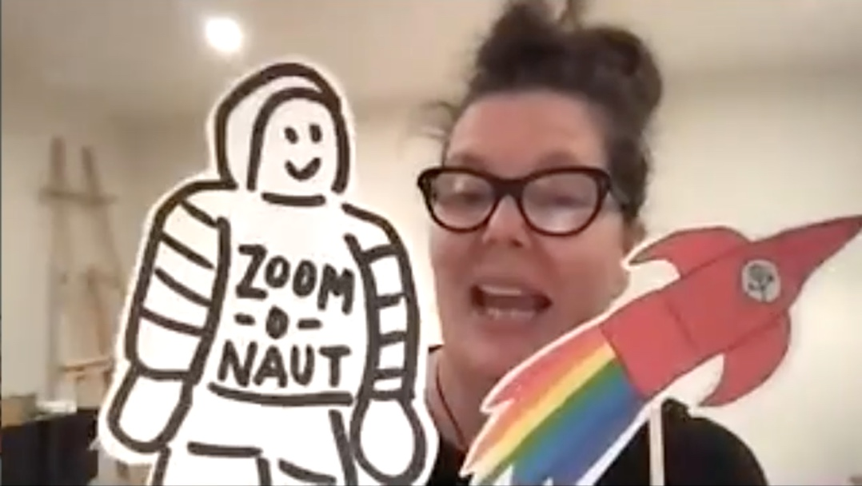
Figure 7 Still image from Workshop 1 video prompt.

Outcome
During the workshop, the artists shared in their breakout groups about the things they like to do and their feelings when doing those things. Each artist’s experiences were recorded on individual stars, and feelings constellations were created from all the feelings they shared. These feelings were then used as a jumping-off point for Workshop 2 activities.
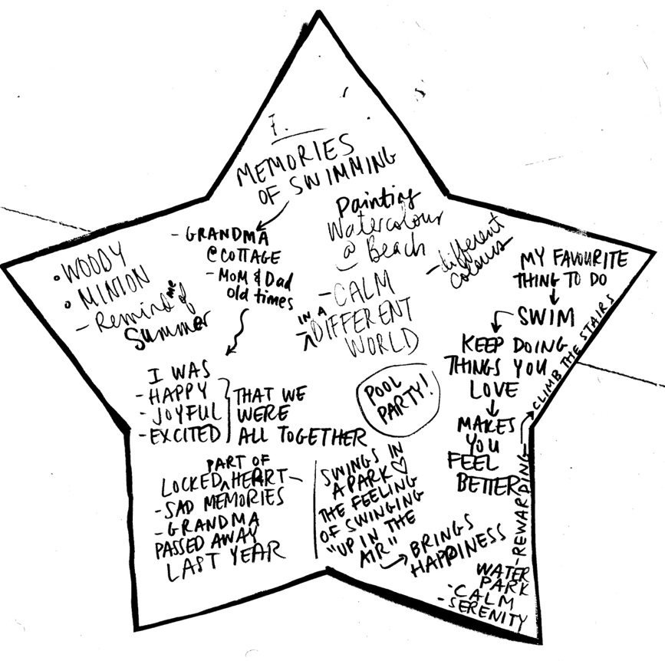
Figure 8 One of the individual artist stars created during Workshop 1.
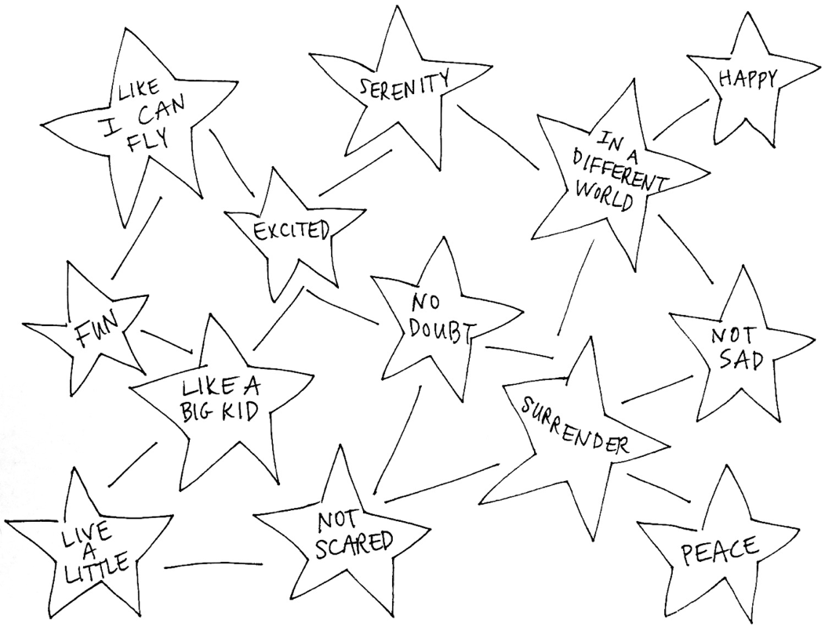
Figure 9 Example of a feelings constellation created based on feelings the artists shared during Workshop 1.

Additional resources:
Workshop 1 - Agenda and Guide
Additional workshop prompt images and constellations:
- Prompt images - pages 4 and 5
- Feelings constellations - pages 6 and 7
- Things I like to do constellation - page 8

Co-design Workshop 2, July 6, 2021

Goal
The goal of the second co-design workshop was to explore the BEING events, activities, and online spaces that the artists liked and wanted to keep, what they might want to change, and what new things they’d like to try in the future in an online / in-person hybrid.

Prompt
Prior to Workshop 2, the IDRC created and shared a video prompt inviting artists to reflect on the questions above. Artists were also encouraged to use the templates provided in the artist kits (sent out in early July) to create art about their vision of Planet BEING Futures.

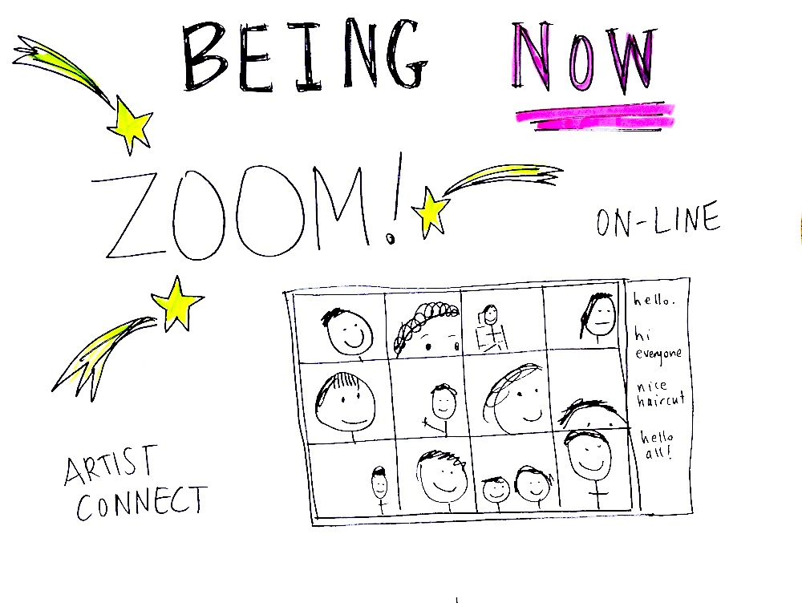
Figure 10 One of the images used in the Workshop 2 video prompt.
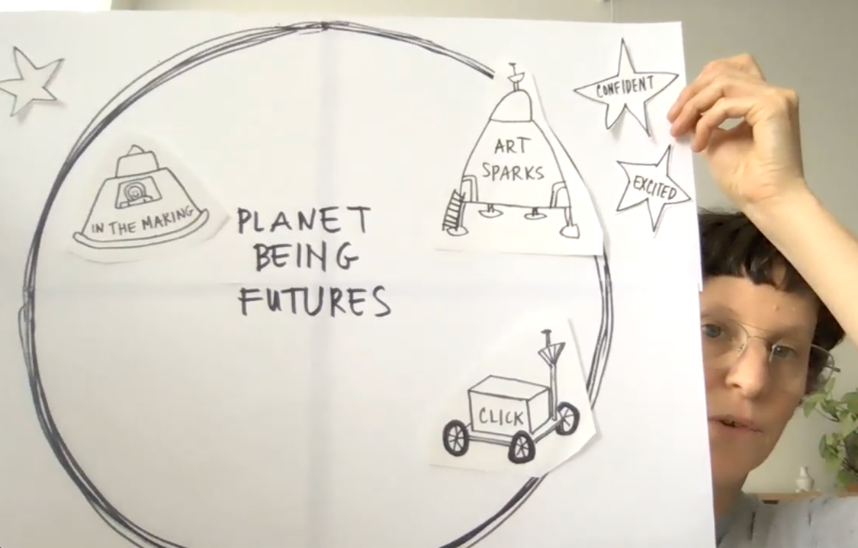
Figure 11 A screen capture from the Workshop 2 prompt, showing a demonstration of how the templates provided in the artist kits could be used to create artwork of Planet BEING Futures.

Outcome
During Workshop 2 some of the artists shared examples of the artwork they had created about BEING Futures, while other artists worked on it during the session. This led into a discussion of the things the artists wanted to keep or change about BEING at home and BEING in-person.
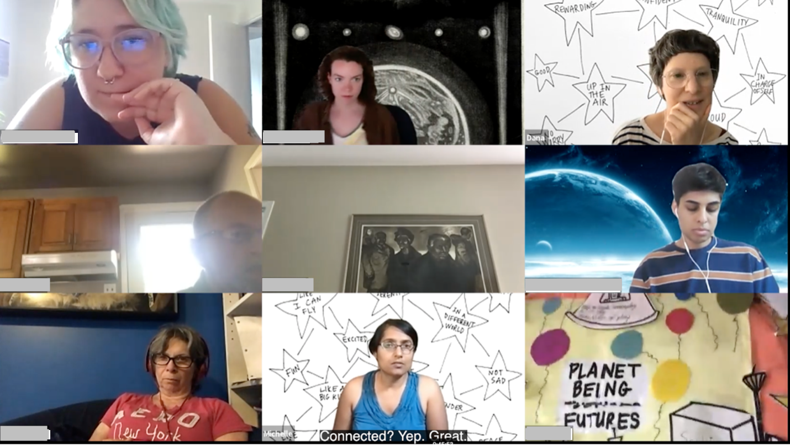
Figure 12 One of the artists sharing their artwork of Planet BEING Futures with the group.
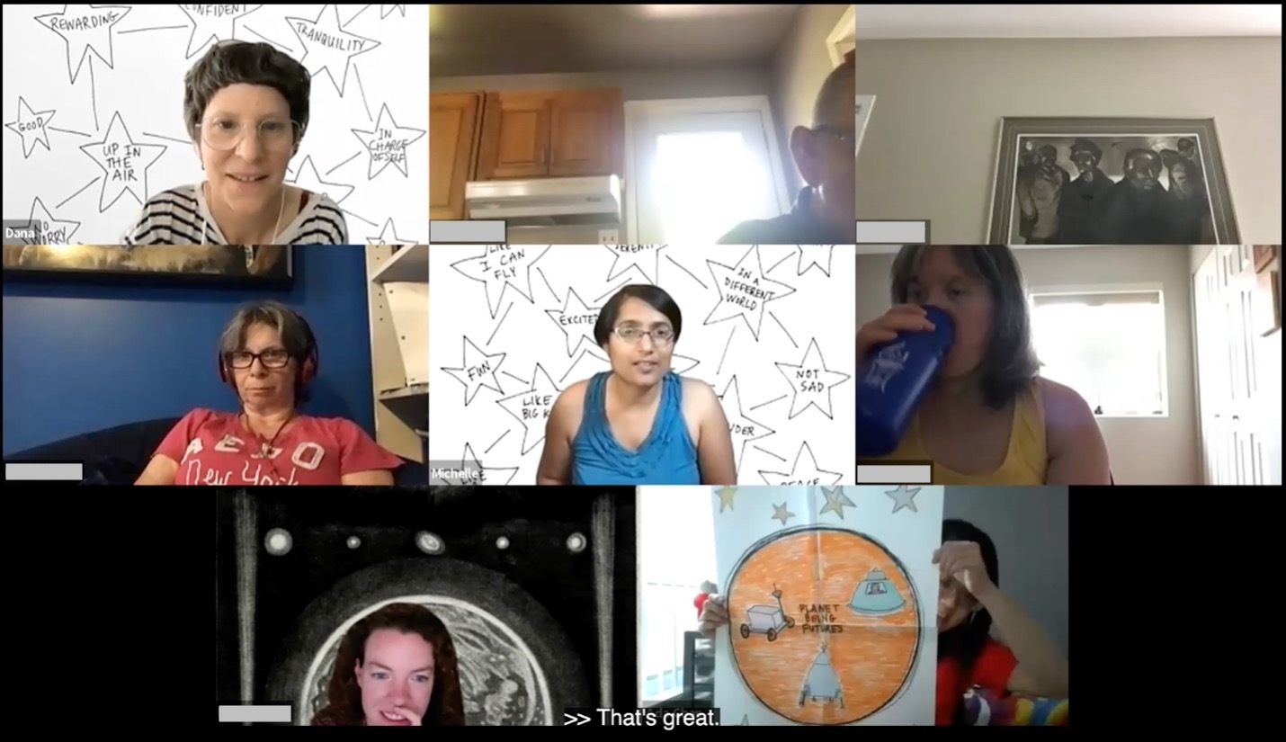
Figure 13 One of the artists sharing their artwork of Planet BEING Futures with the group.
A highlight from Workshop 2 was when one artist expressed a desire to teach a workshop (on movement and exercise), which led to other artists expressing their desire to teach on other topics. One artist said they’d like to teach an online class but do it from the BEING studio - an excellent example of a new BEING future in-person/online hybrid idea!
Between Workshops 2 and 3, the IDRC facilitators put together a “Planet BEING FUTURES Space Map” based on the outcomes of Workshops 1 and 2. An email was sent out to the artists in August that included the map, an annotated video description of the map, and a reminder about the 3rd co-design session.

Additional Resources
Workshop 2 - Agenda and Guide
Additional workshop prompt images and templates:
- Prompt images - pages 9-12
- Art-making templates - pages 13-16

Co-design Workshop 3, September 28, 2021

Goal
The goal of the third co-design workshop was to explore the BEING online space in more detail, by asking the artists to reflect on what they like about the different online spaces, what they might want to change, and what new things they’d like to create and try.

Prompt
Prior to Workshop 3, a survey of questions was sent out to the artists to help determine what activities they might prefer to do during the workshop, and to get them thinking about what “BEING Online” spaces and activities are important to them.
Slides were presented during the Workshop showing examples of BEING online content. The slides and images were used to guide the discussion and to provide examples of all the different aspects of BEING online that already exist.

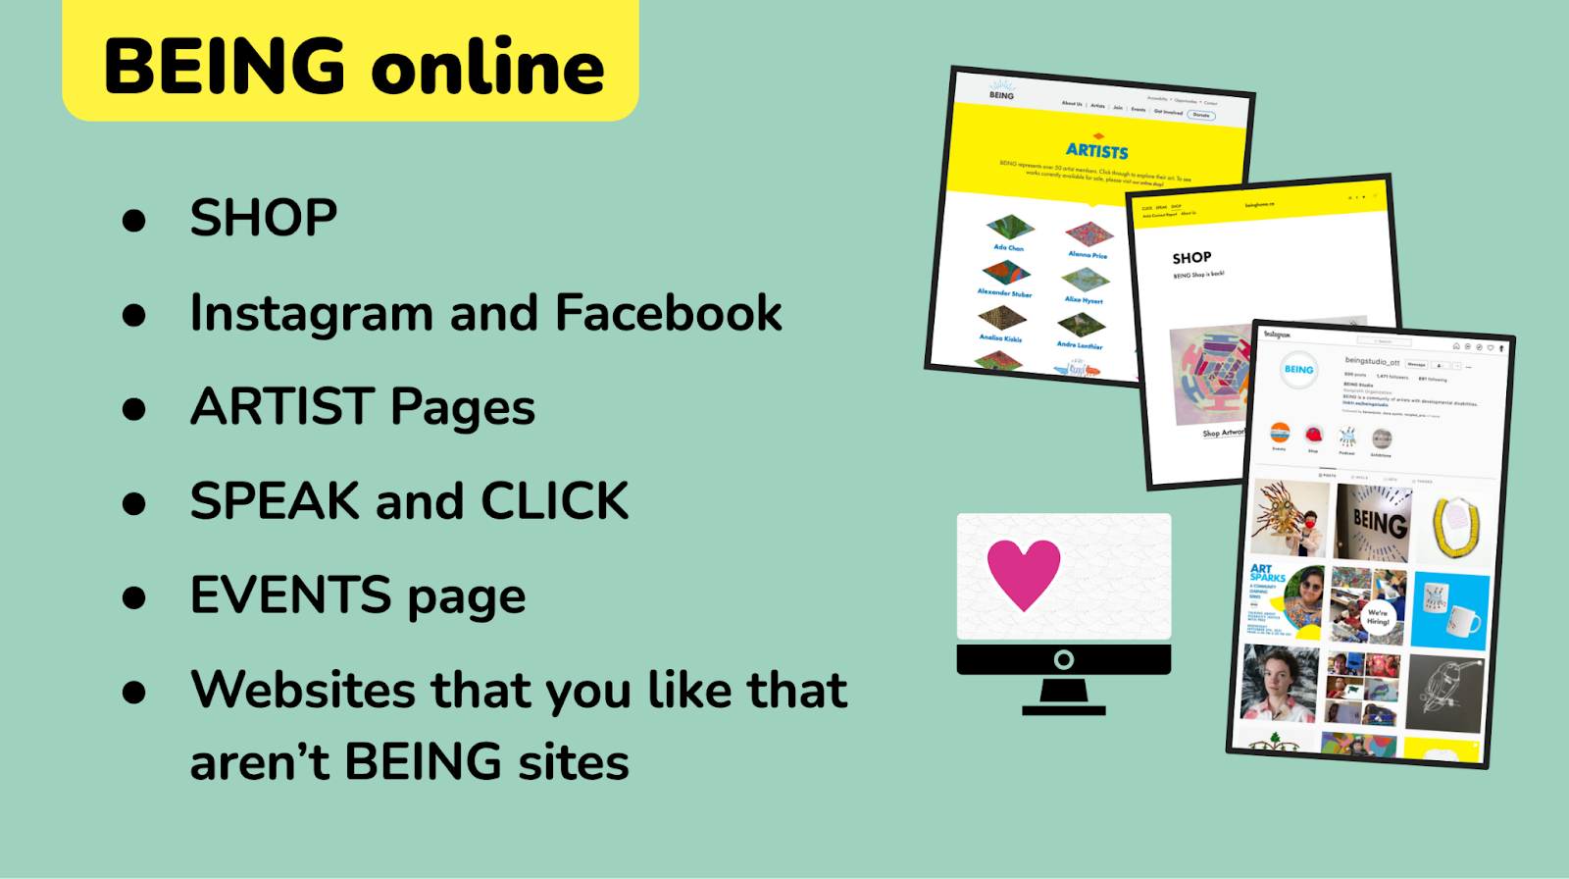
Figure 14 A slide from Workshop 3 introducing the idea of “BEING Online”.
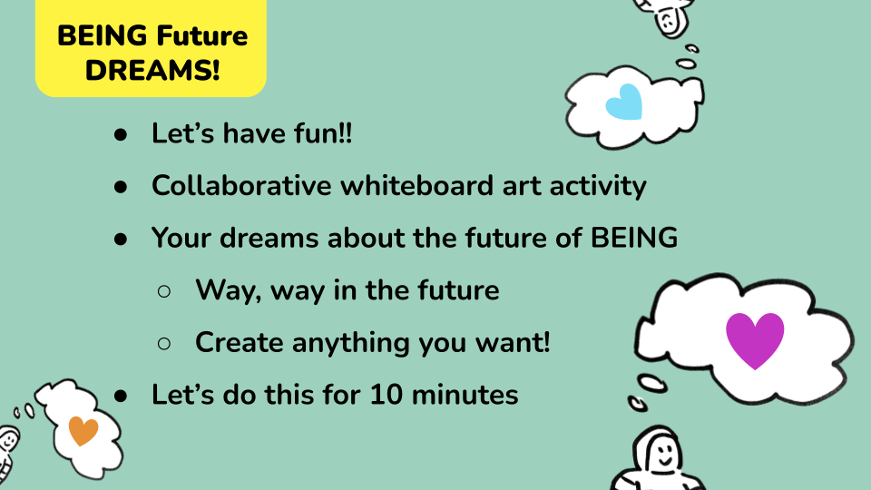
Figure 15 A slide from Workshop 3 introducing the whiteboard activity.

Outcome
A highlight from Workshop 3 was a lengthy discussion about selling artwork, with a focus on using online tools to do so. One artist shared that they did not have any work in the SHOP and did not feel like her artwork was ready to sell. They had also not been aware of the SHOP site prior to seeing it in the Workshop. They shared some of their work with the group during the workshop, and we also looked at the artwork on their artist page together. One facilitator expressed the opinion that their work looked ready to sell. This brought up the question of what support or direction a BEING artist might need to feel confident and ready to sell their work.
Additional discussion points relating to selling work online included the process of creating documentary photos or videos of artwork in order to post them online (one artist shared that their mom had taken the images of her work), as well as the topic of online safety when using social media.

Additional Resources
Workshop 3 Full Slidedeck
Workshop 3 - Agenda and Guide
Final “BEING Futures Space Map”
Additional workshop prompt images (pages 17-19)

Suggested Next Steps
Please see the co-design outcomes spreadsheet for specific suggested next steps related to individual outcomes.
The practice of inclusive co-design involves many iterations of an idea with community members over time; each iteration informs the next. It is therefore our hope that the outcomes and reflections of the work done in 2021 provides guidance for future collaborative work with and within BEING Studio. In addition, what we have learned from the co-design process with BEING Studio will be included in the IDRC’s ever-growing Toolkit on Community-Led Co-design, with the goal of sharing these learnings with the global community of Inclusive Design practitioners.
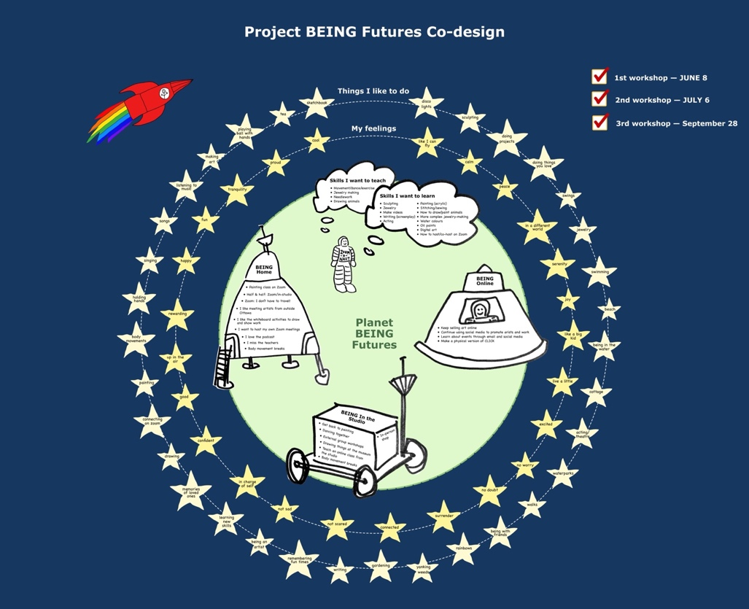
Figure 16 The BEING Futures “Space Map”, a mapping of co-design outcomes.

Additional Documentation
AGM Summary Slides
IDRC Project Wiki Page - BEING Futures

