A comparative analysis of disability policy in the United States and Canada through an occupational lens
Rachel Heeb, OTD/S
Steve Taff, PhD, OTR/L, FAOTA
Parul Bakhshi, PhD, DEA (M.Phil)
Washington University in St. Louis - School of Medicine
Program in Occupational Therapy

Rachel Heeb, OTD/S ’18, is a clinical doctorate student at Washington University School of Medicine in St. Louis. She is currently completing her third and final year of studies in the occupational therapy program. Her main areas of interest include social policy, universal design, and disability studies. As a member of Dr. Parul Bakhshi’s International Initiatives and Global Perspectives research laboratory, Rachel assists in the research of human development and participation sciences, with a specific focus on inclusion of vulnerable populations.

Dr. Steve Taff, PhD, OTR/L, FAOTA, is Associate Director of Professional Education and Academic Affairs and Assistant Professor in Occupational Therapy and Medicine at Washington University School of Medicine. Dr. Taff currently teaches doctoral educational seminars and teaching practicums in the Program in Occupational Therapy. His research interests include the role of occupation as a core concept in occupational therapy curricula, graduate student mental health and support, and faculty development.

Dr. Parul Bakhshi, PhD, DEA (M.Phil) is an Assistant Professor of Occupational Therapy and Surgery at Washington University School of Medicine in St. Louis. As a social psychologist, Dr. Bakhshi has worked on various issues linked to international development including disability, life skills education, processes that create vulnerability and definitions of well-being. Her work focuses primarily on assessment of programs and international policy in low and middle-income countries.

Introduction: This systematic review identified synergies and gaps between the current policy discourses on disability and the new challenges and opportunities for the occupational therapy profession. The authors developed a comprehensive, comparative analysis of disability policy in two high-income countries that have practiced occupational therapy for nearly a century. Objective: The primary aim of this review was to examine the underlying definitions of disability that shape each country’s policy. The review critically appraised central policy documents pertaining to disability and compared the political landscapes of the U.S. and Canada from an occupational viewpoint. Method: An academic literature review of articles regarding disability policy and a grey literature review of national policy documents were conducted. Forty-two policy documents and sixteen articles met inclusion criteria. The theoretical frameworks and underlying definitions of disability from each document were analyzed using the internationally recognized United Nations Convention on the Rights of Persons with Disabilities (UNCRPD) as an inclusive and socially progressive policy gauge. Eight occupational therapists and four disability rights organizational stakeholders participated in a semi-structured interview to gather various viewpoints on disability and occupational therapy’s potential role in disability policy. Results: The most prevalent UNCRPD categories present in U.S. policy related to accessibility and personal mobility, while the most prevalent categories present in Canadian policy related to employment and participation in political and public life. Results demonstrated Canadian policy to be aligned with the social model of disability while U.S. policy was founded in the medical model of disability. Interview responses demonstrated that occupational therapists and disability rights organizational stakeholders employ a more progressive and empowerment based school of thought in their perspectives of disability. Finally, a model of occupational therapy’s potential role within disability policy was developed based upon integration of participants’ and the authors’ professional perspectives. Conclusion: The proposed analysis provides a future road map for scholars and practitioners to better advocate for the role of occupational therapy within disability policy as well as comprehensive social change.
Background
It is currently estimated that one billion individuals are living with some form of disability worldwide, and this number will continue to increase in both size and proportion due to advancements in health care, technology, and medicine along with a continually aging population [1]. As disability continues to gain recognition as a global and human rights issue which will potentially impact all human beings either temporarily or permanently, there is an agreement over the need to understand the complexities of disability and to better understand how inclusive environments can be shaped or improved to address the needs of individuals with disabilities [2, 3]. Occupational therapy, a profession that emphasizes the promotion of health and well-being through engagement in necessary and meaningful everyday activities, works closely with persons with various disabilities in clinical, research, and political settings [4]. The Guide to Occupational Therapy Practice states it is in the occupational therapist’s scope of practice to facilitate participation to the best of his or her ability for all individuals, catering to unique needs [5]. Due to the profession’s advocacy for social inclusion and participation enablement, occupational therapy maintains a close relationship with disability. However, there is a lack of resources outlining the role of occupational therapy in disability legislation, a realm which was created for the very purpose of meeting and protecting the needs of individuals with disabilities [6]. Previous studies have examined specific aspects of health and disability policy and its relation to occupational therapy practice, but these studies lack generalizability due to its localization within specific international contexts or individual practice settings [7, 8]. There is extensive evidence behind occupational therapy’s capacity to facilitate independence and address environmental and social barriers for individuals with disabilities, yet there are gaps in the existing literature between disability policy and occupational therapy practice, as the recognized benefits of occupational therapy are not currently being incorporated into legislation [9-11]. Because of this inconsistency, it is necessary to understand the synergies within disability policy and occupational therapy in order to identify avenues for meeting the emerging challenges of fast changing societies outlined in the American Occupational Therapy Association’s (AOTA) Vision 2025.
In 2014, AOTA began a planning initiative to establish a vision for 2025, building upon their 2017 Centennial Vision to continue to outline a future roadmap for the advancement of the occupational therapy profession [12, 13]. Similar to AOTA’s Vision 2025 is the Strategic Plan for 2016-2019 developed by the Canadian Association of Occupational Therapists (CAOT) [14]. Both visionary statements correspondingly identify specific actions that must be taken, such as the creation of partnerships with governmental organizations and the advancement of research and policy development in order to advance occupational therapy in the policy realm [14, 15]. The comparison of the U.S. and Canada, regarding both future visions and past legislation, allows Canada to be utilized as a yardstick with which the U.S. can potentially gauge the policy landscape and identify barriers and opportunities to achieve its new vision. Even at a glance, the U.S. and Canada share similarities and differences regarding disability policy and definitional perspectives that make a comparison worthwhile.
The overarching goal of the current project is to identify synergies and gaps between the current policy discourses on disability and the new challenges identified for the practice of occupational therapy. This will be achieved through the development of a comprehensive, comparative analysis of disability policy in two high-income countries which have practiced occupational therapy and occupational science for almost a century. The current project objective is to critically appraise central policy documents pertaining to disability and to compare the current political landscapes of the U.S. and Canada from an occupational lens. The expected outcome of this project is to produce an analysis of the way in which occupational therapy can progress through the mapping of disability policy in the U.S. and Canada. The proposed conceptual analysis is to be utilized by policymakers, occupational therapists, researchers, educators, and the public. It will be supported by anecdotal evidence gathered from practicing clinicians and disability organization stakeholders.
Significance
Throughout the last fifty years, definitions and categorizations of disability have shifted away from a medical model of functioning toward a social model that emphasizes systematic and environmental barriers to participation [16, 17]. On a legislative basis, the U.S. passed the Americans with Disabilities Act (ADA) in 1990, which although gives recognition to the social model, has been challenged by the federal courts’ attempt to narrow and medicalize the definition of disability [18, 19]. Although amended in 2008, the definition of disability in the original ADA was borrowed from the Rehabilitation Act of 1973 [20]. In contrast, Canada utilizes a crosscutting, systematic approach to disability policy with an entire sector, the Office for Disability Issues, dedicated to disability management and policy. Rather than passing an omnibus legislation such as the ADA, the needs of individuals with disabilities are addressed throughout various policies, both at the provincial and federal level. Additionally, the Disability Creation Process and the Canadian Human Rights Act, two monumental legislative frameworks, are recognized as incorporating a social perspective of disability. Canada has implemented structures which allow for the mainstreaming of disability concerns, and has succeeded at implementing a community-based model of health care delivery, especially in regard to occupational therapy practice [21, 22].
The World Report on Disability also points to a lack of literature analyzing international policy development to meet the needs of individuals with disabilities [1]. Various conceptual models and frameworks have been introduced to attempt to capture an updated snapshot of the dynamic definition of disability, and often these are met with some form of criticism regarding their inattention to all aspects of disability as well as their cultural relevance and local understandings of disability [23]. One of such models is the Quebec Classification of the Disability Creation Process (DCP), created by the Quebec Committee on the International Classification of Impairments, Disabilities, and Handicaps. This framework of disability illustrates elements of the social model, which frames disability as a consequence of the interaction of an individual and the environmental, social, or attitudinal barriers surrounding him or her [24, 25]. An inconsistency which exemplifies the current state of disarray within disability policy is the contrast between impairment and disability, which is not often recognized or understood. According to the DCP, an impairment is an anatomical, physiological, or histological abnormality, while a disability is created by the interaction of one’s personal factors with an incapacitating environment [25]. In contrast to the social model is the medical model, which views the individual as a physical and biological mechanism that, when injured, needs repair [26]. National policies are founded on the aforementioned models and operational definitions of disability, ones that have evolved within specific political, cultural, and social contexts. There have been unsuccessful recommendations for the universalization of disability policy and for the adoption of a universalistic perspective of disability, with previous research outlining disadvantages to the current organization, pointing to coordination and consistency difficulties as well as decreased accountability and lack of coherent aims [27, 28]. However, researchers have emphasized that effective policy is typically adapted to fit a specific context within each community or nation it is intended to guide [29]. Disability policy is shaped by theoretical and conceptual disability frameworks which define the concept, and this has an implication for the nature of the solutions that are created to address meeting disability needs.
The current research is timely and significant for the following reasons: its purpose of supporting the American Occupational Therapy Association (AOTA) in achieving its Centennial Vision and Vision 2025, its broader application to the Canadian Association of Occupational Therapists (CAOT) and international occupational therapy communities, its innovative approach and design which will lay the foundation for the development of a new avenue of research, and its emphasis of the need for coherency within the realm of disability policy as a whole.
The AOTA’s Centennial Vision, which in 2017 commemorates the 100th anniversary of the profession, and more recently its Vision 2025, identify key elements to progressing the field of occupational therapy. A fundamental purpose of the planning initiative was to facilitate discussion and consideration of future changes anticipated as well as challenges and opportunities for the profession in various situations. Many of the identified key elements in the initiative pertain to expansion in collaboration and increasing the profession’s power and influence [13]. The Centennial Vision also explicitly identifies barriers to achieving this future road map, several of which involve inconsistency, lack of clarity, and misalignment [13]. The more recent Vision 2025 goes beyond the traditional medical model and incorporates social aspects of well-being and quality of life. Moving toward a socially-based community model of disability, AOTA emphasizes the provision of care for “all people, populations, and communities through effective solutions that facilitate participation in everyday living”[12]. In order to establish greater influence, expand the reach of the profession, and “maximize health, well-being, and quality of life for all people” occupational therapists and related community members need resources that clarify their role and articulate what opportunities will be available in the next decades [12]. The current study supports the achievement of AOTA’s Vision 2025 by identifying these challenges and opportunities that face the profession. Existing occupational therapy literature regarding disability policy is scarce; therefore, the current study presents an opportunity to contribute to a new body of evidence that examines the highly relevant field of disability policy and how occupational therapy is embedded within it, as well as how disability policy is utilized and influenced by occupational therapy practice [7]. Through the comparison of national disability policy, occupational therapy practitioners, researchers, and educators will be better informed regarding the profession’s current and potential role within disability policy.
While the current project is ultimately intended to reach an audience of occupational therapists in the United States through tailoring research to support AOTA in reaching its Centennial Vision, it is worth noting that the Canadian Association of Occupational Therapists’ (CAOT) released a similar Strategic Plan for 2016-2019. This strategic agenda serves as a guide for advancements in occupational therapy in regards to disability management and highlights the need for occupational therapists to collaborate with policymakers, researchers, organizations, and additional stakeholders [15]. Therefore, the purpose of the current study potentially translates to a wider audience of international occupational therapy communities.
Literature in recent years regarding the role of occupational therapy within disability policy specifically within the United States is entirely nonexistent. This study utilizes an innovative approach and design which lays the foundation for the development of a relatively unexplored avenue of research. The current study attempts to contribute to the much required paradigm shift in the way modern occupational therapy is viewed and valued in the context of policy. Additionally, the current study utilizes a triangulation of different sources consisting of policy, research, and practice. This research expands the reach of occupational therapy while also clarifying existing discrepancies between practitioners’ views of disability and the definitions found in national legislation documents. Through emphasizing the need for coherence of definitions of disability at a national level, policy development can potentially undergo a shift in the way it attempts to define participation and disability. With the end deliverable of the current project, policymakers, occupational therapists, researchers, and organizational stakeholders will be better prepared to advocate for potential opportunities for occupational therapy as well as opportunities for coherence. The current study also combines a grey literature review, academic literature review, and qualitative interviews that further aids with the dissemination of the evidence and directly impact those it is intended to reach. Practicing occupational therapists along with policymakers and organizational stakeholders have been included in the study process, therefore improving final outcomes and more effectively tailoring the information needed within the occupational therapy community.
In addition to facilitating progress toward national position statements and planning initiatives within the occupational therapy community, the current study also draws attention to the need for coherency within the realm of disability policy. While policies are deliberately constructed around contextual factors to meet each separate nation’s needs and therefore vary on a transnational basis, it is essential for national policies and definitions of disability to have coherence. National definitions directly influence how states develop eligibility criteria and subsequently shape the quantity and type of services needed for the respective individuals with disabilities [30, 31]. Additionally, definitions guide how statistical data is collected, which in turn also shapes the perception of need for the provision of disability services [32]. Therefore, in order to accurately and effectively provide services and properly meet the needs of individuals with disabilities, definitional coherency is essential.
Methods
Grey Literature
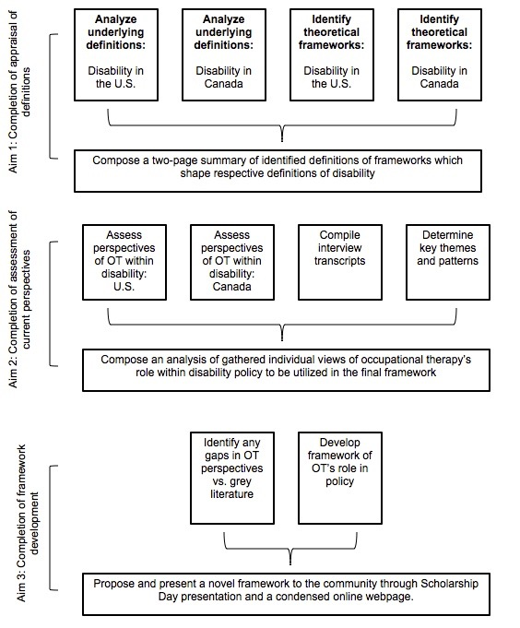
The ultimate objective of Milestone 1 was to critically and conceptually appraise definitions of disability in the U.S. and Canada and their implications on definition of social policy through a systematic review of evidence. The first task involved analyzing theoretical frameworks (e.g., medical model, social model, etc.) and underlying definitions of disability that contribute to each country’s policy through a review of national policy documents. The researchers conducted a grey literature review of each country’s national disability policy documents, with the following websites and organizations searched: American Occupational Therapy Association (AOTA), Canadian Association of Occupational Therapists (CAOT), the Public Health Agency of Canada, the United States Department of Labor, the Department of Justice of Canada, and the International Network on the Disability Creation Process. Thirteen documents were selected from Canada, and nineteen documents were selected from the U.S. The qualitative data analysis software NVivo was used for the coding of each policy document. Codes were developed using the United Nations Convention on the Rights of Persons with Disabilities (UNCRPD). Of the 50 total articles outlined in the UNCRPD, 34 articles were deemed relevant to be used as a framework from which to code the disability policy documents. For example, passages of text discussing non-discriminatory employment practices were coded under Article 5, Equality and Non-Discrimination. Each document was coded according to the UNCRPD nodes using NVivo, and entire passages of text or whole sentences, rather than specific words, were coded to allow for the capturing of more complete ideas. For each document, a preliminary analysis of the table of contents was performed in order to determine if the document contained any mention or discussion of theoretical or conceptual content regarding disability. The following document(s) were excluded based on the preliminary analysis discussed previously: Canada Shipping Act. Two documents were randomly selected to be double coded to ensure coding reliability. The statutes included in the final analysis can be found in Appendix B.
Academic Literature
The next stage of Milestone 1 occurred through the second task of analyzing underlying definitions of disability that contribute to each country’s policy through an academic literature scooping review of journal articles regarding national disability policy and occupational therapy. The search strategy was carried out with the assistance of a library sciences professional through Washington University School of Medicine. The following search terms were developed and applied as extensive, broad concepts to attempt to capture the current relationship between occupational therapy and disability policy in the U.S. and Canada: “disability policy”, “international policy”, “disabled person”, “occupational therapy”, and “disability.” Various national and international databases were used to search the concepts above, including CINAHL, Web of Science, Embase, PubMed, and Scopus. After conducting a formal search using search terms applied to databases, a manual search was conducted to review existing academic literature for relevant disability studies and documents. An additional manual search known as ‘snowballing’ was utilized to conduct evidence. Inclusion and exclusion criteria were developed based upon policy type and relevance. To manage all retrieved articles, the software EndNote was utilized as a bibliographic reference manager; the inclusion and exclusion criteria were also applied through EndNote. The academic literature search resulted in 41 unique citations 16 of which met inclusion criteria.
Interviews
The objective of Milestone 2 was to assess current perspectives of occupational therapy’s role within disability policy from practicing clinicians and stakeholders through interviews. The first task involved identifying eight occupational therapists and four organizational stakeholders with which to conduct interviews regarding perspectives of disability in both the U.S. and Canada. Email invitations were sent to potential interviewees with a description of the study, purpose, timeline, and requested commitment from each participant. Participants were provided the option of phone call or a video-muted Skype phone call. It was requested that each interview be recorded to allow for ease of transcription. Four practicing occupational therapists and two disability organizational stakeholders were identified from each country as potential interview candidates, for a total of twelve participants. Inclusion criteria included clinically practicing as a licensed occupational therapist in one of the following settings: acute care, inpatient rehabilitation, home health, school, adult or pediatric outpatient, mental health, hands or upper extremity, neuro-rehabilitation, skilled nursing facilities, community practice, and early intervention; optional additional involvement in disability policy at the national or state level; has lived in Canada or the United States for a minimum of ten years; has been practicing for a minimum of three years; received a baccalaureate (Canada) or master’s (U.S.) equivalent degree or higher from an accredited occupational therapy program. Exclusion criteria included: any involvement in policy not related to disability; currently holds or has held a part-time or full-time position in academia; has previously worked in a policy setting before becoming an occupational therapist or attending occupational therapy school. Interview candidates were identified through personal and professional relationships of Dr. Parul Bakhshi and Dr. Steve Taff, professors at Washington University School of Medicine’s Program in Occupational Therapy. Interview questions were developed based upon themes that emerged from previous grey literature data. Categories of nodes from Milestone 1 were developed based upon emergent themes from the grey and academic literature reviews. Questions were separated into subsections asking participants about challenges that they perceive to face as an entire profession as well as challenges they perceive to they face as an individual clinician. The interview questions, once developed and deemed ready, were vetted by two professors within the Washington University School of Medicine Program in Occupational Therapy. Both professors selected to provide feedback have extensive knowledge in disability policy as well as insight into the research process and interview techniques. Questions were also tested with two employees from a local independent living center with knowledge of disability policy and experience providing equipment and assistive technology to individuals with disabilities. Both faculty members and employees were asked to provide edits and critiques regarding phrasing, flow, and general content of the interview questions. The questions were then revised according to the feedback given.
The conducted interviews were each less than sixty minutes and began with open-ended questions (i.e., how do you define disability? what has been your exposure to disability policy as a practicing clinician?) to see which thematics were covered naturally. Participants were also asked to identify, from their perspective as a practicing clinician or organizational manager, the most critical UNCRPD articles for individuals with disabilities. The interviewer then provided follow-up questions based on which thematics still needed to be addressed. Transcripts and notes of each recorded interview were then compiled and analyzed using NVivo. Key themes and patterns were determined using previously identified theoretical frames of reference. Interviews were conducted in a manner that attempted to capture each occupational therapist’s and organizational lead’s unique and meaningful experiences. Additionally, member checking was performed with three participants to improve validity and accuracy of analyses. Participants were encouraged to informally provide feedback through general email suggestions.
Analysis
Grey Literature
The first task of analysis was to investigate the node occurrences of both the United States and Canada. This was performed through NVivo, and the node occurrences of each country separately were then examined. Using the software’s word frequency feature, each country’s policy documents were analyzed regarding the most frequently used terms not including articles such as “it”, “the”’, or “a.” Additionally, in order to avoid including frequently used irrelevant words in the word frequency analysis, specific words were added to the Stop Words list, including: “section”, “program”, and “stating” for the United States and “section” and “pour” for Canada. A word cloud was produced for each country based upon the word frequency analysis results; this diagrammatic format helps to illustrate the emerging themes found by simply investigating specific words which are used more frequently than others. Following the word cloud, a word tree analysis was performed for specific text searches. For example, relevant, overarching terms such as “disability”, “accessibility”, and “rights” were manually entered into an analysis which produced a word tree diagram. This diagram provides a contextual analysis of the way in which certain terms are used throughout each country’s policy documents. The word tree diagram provides contextual phrases used both before and after specific words to allow the reader to understand the way in which a term is situated within text.
The next stage of analysis occurred in the selection of one or two central policy documents from each country and consequently narrowed the scope of the grey literature. These documents were identified as texts which provided the most evident and visible philosophies and underlying theories of disability. The researchers elected to focus on the original, foundational documents of each country’s policy: the Americans with Disabilities Act from the United States and the Canadian Human Rights Act and the Constitution Act from Canada. A word frequency and word cloud analysis were performed on each country’s central policy documents. Once again, a word tree analysis was also performed using specific text searches for terms such as “disability”, “accessibility”, and “rights.”
Academic Literature
Each journal article was coded with the same strategy utilized for the grey literature analysis. Entire sentences and phrases were coded using the UNCRPD articles, and two articles were randomly selected to be double coded so as to ensure reliability.
Interviews
Interview audio recordings were imported to NVivo for transcription. A similar analysis process was conducted for interview content, including a word frequency, word cloud, and word tree analysis. Additionally, each interview was manually coded for general themes and patterns until theoretical saturation was reached. The UNCRPD nodes were used as a final coding strategy.
Results
Academic Literature
The most prevalent UNCRPD codes among the academic literature were Article 9, Accessibility (n = 4); Article 2, Definitions (n = 3); Article 27, Work and employment (n = 3); Article 25, Health (n = 2); and Article 29, Participation in political and public life (n = 2). Literature citing Article 2, which concerns definitions of disability, was focused on how disability is conceptualized and defined internationally.
Authors | UNCRPD node
Sin, 2009 | 5, 27
Layton, 2014 | 9, 31
Kolwitz & Radlinska, 2015 | 29, 2
Kjellberg, 2010 | 9, 29, 30
Hammell & Whalley, 2015 | 9, 20
Hammel et al., 2015 | 19
da Cruz & Emmel, 2013 | 9
Côté, 2013 | 2, 27
Conti-Becker et al., 2007 | 2
Brite, Nunes, & Souza, 2015 | 27
Black, Wheeler, Tovar, & Webster-Smith, 2015 | 8, 25
Pereira & Whiteford, 2013 | 19
Carrier & Levasseur, 2015 | 25, 26

Article 1 – Purpose
Article 2 – Definitions
Article 3 – General principles
Article 4 – General obligations
Article 5 – Equality and non-discrimination
Article 6 – Women with disabilities
Article 7 – Children with disabilities
Article 8 – Awareness-raising
Article 9 – Accessibility
Article 10 – Right to life
Article 11 – Situations of risk and humanitarian emergencies
Article 12 – Equal recognition before the law
Article 13 – Access to justice
Article 14 – Liberty and security of person
Article 15 – Freedom of torture or cruel, inhuman or degrading treatment or punishment
Article 16 – Freedom from exploitation, violence and abuse
Article 17 – Protecting the integrity of the person
Article 18 – Liberty of movement and nationality
Article 19 – Living independently and being included in the community
Article 20 – Personal mobility
Article 21 – Freedom of expression and opinion, and access to information
Article 22 – Respect for privacy
Article 23 – Respect for home and the family
Article 24 – Education
Article 25 – Health
Article 26 – Habilitation and rehabilitation
Article 27 – Work and employment
Article 28 – Adequate standard of living and social protection
Article 29 – Participation in political and public life
Article 30 – Participation in cultural life, recreation, leisure and sport

Grey Literature
The most prevalent UNCRPD codes present in U.S. policy were related to accessibility and personal mobility while the most prevalent categories present in Canadian policy were related to work and employment participation in political and public life. Additionally, results demonstrated Canadian policy to be human rights and socially based while U.S. policy follows a physically- and medically-based model of disability. The results of the first analysis of grey literature, which included examining node occurrences for both countries combined, are shown in Figure 1. The most commonly occurring UNCRPD nodes among both the U.S. and Canada were Accessibility, Definitions, Work and Employment, Purpose, and Equality and Non-discrimination. Accessibility was found to occur significantly more often in policy text than the second and third most frequently occurring nodes, definitions and work and employment. Worth noting is the general absence of nodes relating to awareness-raising, right to life, respect for privacy, and situations of risk and humanitarian emergencies. The results of the second analysis of grey literature, which included examining node occurrences for each country separately, are shown in Figures 2 and 3. The most commonly occurring UNCRPD node among U.S. policy was accessibility, with a total of 54 coding references. The next most frequently occurring nodes were definitions, equality and non-discrimination, education, and personal mobility. It should be noted that accessibility was found to have more than twice the number of coding references (54) as definitions, the second most frequently occurring node (22). The most commonly occurring UNCRPD node among Canadian policy was definitions, with a total of 22 coding references. The next most frequently occurring nodes were work and employment, accessibility, and purpose. The results of the third stage of analysis of grey literature, which included examining word frequencies for each country separately, are shown in Figures 4 and 5. Each image is formatted in a word cloud diagram, and this allows the viewer to see a comprehensive display of themes and patterns found within the text. Canadian policy, illustrated in Figure 4, displays words such as “marginal,” “rights,” and “respect.” American policy, as illustrated in Figure 5, displays words such as “individuals,” “disabilities,” “entity,” and “transportation.”

Interviews
When asked to provide a definition of disability from their own perspective as a practicing clinician, 100% (n = 12) of participants included mention in some form of an individual’s inability to participate in activities that are meaningful and important to him or her.
One interviewee specifically described disability as “a naturally occurring part of life that we as a society need to figure out how to adapt to. We as a society need to adapt for people with disabilities as opposed to people with disabilities doing the adapting to what the norm looks like in society.” Another participant explained disability as “a mismatch between an individual, their goals and they want to accomplish, and the context that they find themselves in. That context can be an environmental context, physical context, a digital contest that precludes them from getting to do what they want to do.” Participants were then asked to discuss how they perceived their own view of disability as well as their nation’s view of disability based off of several models, which were presented to them as neither on a continuum nor as mutually exclusive: social (i.e., disability is the result of the way society is organized), medical (i.e., disability is the result of a physical condition intrinsic to the individual), deficiency (i.e., a perspective highlighting the need to repair or fix the individual), and empowerment (i.e., a perspective of capabilities highlighting what people with disabilities can do). One participant explained, “I think in society we're still lagging behind a little bit, I think there’s an effort to sort of change it. But I do think that there’s this sort of medical model where disability is a very physical thing—you look different than other people, you sound different than other people, you get around different than other people, you need support from different people. I don't think it's intentional, but I think it's just the cultural implications.” Another participant described their own views, stating, “where I work it’s very empowerment focused. When it comes to the idea of disability, I think professionally as an occupational therapist I'm always looking at what are the things you can do rather than can’t. [My patients] are amazing regardless of their condition—they all have amazing strength and things that they can do so well and we just have to unleash that potential and allow them to do those things.”
When asked about experience disability policy during practice, 92% (n = 11) of participants reported having been exposed to policy in some form, whether in the acute care setting, through home health, or additional experiences leading to contact with policy. One of the eight practicing therapists reported having sought exposure to disability policy purely out of self interest, with two others acknowledging they had received a small but brief overview of policy during their educational training. In response to being asked how they think realistically the profession of occupational therapy will progress in the future in terms of its relationship with disability policy, clinicians shared either skepticism or cautious optimism. One participant expressed concern that “organizations like AOTA are definitely more on the ball, but I feel like we got left out of policy a while back.” Another interviewee explained, “there's a lot of really thoughtful and passionate, motivated occupational therapists out there who really have a lot to say, but at the same time we haven't had a lot of traction for the profession and around what we do, why we do it, and how we can contribute in such a unique and meaningful way.” Participants emphasized that if the profession is to advance within the realms of policy or health care, there is an urgent need for members of the profession to adopt a more active voice and advocate for their potential contributions.
A Proposed Model of Occupational Therapy’s Role in Disability Policy
Regarding new and innovative roles that clinicians viewed occupational therapists as potentially serving, interviewees provided an extensive list ranging from consultation services and capacity building to direct interactions with policymakers. The profundity of these responses led to the development of a visual (see Appendix A, Figure 6) which attempts to capture a combination of the authors’ interviewees’ perspectives of potential occupational therapy impact in the field of disability policy (see Figure 6). The figure displays a cyclical process with several stages in which occupational therapists can provide a voice within disability policy. Beginning with policy consultation, therapists may directly serve as consultants to policymakers by providing professional recommendations regarding policy needs. That occupational therapists are holistic in their broad understanding of human functioning, participation, and engagement allows them to provide a more comprehensive perspective when consulting and informing policymakers. More importantly, therapists may also interact directly with individuals with disabilities through capacity building and encouragement of involvement in the consultation process. Secondly, therapists may serve an intermediary role by communicating the needs of individuals with disabilities to policymakers.
As illustrated in the third grey bubble, throughout the policy development process, therapists may provide a perspective of pragmatism and ensure that the developing policy will effectively address identified issues. Additionally, therapists may encourage individuals with disabilities and disability rights organizations to become involved in the actual development process. This stage is particularly crucial in that it transforms a process which was originally top-down in nature into a true, participatory system. Participation as it is currently defined in the realm of disability policy translates to persons with disabilities being offered a consultation role, yet they are excluded from the writing and development stages [33]. As depicted in the fourth grey bubble, throughout the policy implementation stage, therapists may assist in monitoring effective implementation and continue to promote preventative efforts within communities to address the needs of individuals with disabilities. Alluded to by an interviewee, an additional suggestion is for disability rights organizations and occupational therapists to promote partnerships with communities and businesses. Rather than penalize for noncompliance with the ADA, therapists and organizations should be encouraged to partner with communities and businesses to assist them with finding answers and solutions to becoming more accessible in a preventative manner. Finally, the last grey bubble depicts the process of policy evaluation, through which an occupational therapist may assist in assessing the impact of disability policy, eliciting or acting upon stakeholder feedback, and evaluating whether or not legislation should be revised or improved.
The center of the diagram highlights that individuals with disabilities themselves are the most knowledgeable about their own needs and what policies may effectively provide solutions. This concept is also illustrated through an interviewee’s comment: “We really think people with disabilities have the best knowledge about what policies and programs and services should look like for people with disabilities.” Worth noting is the inclusion of the families, caregivers, and communities of persons with disabilities. This concept of broader inclusion did not appear in the discourses throughout the participants’ interviews, yet the authors felt it was necessary to integrate within the central component of the model. The discourse surrounding persons with disabilities remains individually focused, and dialogue regarding context and community are still essential but not yet mainstream.
Conclusion
From the data emerged three central themes relating to 1) international differences in models of disability embedded within legislation, 2) the progressive mindsets of occupational therapists of both nationalities, and 3) the significant potential roles for occupational therapy within the realm of disability policy. First, the results of this study suggest that American legislation continues to be rooted in the medical model, while Canadian legislation is grounded within the social model. Secondly, occupational therapists in both countries appear to be more progressive than current legislation and demonstrate more forward thinking (i.e., their perspectives and definitions of disability aligned with an empowerment model of disability rather than a medically-based model). Finally, this study demonstrates that occupational therapists have a significant potential role to serve in the field of disability policy through many different avenues. Occupational therapists have the potential to positively influence disability policy through consulting policymakers with a more holistic view of individuals with disabilities, building the capacity of persons with disabilities to participate in the development process either as consultants or as committee members, and providing recommendations for efficient, practical, and effective policy implementation (see Figure 6). Occupational therapists also have the potential to address empowerment. As one participant stated, “we have the capacity to build confidence, make individuals feel empowered, connect with people and actually encourage them to believe and realize that they can do something.”
This analysis intends to spark meaningful conversation within the profession of occupational therapy regarding its opportunities and challenges that lie ahead. In order for the field of occupational therapy to progress, the profession must advance its leadership and collaboration, two of the main guideposts of Vision 2025 [12]. Highlighting occupational therapy’s unique and meaningful contributions to individuals, communities, and populations, and advocating for others to join in looking through the profession’s valuable occupational lens will allow for continued growth of the profession as well as comprehensive social change.

Appendix A: Figures
Figure 1.
Figure 2

Figure 3

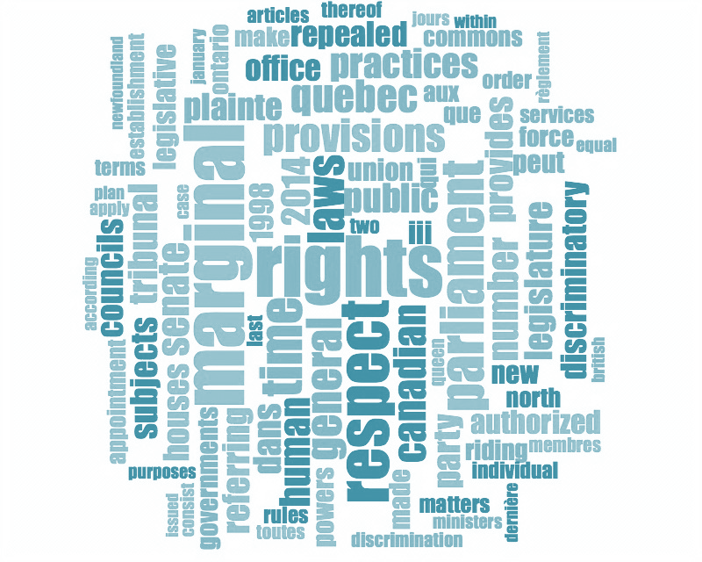
Figure 4

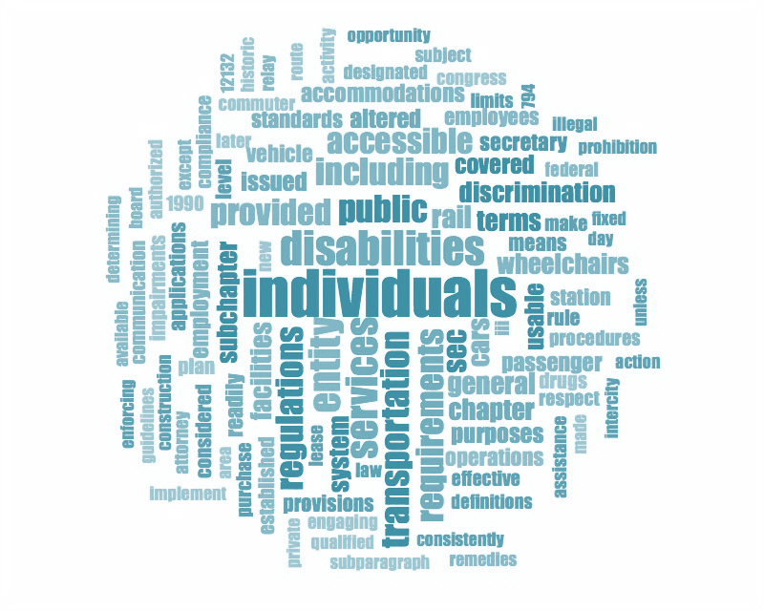

Figure 5
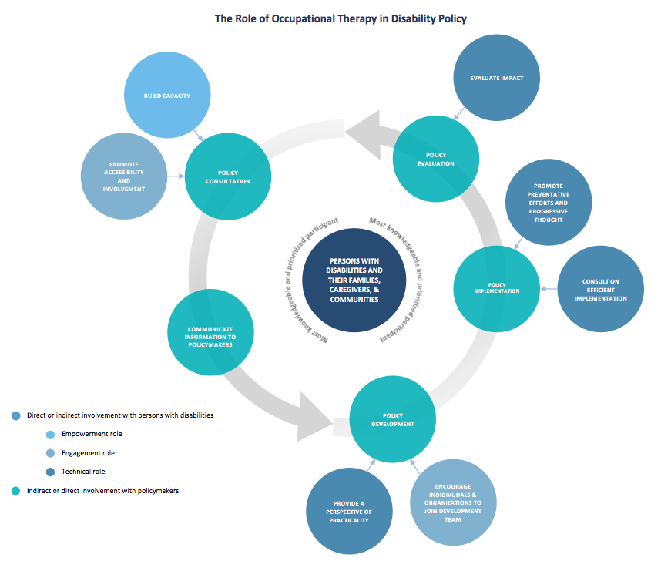
Figure 6

Appendix B

Table 1.
United States | Canada
Air Carrier Access Act | Canada Disability Savings Act
Americans with Disabilities Act | Canada Elections Act
AOTA Centennial Vision | Canada Health Act
AOTA Statement | Canada Pension Plan
AOTA Vision 2025 | Canada Student Financial Assistance
Architectural Barriers Act | Canadian Human Rights Act
Assistive Technology Act | Canadian Transportation Act
Civil Rights of Institutionalized Persons Act | CAOT Strategic Plan 2016-2019
Developmental Disabilities Assistance and Bill of Rights Act | Department of Human Resources and Skills Development
Early Childhood Inclusion Statement | Disability Creation Process
Hearing Aid Compatibility Act | Employment Equity Act
Individuals with Disabilities Education Act | Income Tax Act
National Voter Registration Act | Vocational Rehabilitation of Disabled Persons Act
Patient Protection and Affordable Care Act
Rehabilitation Act
Telecommunications Accessibility Enhancement Act
Telecommunications Act
Television Decoder Circuitry Act
Voting Accessibility for the Elderly and Handicapped

References
1. Organization, W.H., World report on disability. 2011.
2. Burchardt*, T., Capabilities and disability: the capabilities framework and the social model of disability. Disability & society, 2004. 19(7): p. 735-751.
3. Hurst, R., The international disability rights movement and the ICF. Disability and rehabilitation, 2003. 25(11-12): p. 572-576.
4. Brownson, C. and M. Scaffa, Occupational therapy in the promotion of health and the prevention of disease and disability statement. The American journal of occupational therapy: official publication of the American Occupational Therapy Association, 2000. 55(6): p. 656-660.
5. Moyers, P.A., The guide to occupational therapy practice. American Journal of Occupational Therapy, 1999. 53(3): p. 247-322.
6. Kielhofner, G., Rethinking Disability and What To Do About It: Disability Studies and Its Implications for Occupational Therapy. American Journal of Occupational Therapy, 2005. 59(5): p. 487-496.
7. Mahaffey, L., et al., Role for occupational therapy in community mental health: Using policy to advance scholarship of practice. Occupational therapy in health care, 2015. 29(4): p. 397-410.
8. Kjellberg, A., From patient to participatory citizen: literature review of disability policy on participation and access in relation to occupational therapy practice. World Federation of Occupational Therapists Bulletin, 2010. 61(1): p. 32-38.
9. Vrkljan, B.H., Dispelling the disability stereotype: Embracing a universalistic perspective of disablement. Canadian Journal of Occupational Therapy, 2005. 72(1): p. 57-60.
10. Hällgren, M. and A. Kottorp, Effects of occupational therapy intervention on activities of daily living and awareness of disability in persons with intellectual disabilities. Australian Occupational Therapy Journal, 2005. 52(4): p. 350-359.
11. Rogers, A.T., et al., Higher Hospital Spending on Occupational Therapy Is Associated With Lower Readmission Rates. Medical Care Research and Review, 2016: p. 1077558716666981.
12. AOTA, Vision 2025. American Journal of Occupational Therapy, 2017. 71(7103420010).
13. AOTA, AOTA’s Centennial Vision and executive summary. American Journal of Occupational Therapy, 2007. 61(6): p. 613-614.
14. CAOT, Strategic Plan 2016-2019. 2016.
15. CAOT, Position Statement Occupational therapy and disability management services. 2011.
16. Stucki, G., A. Cieza, and J. Melvin, The international classification of functioning, disability and health: A unifying model for the conceptual description of the rehabilitation strategy. Journal of Rehabilitation Medicine, 2007. 39(4): p. 279-285.
17. Hughes, B. and K. Paterson, The social model of disability and the disappearing body: Towards a sociology of impairment. Disability & society, 1997. 12(3): p. 325-340.
18. Scotch, R.K., Models of disability and the Americans with Disabilities Act. Berkeley J. Emp. & Lab. L., 2000. 21: p. 213.
19. Sullivan, K., The Prevalence of the Medical Model of Disability in Society. 2011.
20. Parmet, W.E., Discrimination and disability: the challenges of the ADA. The Journal of Law, Medicine & Ethics, 1990. 18(4): p. 331-344.
21. Graff, M.J., et al., Effects of community occupational therapy on quality of life, mood, and health status in dementia patients and their caregivers: a randomized controlled trial. The Journals of Gerontology Series A: Biological Sciences and Medical Sciences, 2007. 62(9): p. 1002-1009.
22. Polatajko, H.J., Dreams, dilemmas, and decisions for occupational therapy practice in a new millennium: A Canadian perspective. American Journal of Occupational Therapy, 1994. 48(7): p. 590-594.
23. Altman, B.M., 4Q DEFINITIONS OF DISABILITY AND THEIR OPERATIONALIZATION, AND MEASUREMENT IN SURVEY DATA: AN UPDATE. Exploring theories and expanding methodologies: Where we are and where we need to go, 2001. 2: p. 77.
24. Lang, R., The development and critique of the social model of disability. London: Leonard Cheshire Disability and Inclusive Development Centre, 2007.
25. Fougeyrollas, P., et al., The Quebec classification: Disability creation process. 1998: Québec RIPPH/SCCIDIH.
26. Pfeiffer, D., The disability paradigm. Journal of Disability Policy Studies, 2000. 11(2): p. 98-99.
27. Bickenbach, J.E. and A. Cieza, The prospects for universal disability law and social policy. Journal of accessibility and design for all, 2011. 1(1): p. 23-37.
28. Zola, I.K., Toward the necessary universalizing of a disability policy. The Milbank Quarterly, 1989: p. 401-428.
29. Trani, J.-F., et al., Disabilities through the Capability Approach lens: Implications for public policies. ALTER-European Journal of Disability Research/Revue Européenne de Recherche sur le Handicap, 2011. 5(3): p. 143-157.
30. NICHCY, Categories of Disability Under IDEA. 2016.
31. Shackelford, J., State and Jurisdictional Eligibility Definitions for Infants and Toddlers with Disabilities under IDEA. NECTAC Notes. Issue No. 21. National Early Childhood Technical Assistance Center (NECTAC), 2006.
32. Madden, R. and T. Hogan, The Definition of Disability in Australia: Moving Towards a National Consistency. 1997: Australian Institute of Health and Welfare Canberra.
33. International Disability Alliance, Persons with Disabilities Excluded from National Sustainable Development Plans, I.D.a.D. Consortium, Editor. 2015. p. 1-2.

