The Story Builder Tool User Guide
Author: Inclusive Design Research Centre
February 2019
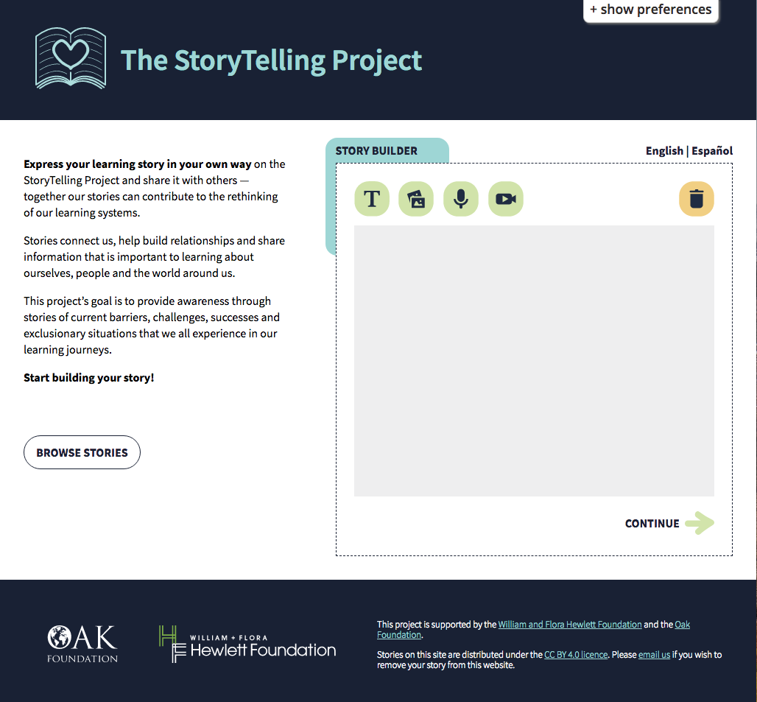

Table of Content
Story Builder Instructions — Short version 3
Add Content Blocks 3
Add Descriptions (Metadata) to Content Blocks 3
Remove Content Blocks 3
Add Story Title, Author Name and Keywords 3
Preview Story 3
Publish Story 3
Story Builder Instructions — Long version 4
Content Blocks 4
Add blocks to your story 4
Add descriptions (metadata) to your blocks 4
Add Section Title: 5
Add Summary: 5
Add description: 5
Add alt text (Alternative text): 5
Add transcripts: 5
Remove blocks from your story 5
Add title, author and keywords 6
Preview your story 6
Publish your story 6

Story Builder Instructions — Short version
To upload your story please go to the Storytelling website at https://stories.floeproject.org/

Add Content Blocks
The Story Builder is designed based on building blocks. To create your story, click on an icon at the top of the Story Builder to add a content block. You can add as many blocks as you like but you won’t be able to reorder them. There are four types of blocks you can use to build your story: Written content, images (photos of items, drawings, diagrams, etc.), audio (sound), video (audio and visual)

Add Descriptions (Metadata) to Content Blocks
Each block includes a few extra text fields for additional information about its content. This information is called ‘Metadata’ and it helps screen readers, search engines and other assistive technologies to find and access the content of each block.

Remove Content Blocks
To remove a content block, first select the checkbox at the top right corner of each block and then click on the trash can icon on the top right corner of the Story Builder Tool. Deleted blocks cannot be retrieved.

Add Story Title, Author Name and Keywords
Selecting "Continue" takes you to the next step where you can add a title, author name and keywords to your story. This information helps others to find your story and attribute it to you when they are reusing it.

Preview Story
Selecting “Preview My Story” displays how your story would look like when it is published. You can always select the “Back” button to go to the previous section and continue editing your story.

Publish Story
Selecting “Publish My Story” submits your story to the Storytelling project website. Published stories are licensed under CC BY 4.0, which means others can reuse the content, make modifications, and attribute to the original author. Published stories are not editable and you cannot remove them from the site. If you wish to remove your story from the website, please send an email to stories@idrc.ocadu.ca.

Story Builder Instructions — Long version
To upload your story please go to the Storytelling website at https://stories.floeproject.org/

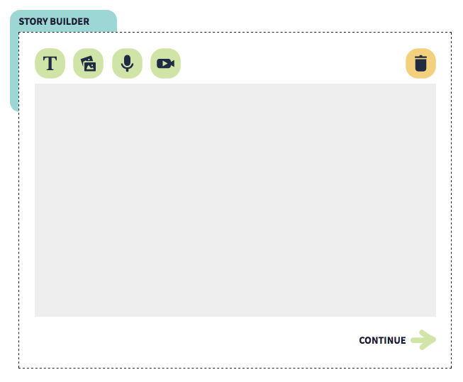
Content Blocks

The Story Builder is designed based on building blocks. Each type of content has its own block. Each block invites you to add your content. There are four types of content you can use to build your story
- Written content—type directly in the tool
- images (photos of items, drawings, diagrams, etc.)—upload files
- audio (sound)—upload files
- video (audio and visual)—upload files
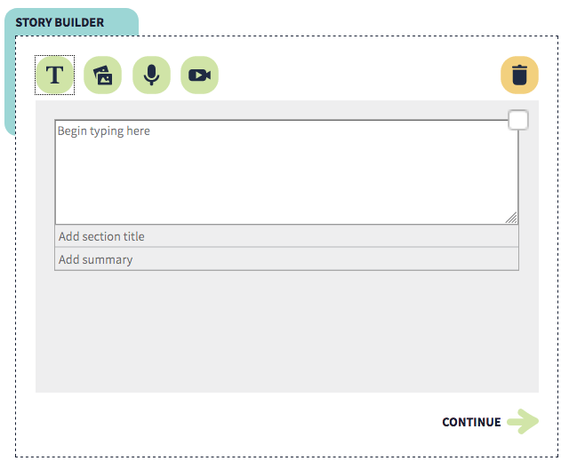

Add blocks to your story
To build your story, you can click on an icon at the top of the Story Builder to add a block to your story. You can add as many blocks as you like.
Tip: outline the order of your blocks before building your story. You won’t be able to reorder the blocks once you have added them in the Story Builder Tool.

Add descriptions (metadata) to your blocks
Each block you add to your story includes a few extra text fields where you can enter additional information about the content of that block. This information is called ‘Metadata’ and it helps screen readers, search engines and other assistive technologies to find and access the content of each block.

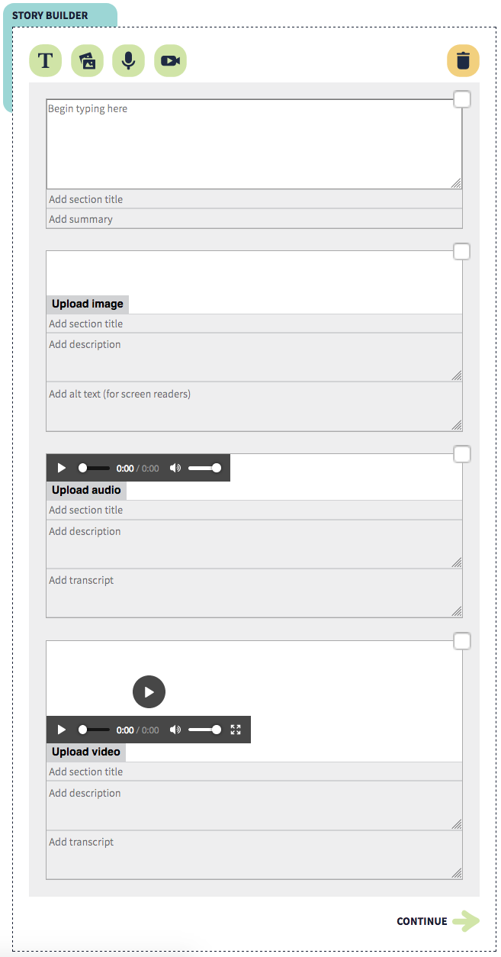
Add Section Title:
This applies for all different blocks. Giving each section a title helps readers and screen readers (apps that read words out loud on a computer) understand the content of your story better.

Add Summary:
This only applies to text blocks. Summarizing this section helps people who may not be able to read or understand the full text.

Add description:
This applies to image, video and audio blocks. Description is displayed with an image, video or audio file and is usually a short sentence explaining their content.

Add alt text (Alternative text):
This only applies to image blocks and is accessible to screen readers. Alt text describes the main points of an image in text format to help communicate the meaning of an image with anyone unable to see the image.

Add transcripts:
This information is only needed for video and audio blocks. A transcription of an audio file helps anyone unable to hear or understand the audio have better access to your story.

Remove blocks from your story
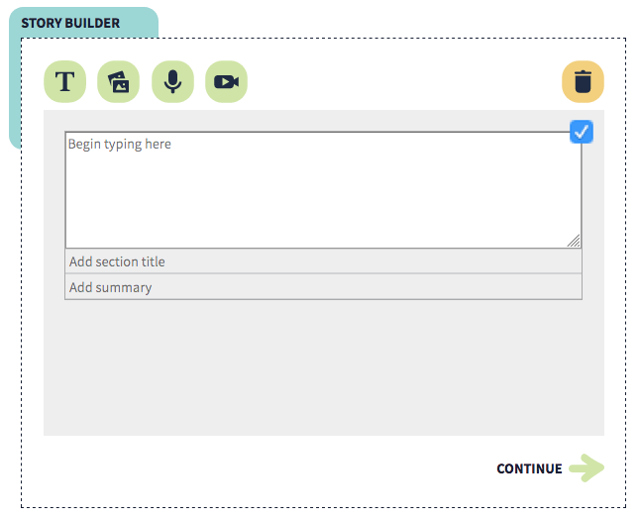
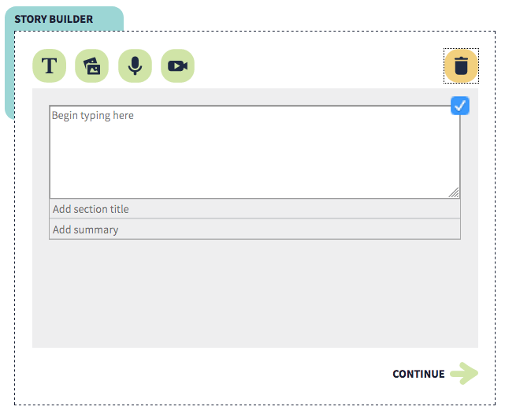
To remove a block, first select the checkbox at the top right corner of each block and then click on the trash can icon on the top right corner of the story builder panel. Deleted blocks cannot be retrieved.

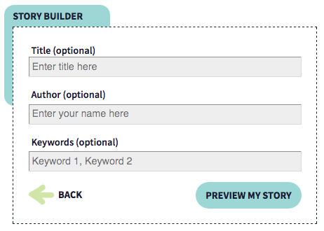
Add title, author and keywords
When you've added all the blocks to your story, select "Continue" to give your story a title, author and keywords. This information helps others find your story and attribute it to you when they are reusing your story.
* If you are entering several different keywords, make sure they are separated by a comma.
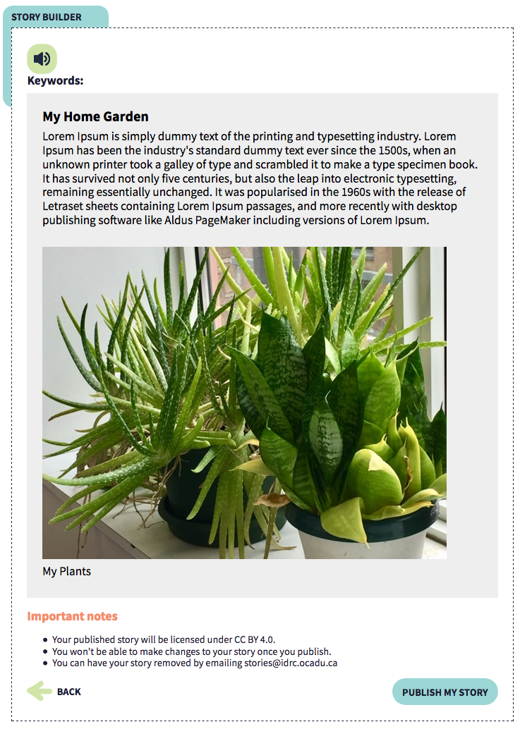

Preview your story
Selecting the “Preview” button will display how your story will look like when it is published. You can always select the “Back” button to go back to the previous sections and edit your story.

Publish your story
Once you are ready, select “Publish my story” to submit your story to the Storytelling Project website. Published stories are licensed under CC BY 4.0, which means others can reuse the content, make modifications, and attribute to the original author. Published stories are not editable and you cannot remove them from the site. If you wish to remove your story from the website, please send an email to stories@idrc.ocadu.ca.

