Preferences for Global Access

Institute for the Study of Knowledge Management in Education (ISKME)
Contract #ED-OSE-12-D-0013-0002

Deliverable Task 2.2: Dev Milestone 2 Application specific features
Cloud-Based Accessibility For Individuals with Disability
Tools for Creating Specifications of User Needs and Preferences for Online Interactions in Several Different Application Settings

Prepared by:

ISKME

Ontario College of Art and Design University

IBM

WGBH

Raising the Floor International

Inclusive Technologies

The development of this document was led by PGA team members
Dana Ayotte

Inquiries about this work can be addressed to lisa@iskme.org

June 30, 2015

Table of Contents
First Discovery Tool Customizations 3
1. Introduction 3
2. Customization Example - Voting 4
2.1 Use Case - Voting 4
3. Customization Example - Online Educational Assessment 7
3.1 Use Case - Educational Assessment 8
4. Customization Example - Community-based Technology Support for Older Citizens 12
4.1 Use Case - Community-based Technology Support for Older Citizens 12
References 17

List of Figures
Figure 1: Language Preference Panel
Figure 2: Color contrast preference panel
Figure 3: First discovery process leads directly into voting ballot
Figure 4: Self-voicing preference panel
Figure 5: Text and button size preference panel
Figure 6: Confirmation panel
Figure 7: Confirmation leads directly into math quiz
Figure 8: Welcome panel
Figure 9: First screening question
Figure 10: Second screening question
Figure 11: On-screen keyboard preference panel
Figure 12: Completion/congratulations panel

First Discovery Tool Customizations

1. Introduction
In the early stages of the PGA design process, the team described use cases and scenarios for the four application settings where the First Discovery tool would be used¹. These settings include:
- Voting
- Open Education Resources
- Educational assessment
- Community-based technology support for older citizens
Establishing these application settings allowed the team to determine which preferences might be included in the tool and also to understand the ways in which the tool might look and function differently in different settings. This in turn helped the team define the process for customizing first discovery².

To address unique uses, the First Discovery Tool is designed to be easily customizable to any setting or context. Preferences can be added or removed, the order of preferences can be changed, styling can be adjusted, and the tool can be integrated into a given context (e.g. the first discovery process can lead into a given task such as voting, or the tool can be made findable within the context of a given task).

This document shows examples of three different tool customizations, including customizations for the following application settings:
- Voting (a simplified tool at the ballot location)
- Online educational assessment (in the context of a math quiz)
- Community-based technology support for older citizens (a seniors’ tech-center intake process)

2. Customization Example - Voting
The voting application setting illustrates a customization that requires a significant simplification of the tool, resulting in only three available preferences.

An interactive and functional demonstration of the First Discovery Tool in a voting context can be found at the following link:
http://build.fluidproject.org/first-discovery/demos/voting/

In this case preferences are selected based on what is applicable to the voting interface, as well as what is appropriate in the voting context: a desire to keep the process as quick and efficient as possible. In addition to reducing the number of preferences, the colour scheme of the interface has been modified to be consistent with the voting kiosk interface, and the icons along the bottom of the screen have been simplified.

2.1 Use Case - Voting
The following use case describes a potential user of the First Discovery Tool in a voting scenario:
Name: Minjun (pronounced Min-Joon)
Age: 28
Occupation: Home health aid

Interests:
- His parents
- TV
- Korean singing

Description:
- Has vision loss, including being color blind.
- As an immigrant, newly naturalized, English is Minjun’s second language.
- Although he can remember who the candidates are from seeing them on TV, he has problems reading their names.
- Comfort level with tech: Functional
- Has not voted before.

Needs & Preferences:
- Color Contrast
- Text size
- Language (Korean) (ability to switch back an forth)
- Audio

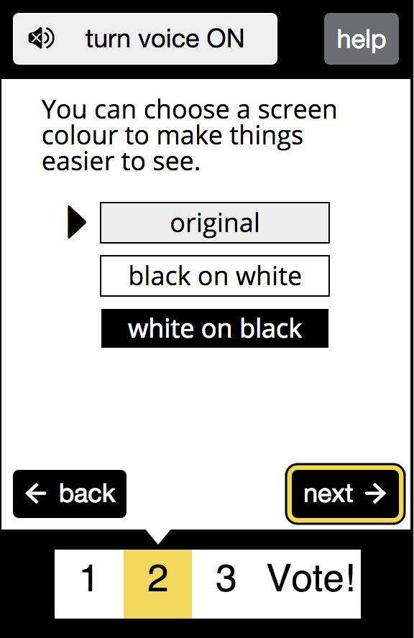
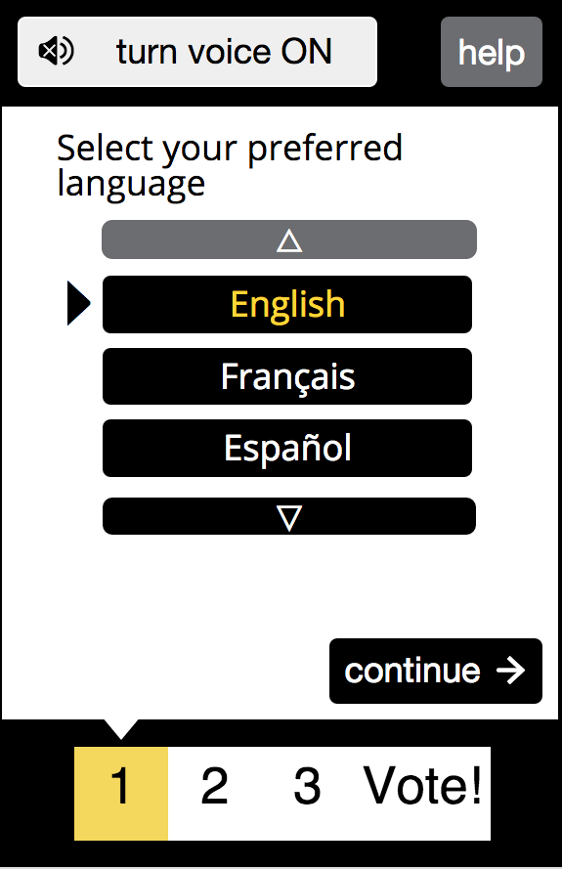
Sample screens from the First Discovery Tool in a voting context:
Figure 2: Color contrast preference panel
Figure 1: Preference Panel

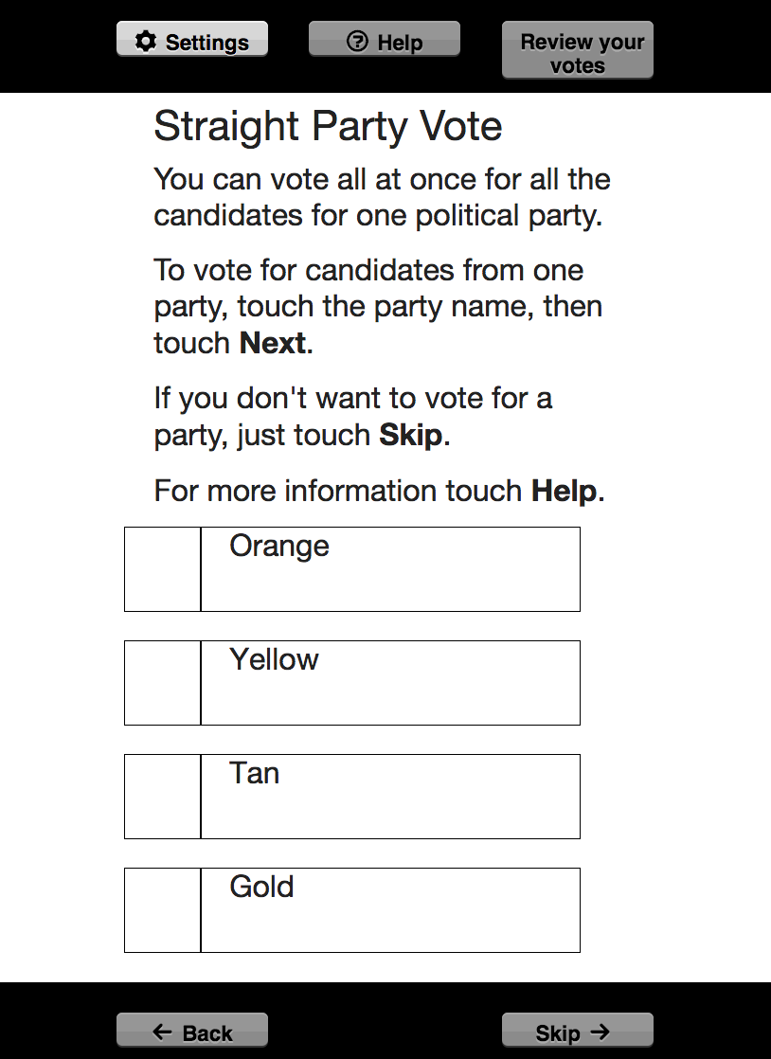
Figure 3: First discovery process leads directly into voting ballot

3. Customization Example - Online Educational Assessment

The online educational assessment setting demonstrates a customization that requires changes to the language level and language style of the tool to meet the needs of a younger student audience, as well as a “re-branding” of the tool to blend in with the styling of the online quiz environment.

An interactive and functional demonstration of the First Discovery Tool in an educational assessment context can be found at the following link:
http://build.fluidproject.org/first-discovery/demos/assessment/

In this case, the First Discovery process is being carried out by Grade 3 students prior to taking a math quiz. The tool is integrated into the testing environment – once the first discovery process is complete the student is taken directly into the test, with the ability to return to the discovery tool at any time if changes to their settings are desired.

The following use case describes another potential user of the first discovery tool in another educational assessment scenario:

3.1 Use Case - Educational Assessment
Name: Pat
- 13 years old
- moving foster homes
- transitioning from one school district to another one month prior to end-of-year assessment
- Pat is beginning to feel disengaged from formalized learning
- passionate about bats (Stella Luna was a favorite childhood book)

Episodic mobility needs
- fatigue increases over the course of day
- becomes more difficult for Pat to write, speak and read

Access to technology?
- uses voice recognition, screen reader, alternative pen grip, joystick, adjustable track pad
- transfer to new school means re-training of Pat to use new brand of AT

Needs and preferences?
- wants learning related to passion (bats)
- doesn't want to be identified with disability or special needs
- wants to take test at same time as the rest of the class
- needs to use needs and prefs more (or different ones) as the day goes on

Goal user is trying to accomplish in setting?
- fitting in at school
- learning more about bats
- wants to build a bat house at home
- pass the test!

Goal that educators/system are trying to accomplish?
- get a good score?
- determine where to place Pat

Steps to accomplish
- transfer of needs and preferences from school to school while maintaining Pat's privacy
- accessible assessment to determine knowledge gaps in new school district
- opportunity for Pat to try out AT/preferences outside of class and prior to testing

Other use cases/considerations
- cognitive needs
- test anxiety
- effort required to negotiate test mechanics outweigh intellectual process
- different life stages (very young student)
- changing landscape of assessment - jumping where the mouse has been, rather than where the mouse is going!
- "adjacent possible"? take long vision and work our way back
- "perimeter passing" ?

Sample screens from the First Discovery Tool in an educational assessment context:
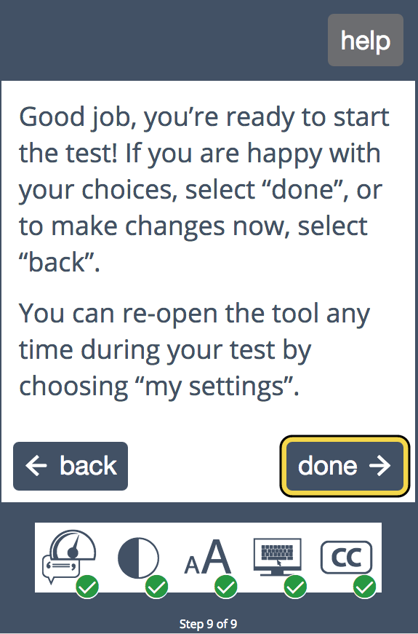
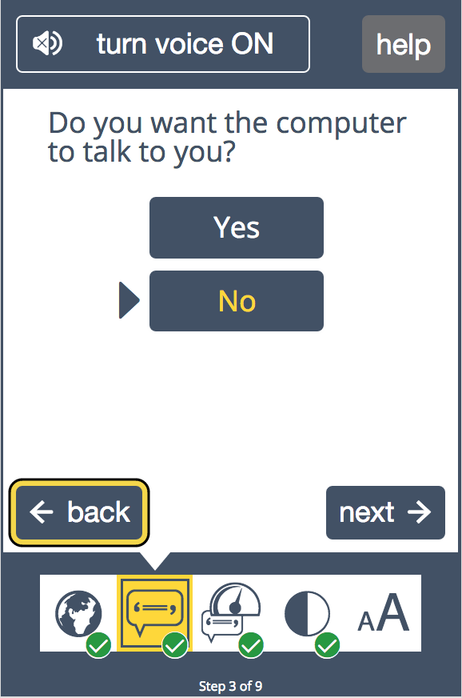
Figure 5: Text and button size preference panel
Figure 4: Self-voicing preference panel

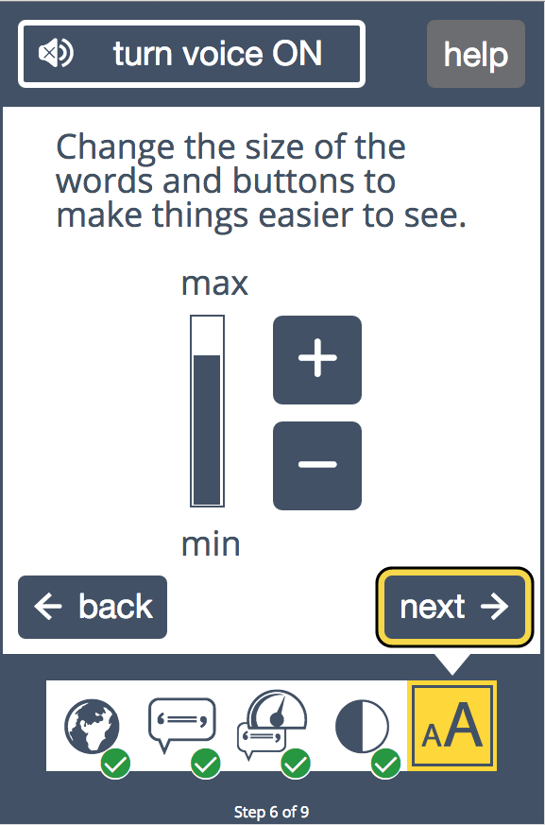
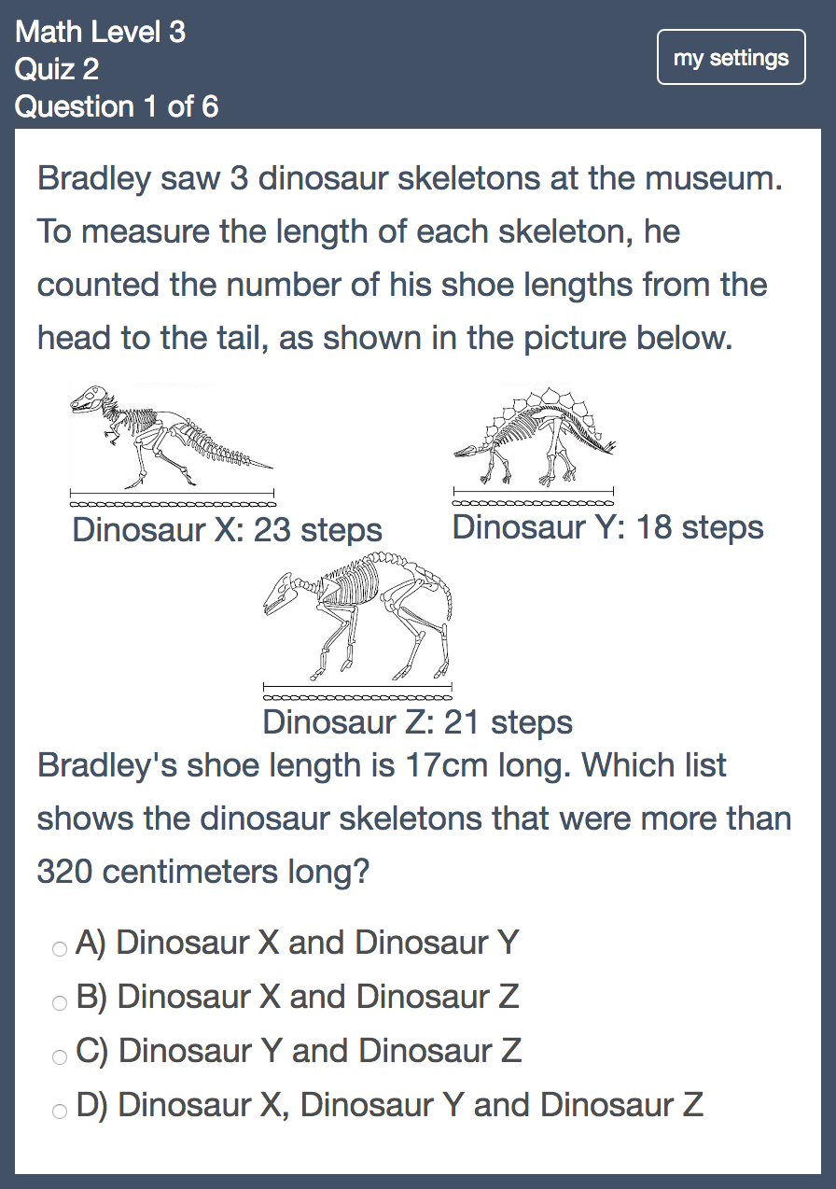
Figure 6: Confirmation panel
Figure 7: Confirmation leads directly into math quiz

4. Customization Example - Community-based Technology Support for Older Citizens
This setting demonstrates a customization that requires the addition of screening-type questions into the tool flow, as well as a “re-branding” of the tool to blend in with the styling of a seniors technology center online intake form and/or online course.

An interactive demonstration of the First Discovery Tool in a seniors’ intake context can be found at the following link:
http://invis.io/7T363VAUZ (Chrome only)

This demo illustrates how the First Discovery Tool could be configured to take the user through a different path depending on answers to questions. In this demo, if the user has no experience with computers, they will be presented with the preferences, but if they already have some experience, they will be asked about that experience, and presented with preferences deemed relevant to them, based on their answers.

The following use case describes a potential user of the First Discovery Tool in a seniors’ intake scenario:

4.1 Use Case - Community-based Technology Support for Older Citizens
Name: Maude
- 86 years old
- retired teacher
- widow
- lives alone in her own home
- socially isolated
- family lives far away
- no technology experience

Interests:
- watching TV,
- reading (large print books with a magnifying glass),
- she used to knit and garden and play bingo but these are more difficult now

Goal:
- she was given an iPad by her family and wants to use it to FaceTime with them. They set up themselves as contacts, and told er to go to the Apple store if she needed help. She doesn't want to do that because it is far away and too much effort. She already has WiFi in her house, installed by her family for their own use when they came to visit.
- she knows her family members share information and photos through Facebook and texts and feels she's missing out
- she might enjoy reading with large fonts on the iPad, but isn't aware that's possible
- steps to accomplish goal:
  - Turn on iPad (fiddly because she has arthritis and a mild tremor)
  - Swipe the screen (she can't read what's on the screen if the text is not enlarged, but she does have her magnifying glass. She may have trouble swiping.)
  - Find and recognize Facetime icon
  - Tap the icon (she may have trouble tapping on the icon, double tap, or slip while tapping)
  - scan list of contacts on left
  - tap on the person
  - ringing begins (she might not be able to hear)
  - daughter answers
  - talk and listen (she might accidentally touch the home button and be unable to see her daughter, or get back to the call, or hang up)
  - hang up
- needs and preferences
  - very large text
  - high volume
  - Perhaps also high contrast
  - Perhaps also text-to-speech
  - Perhaps also tremor filtering

Sample screens from the first discovery tool in a seniors’ intake context:
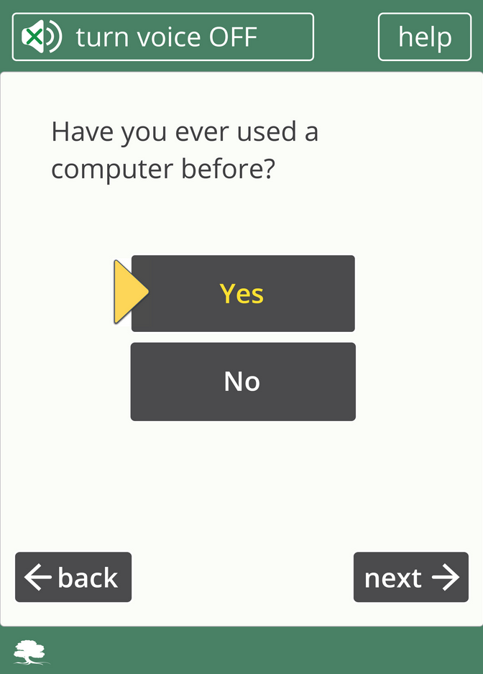
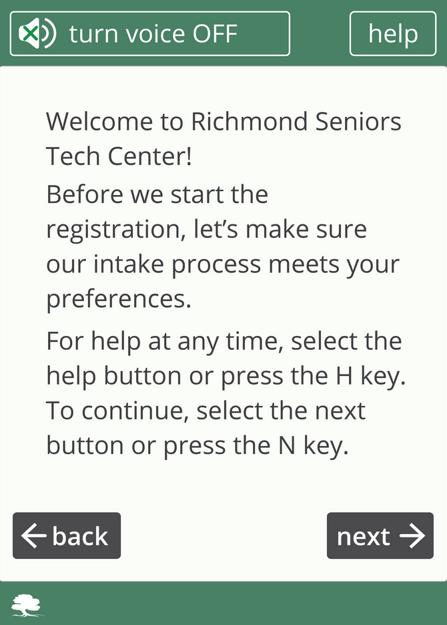
Figure 9: First screening question
Figure 8: Welcome panel

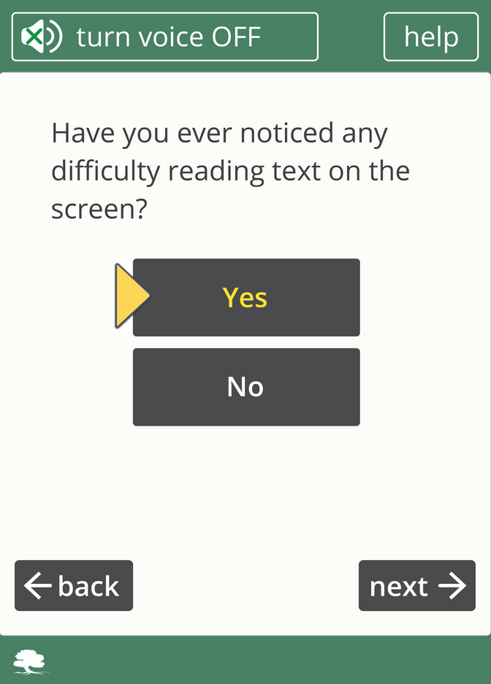
Figure 10: Second screening question
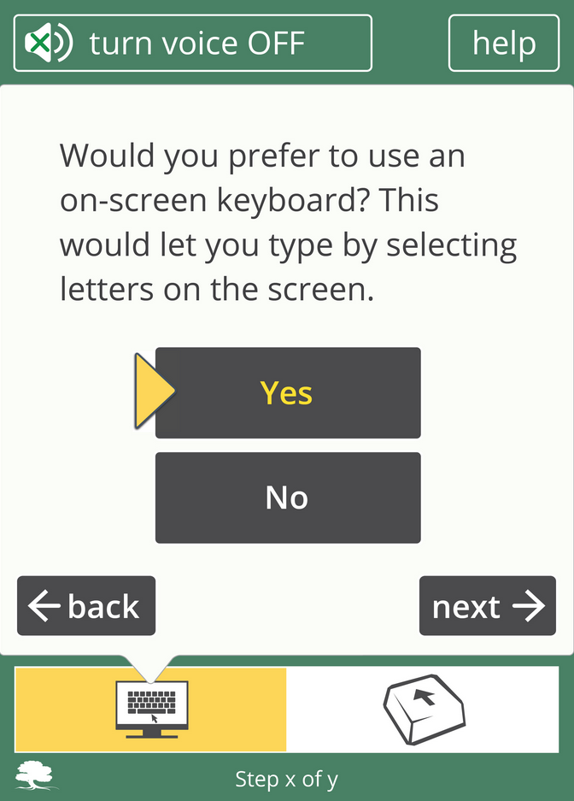
Figure 11: On-screen keyboard preference panel

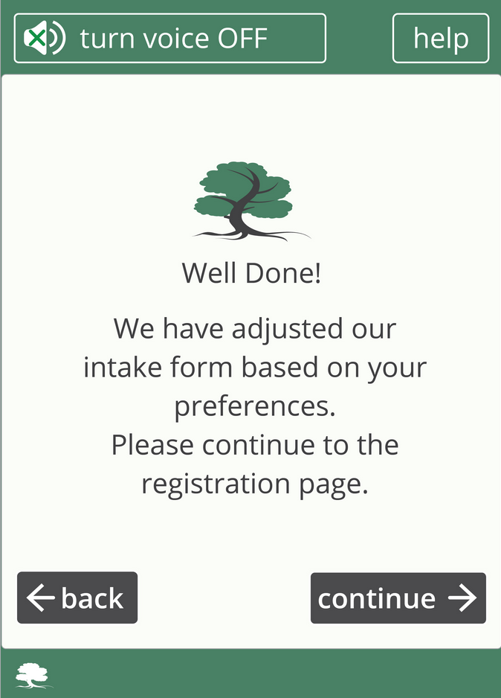
Figure 12: Completion/congratulations panel

References
1. For details about the first workshop and process of developing application settings please refer to Deliverable 1.2: Workshop Report
2. For technical details about the customization process please refer to the Deliverable Task 2.2: Architecture Report

